|  |  |
| --- | --- |
| Software Design and analysis on PGDIT Automation system |  |

SOFTWARE DESIGN AND ANALYSIS ON PGDIT AUTOMATION SYSTEM

Submitted to:

Nadia Nahar

Lecturer

Institute of Information Technology

University of Dhaka

Submitted by:

Jarifa Khatun (0710)

Asadullah Hil Galib (0712)

Satyaki Das (0720)

Moumita Asad (0731)

Shafi ul Alam (0735)

3rd Year, 6th Semester, 7th Batch

Session: 2014-2015

Institute of Information Technology

University of Dhaka

Submission Date: 19th November, 2017

Letter of Transmittal

19th November, 2017

Nadia Nahar

Lecturer

Institute of Information Technology

University of Dhaka

Subject: Submission of design document on “PGDIT Automation System”.

Madam,

We, the team, on which the project on “PGDIT Automation System” was assigned, are submitting our report with due respect. We have tried our best for the report. However, it might lack perfection. So, we therefore, hope that you would be kind enough to accept our report and oblige thereby.

Yours sincerely

Jarifa Khatun (0710)

Asadullah Hil Galib (0712)

Satyaki Das (0720)

Moumita Asad (0731)

Shafi ul Alam (0735)

3rd Year, 6th Semester, 7th Batch

Institute of Information Technology

University of Dhaka

Session: 2014-15

Table of Contents

Chapter 1. Introduction 1

Chapter 2. Architectural Design of PGDIT Automation System 2

2.1 Representing the System in Context 2

2.2 Defining Archetypes 4

2.3 Refining the Architecture into Components 6

2.4 Describing Instantiations of the System 7

2.5 Architectural mapping using data flow 7

Chapter 3. Component-Level Design of PGDIT Automation System 24

3.1 Identify All Design Classes that Correspond to the Problem Domain 24

3.2 Identify All Design Classes that Correspond to the Infrastructure Domain 25

3.3 Elaborate All Design Classes that are not Acquired as Reusable Components 26

3.3.1 Specify Message Details when Classes or Components Collaborate 36

3.3.2 Identify Appropriate Interfaces for Each Component 54

3.3.3 Elaborate Attributes and Define Data Types and Data Structures required to Implement Them 61

3.3.4 Describe Processing Flow within Each Operation in Detail 63

3.4 Describe Persistent Data Sources and Identify the Classes required to Manage Them 104

3.5 Develop and Elaborate Behavioral Representations for a Class or Component 105

3.6 Elaborate Deployment Diagrams to Provide Additional Implementation Detail 112

Chapter 4. User Interface Design 113

4.1 Interface Analysis 113

4.1.1 User Analysis 113

4.1.2 Task Analysis 116

4.2 Interface Design Steps 121

4.2.1 Define Interface Objects and Actions 122

4.2.2 Define Events that will Cause the State of the User Interface to Change 151

4.2.3 Depict Each Interface State as It Look to End User 157

List of Figures

Figure 1 Design Model 1

Figure 2 Steps of Architectural Design 2

Figure 3 Architectural Context Diagram of PGDIT Automation System 3

Figure 4 Archetypes 5

Figure 5 Overall Architectural Structure with Top-Level Components 6

Figure 6 An Instantiation of the PGDIT Automation System Architecture 7

Figure 7 Architectural Mapping 8

Figure 8 Level 0 Dataflow Diagram 8

Figure 9 Level 1 Dataflow Diagram 9

Figure 10 Dataflow Diagram of Authentication and Registration 9

Figure 11 Program Chairperson's Dataflow Diagram of Registration 9

Figure 12 Teacher's Dataflow Diagram of Registration 10

Figure 13 User's Dataflow Diagram of Authentication 10

Figure 14 Dataflow Diagram of Admission System 11

Figure 15 Applicant's Dataflow Diagram of Admission System 11

Figure 16 Exam Controller's Dataflow Diagram of Admission System 12

Figure 17 Receptionist's Dataflow Diagram of Admission System 12

Figure 18 Scrutinizing team's Dataflow Diagram of Admission System 12

Figure 19 Teacher's Dataflow Diagram of Admission System 12

Figure 20 Dataflow Diagram of Course Management System 13

Figure 21 Program Chairperson's Dataflow Diagram of Course Management System 13

Figure 22 Student's Dataflow Diagram of Course Management System 13

Figure 23 Teacher's Dataflow Diagram of Course Management System 14

Figure 24 Dataflow Diagram of Result Generation System 14

Figure 25 Program Chairperson's Dataflow Diagram of Result Generation System 15

Figure 26 Exam Controller's Dataflow Diagram of Result Generation System 15

Figure 27 Teacher's Dataflow Diagram of Result Generation System 16

Figure 28 Student's Dataflow Diagram of Result Generation System 16

Figure 29 DFD mapping of Teacher's Dataflow Diagram of Registration 16

Figure 30 DFD mapping of Program chairperson's Dataflow Diagram of Registration 17

Figure 31 DFD mapping of User's Dataflow Diagram of Authentication 17

Figure 32 DFD mapping of Applicant's Dataflow Diagram of Admission System 18

Figure 33 DFD mapping of Exam Controller's Dataflow Diagram of Admission System 18

Figure 34 DFD mapping of Receptionist's Dataflow Diagram of Admission System 19

Figure 35 DFD mapping of Scrutinizer's Dataflow Diagram of Admission System 19

Figure 36 DFD mapping of Teacher's Dataflow Diagram of Admission System 20

Figure 37 DFD mapping of Program Chairperson’s Dataflow Diagram of Course Management System. 20

Figure 38 Teacher's Dataflow Diagram of Course Management System 21

Figure 39 DFD mapping of Student's Dataflow Diagram of Course Management System 21

Figure 40 DFD mapping of Program Chairperson's Dataflow Diagram of Result Generation System 21

Figure 41 DFD mapping of Exam Controllers's Dataflow Diagram of Result Generation System 22

Figure 42 DFD mapping of Teacher's Dataflow Diagram of Result Generation System 23

Figure 43 DFD mapping of Student’s Dataflow Diagram of Result Generation System 23

Figure 44 Steps of Component-Level Design 24

Figure 45 Analysis classes 25

Figure 46 Design classes 26

Figure 47 Elaborated Applicant class 27

Figure 48 Elaborated User class 28

Figure 49 Elaborated ProgramChairperson class 29

Figure 50 Elaborated Scrutinizer class 30

Figure 51 Elaborated Receptionist class 31

Figure 52 Elaborated ExamController class 33

Figure 53 Elaborated Teacher class 35

Figure 54 Elaborated Student class 36

Figure 55 Method applyForAdmission() of Applicant Class 37

Figure 56 Method downloadAdmitCard() of Applicant Class 37

Figure 57 Method checkFulfillmentOfPrerequisites() of ProgramChairperson Class 38

Figure 58 Method addNewStudentsIntoCourse() of ProgramChairperson Class 38

Figure 59 Method selectInstructor() of ProgramChairperson Class 39

Figure 60 Method viewAccountRequest() of ProgramChairperson Class 39

Figure 61 Method approveAccountRequest() of ProgramChairperson Class 40

Figure 62 Method viewResult() of ProgramChairperson Class 40

Figure 63 Method viewFilteredApplications() of Scrutinizer Class 41

Figure 64 Method updateStatusOfEligibility() of Scrutinizer Class 41

Figure 65 Method viewApplicantInformation() of Receptionist Class 42

Figure 66 Method updateStatusOfPayment() of Receptionist Class 42

Figure 67 Method addApplicationTimeRange() of ExamController Class 43

Figure 68 Method addPaymentTimeRange() of ExamController Class 43

Figure 69 Method addScrutinizationTimeRange() of ExamController Class 44

Figure 70 Method generateSeatPlan() of ExamController Class 44

Figure 71 Method updateVivaSchedule() of ExamController Class 45

Figure 72 Method updateWrittenMarks() of ExamController Class 45

Figure 73 Method updateVIVAMarks() of ExamController Class 46

Figure 74 Method getVivaNotification() of Teacher Class 46

Figure 75 Method getCourseAssignmentNotification() of Teacher Class 47

Figure 76 Method viewListOfCourses() of Teacher Class 47

Figure 77 Method viewCourseInformation() of Teacher Class 48

Figure 78 Method updateCourseInformation() of Teacher Class 48

Figure 79 Method setSupplementaryMarks() of Teacher Class 49

Figure 80 Method setCourseMark() of Teacher Class 49

Figure 81 Method generateResultPdf() of Teacher Class 50

Figure 82 Method checkGradeForSupplementary() of Teacher Class 50

Figure 83 Method generateSupplementaryList() of Teacher Class 51

Figure 84 Method generateSupplementaryResultPdf() of Teacher Class 51

Figure 85 Method notifyForSupplementaryExam() of Teacher Class 52

Figure 86 Method uploadFinalResultPdf() of Teacher Class 52

Figure 87 Method viewCourseList() of Student Class 53

Figure 88 Method viewCourseDetails() of Student Class 53

Figure 89 Method getMarks() of Student Class 54

Figure 90 Method getNotification() of Student Class 54

Figure 91 Authentication class 55

Figure 92 RollGenerator class 56

Figure 93 ReportCard class 56

Figure 94 RoomHandler Class 58

Figure 95 HeaderDisplayer class 59

Figure 96 PDFHandler class 60

Figure 97 verifyUsernameAndPassword() of Authentication 63

Figure 98 forgotPassword() of Authentication 64

Figure 99 verifyUsernameAndRecoveryCode() of Authentication 65

Figure 100 setNewPassword() of Authentication 65

Figure 101 applyForAdmission() of Applicant 66

Figure 102 checkAvailabilityOfAdmitCard() of Applicant 67

Figure 103 generateAdmitCard() of Applicant 67

Figure 104 generateQuery() of QueryGenerator 68

Figure 105 updateAddress() of User 69

Figure 106 updateMobileNo() of User 69

Figure 107 updatePicture() of User 70

Figure 108 getBlockingNotification() of User 70

Figure 109 viewName() of HeaderDisplayer 71

Figure 110 viewImage() of HeaderDisplayer 71

Figure 111 viewListOfUsers() of ProgramChairperson 72

Figure 112 updateFullName() of ProgramChairperson 72

Figure 113 updateUserEmail () of ProgramChairperson 73

Figure 114 addNewStudentsIntoCourse() of ProgramChairperson 73

Figure 115 approveAccountRequest() of ProgramChairperson 74

Figure 116 checkFulfillmentOfPayment() of ProgramChairperson 74

Figure 117 selectInstructor() of ProgramChairperson 75

Figure 118 createStudentAccount() of ProgramChairperson 75

Figure 119 viewResult() of ProgramChairperson 76

Figure 120 viewInformationOfOneUser() of ProgramChairperson 77

Figure 121 viewListOfCourses () of ProgramChairperson 77

Figure 122 checkGradeForSupplementary() of Teacher 78

Figure 123 generateResultPdf() of Teacher 78

Figure 124 generateGrade() of Teacher 79

Figure 125 generateSupplementaryList() of Teacher 80

Figure 126 generateSupplementaryResultPdf() of Teacher 81

Figure 127 getResultSheet() of Teacher 81

Figure 128 notifyForSupplementaryExam() of Teacher 82

Figure 129 setCourseMark() of Teacher 82

Figure 130 setSupplementaryMark() of Teacher 83

Figure 131 updateCourseInformation() of Teacher 83

Figure 132 viewCourseInformation() of Teacher 84

Figure 133 viewListOfCourse() of Teacher 84

Figure 134 viewSupplementaryList() of Teacher 85

Figure 135 generateResultPdf() of PDFHandler 85

Figure 136 generateSupplementaryResultPdf() of PDFHandler 86

Figure 137 updatePdf() of PDFHandler 86

Figure 138 uploadFinalResultPdf() of PDFHandler 87

Figure 139 getNotification() of Student 88

Figure 140 viewCourseDetails() of Student 89

Figure 141 viewCourseList() of Student 90

Figure 142 generatePdf() of ReportCard 91

Figure 143 getMarks() of ReportCard 91

Figure 144 addApplicationTimeRange() of Exam Controller 92

Figure 145 addPaymentTimeRange() of Exam Controller 92

Figure 146 addScrutinizationTimeRange() of Exam Controller 93

Figure 147 endAdmissionSession() of ExamController 93

Figure 148 lockVivaMarks() of ExamController 94

Figure 149 lockWrittenMarks() of ExamController 94

Figure 150 updateAvailabilityOfAdmitCard() of ExamController 95

Figure 151 updateEnrollmentState() of ExamController 95

Figure 152 updateVivaSchedule() of ExamController 96

Figure 153 updateWrittenMarks() of ExamController 96

Figure 154 viewListOfApplicants() of ExamController 97

Figure 155 viewListOfEligibleCandidateAfterFullResult() of ExamController 97

Figure 156 viewListOfEnrolledCandidates() of ExamController 98

Figure 157 addNewRoom() of RoomHandler 98

Figure 158 generateSeatPlan() of RoomHandler 99

Figure 159 showListOfRoom() of RoomHandler 99

Figure 160 updateRoomCapacity() of RoomHandler 100

Figure 161 viewFilteredApplcations() of Scrutinizer 100

Figure 162 searchByApplicationID () of Scrutinizer 101

Figure 163 updateStatusOfEligibility() of Scrutinizer 101

Figure 164 assignRollToEligibleApplicants() of RollGenerator 102

Figure 165 generateRoll() of RollGenerator 103

Figure 166 updateStatusOfPayment() of Receptionist 103

Figure 167 viewApplicantInformation() of Receptionist 104

Figure 168 DatabaseHandler class 104

Figure 169 State Diagram of the Applicant class 105

Figure 170 State Diagram of the Authentication class 105

Figure 171 state diagram of the Authentication class 106

Figure 172 State Diagram of the HeaderDisplayer class 106

Figure 173 State Diagram of the ProgramChairperson class 107

Figure 174 State Diagram of the ExamController class 108

Figure 175 State Diagram of the RoomHandler class 109

Figure 176 State Diagram of the Receptionist class 109

Figure 177 State Diagram of the Scrutinizer class 109

Figure 178 State Diagram of the RollGenerator class 109

Figure 179 State Diagram of the Teacher class 110

Figure 180 State Diagram of the PDFHandler class 110

Figure 181 State Diagram of the Student class 111

Figure 182 State Diagram of the ReportCard class 111

Figure 183 Deployment Diagram of PGDIT Automation System 112

Figure 184 Interface Design Steps 121

Figure 185 Home 122

Figure 186 About us 123

Figure 187 Contact us 123

Figure 188 Registration 124

Figure 189 Forgot Password 125

Figure 190 Reset Password 126

Figure 191 New Password 126

Figure 192 Admission form 127

Figure 193 Download Admit Card 128

Figure 194 Profile of Program Chairperson 129

Figure 195 Update Profile 129

Figure 196 Course Management 130

Figure 197 Select Teacher 130

Figure 198 View Students of a Course 131

Figure 199 Allocate Students 132

Figure 200 Account Requests 132

Figure 201 View Users 133

Figure 202 View User Details 133

Figure 203 Edit User Information 134

Figure 204 Course wise Result 134

Figure 205 Student wise Result 135

Figure 206 Teacher's Profile 136

Figure 207 View Courses 137

Figure 208 View Students 137

Figure 209 Manage Result 138

Figure 210 Provide Marks 139

Figure 211 Notifications 139

Figure 212 Student Profle 140

Figure 213 Download Report Card 141

Figure 214 View Courses 141

Figure 215 Exam Controller's Profile 142

Figure 216 Manage Admission Initiation 143

Figure 217 Setting New Admission 143

Figure 218 Manage Admission Exam 144

Figure 219 Provide Written Marks 144

Figure 220 Room Management 145

Figure 221 Term Result 146

Figure 222 Update Signature 146

Figure 223 Receptionist Profile 148

Figure 224 View Applicants 148

Figure 225 Update Payment Status 149

Figure 226 View Applicants (Scrutinizer) 150

Figure 227 Update Eligibility Status 150

Figure 228 Home Page 157

Figure 229 Registration Page 158

Figure 230 About us Page 159

Figure 231 Contact us Page 160

Figure 232 Program Chairperson:Profile 161

Figure 233Program Chairperson: Course Management 162

Figure 234 Program Chairperson: Account Requests 163

Figure 235 Program Chairperson: View Users 164

Figure 236 Teacher: Profile 165

Figure 237 Teacher: View Course 166

Figure 238 Teacher: Manage Results 167

Figure 239 Teacher: Notifications 167

Figure 240 Exam Controller: Profile 169

Figure 241 Exam Controller: Introduce New Admission 170

Figure 242Exam Controller: Update Admission Information 170

Figure 243 Exam Controller: Additional Admission Initiation Activities 171

Figure 244 Exam Controller: Upload Marks written/VIVA 172

Figure 245 Exam Controller: Generate Seat Plan 173

Figure 246 Exam Controller: Update Enrollment State 173

Figure 247 Exam Controller: Manage Rooms 174

Figure 248 Exam Controller: Term Result Management 175

Figure 249 Exam Controller: Update Director’s Signature 175

Figure 250 Exam Controller: Notifications 176

Figure 251 Student: Profile 177

Figure 252 Student: View Running Courses 178

Figure 253 Student: View Courses Not Yet Taken 180

Figure 254 Student: View Courses Already Taken 181

Figure 255 Student: Notifications 182

Figure 256 Scrutinizer: View Applicants 182

Figure 257 Receptionist: Profile 183

Figure 258 Receptionist: View Applicants 184

List of Tables

Table 1 Elaborated Attributes of Design classes 61

Table 2 Analyzing Teacher 113

Table 3 Analyzing Student 114

Table 4 Analyzing Program Chairperson 114

Table 5 Analyzing Applicant 114

Table 6 Analyzing Exam Controller 115

Table 7 Analyzing Scrutinizer 115

Table 8 Analyzing Receptionist 116

# Chapter 1. Introduction

Software design encompasses the set of principles, concepts, and practices that lead to the development of a high-quality product. According to Mitch Kapor, the creator of Lotus 1-2-3,”Design is where you stand with a foot in two worlds—the world of technology and the world of people and human purposes—and you try to bring the two together.” Design allows to model the system is to be built in such a way that the model can be assessed for quality and improved before code is generated, tests are conducted, and end users become involved in large numbers. Design is the place where software quality is established.

The design model provides detail about software architecture, data structures, interfaces, and components that are necessary to implement the system. Figure 1 shows the elements of design model. This document contains the architectural design, component-level design and interface design of PGDIT Automation System.

Figure 1 Design Model

# Chapter 2. Architectural Design of PGDIT Automation System

The software architecture of a program is the structure or structures of the system, which comprise software components, the externally visible properties of those components, and the relationships among them. Architectural design represents the structure of data and program components that are required to build a computer-based system. It considers the architectural style that the system will take, the structure and properties of the components that constitute the system, and the interrelationships that occur among all architectural components of a system. Architectural design provides big picture of the system.

Figure 2 shows the steps of Architectural design.

Figure 2 Steps of Architectural Design

## 2.1 Representing the System in Context

Architectural Context Diagram is used to model the manner in which software interacts with entities external to its boundaries. In architectural context diagram systems that interoperate with the target are represented as

* Super-ordinate systems: Use target system as part of some higher level processing scheme
* Sub-ordinate systems: Used by target system and provide necessary data or processing
* Peer-level systems: Interact on a peer-to-peer basis with target system to produce or consume data
* Actors: People or devices that interact with target system to produce or consume data

Each of these external entities communicates with the target system through an interface.

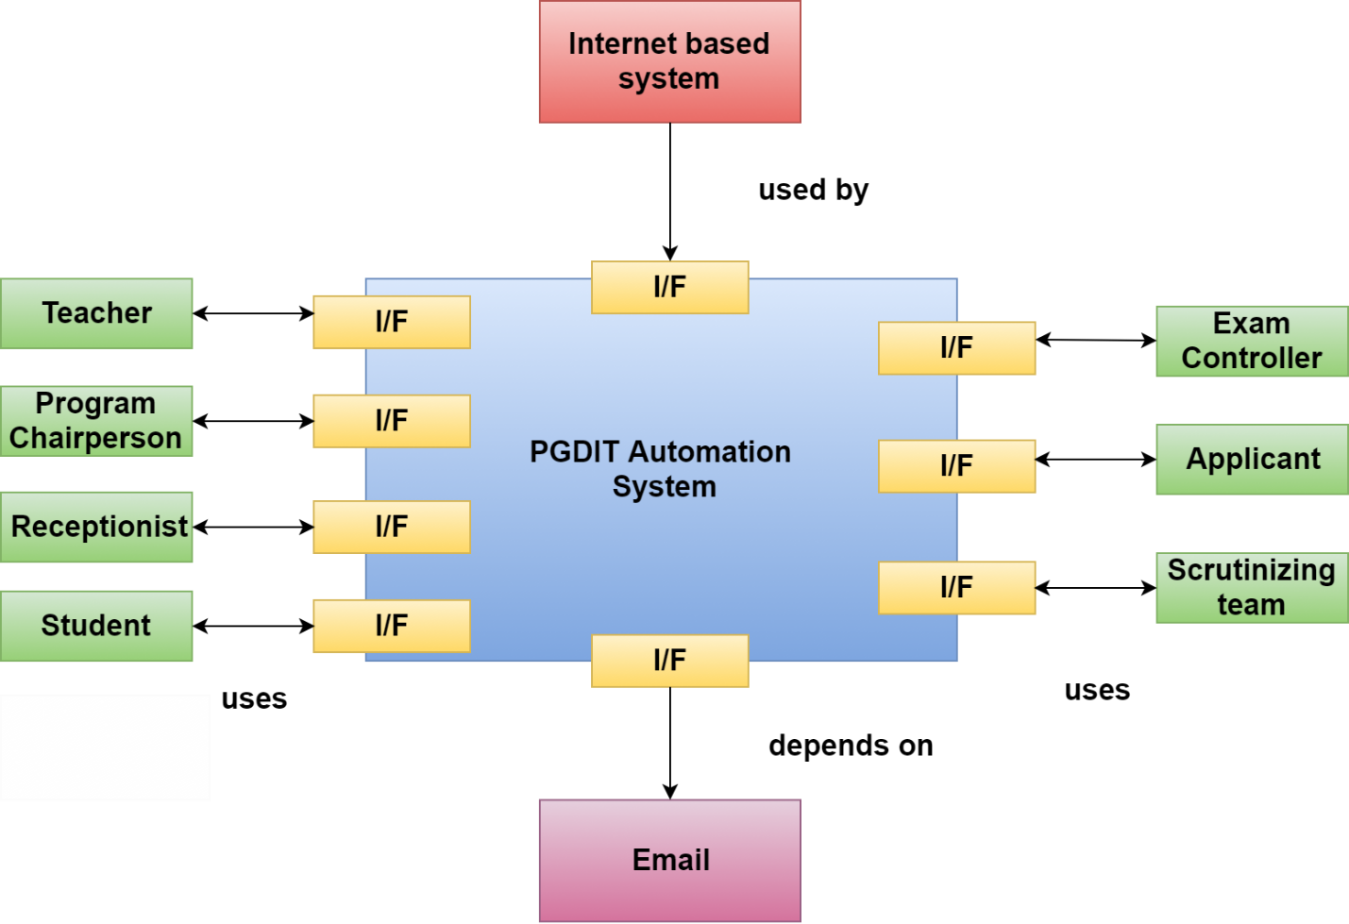

Figure 3 Architectural Context Diagram of PGDIT Automation System

Figure 3 shows architectural context diagram of PGDIT Automation System. The Internet based system is the superordinate system here. Teacher, program chairperson, exam controller, scrutinizing team, student, applicant, and receptionist are actors that are both producers and consumers of information used or produced by the PGDIT Automation System. Finally, email is used by the system and is shown as subordinate to it.

## 2.2 Defining Archetypes

An archetype is a class or pattern that represents a core abstraction that is critical to the design of an architecture for the target system. They represent stable elements of the architecture. Archetypes can be derived by examining the analysis classes defined as part of the requirements model. The archetypes of PGDIT Automation System are:

* Teacher
* ProgramChairperson
* ExamController
* Scrutinizer
* Student
* Applicant
* Receptionist

The archetypes, their attributes, methods and relationships are illustrated in figure 4.

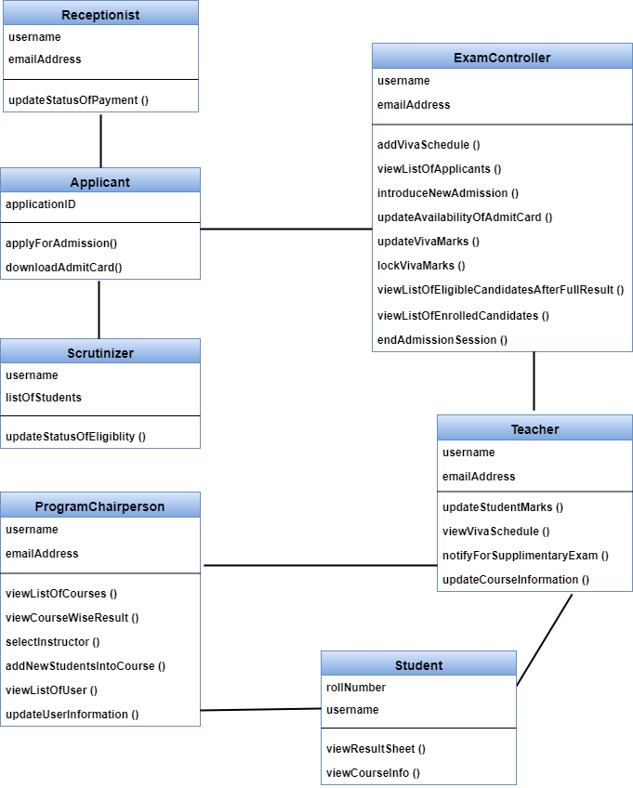

Figure 4 Archetypes

## 2.3 Refining the Architecture into Components

In this step software architecture is refined into components. These components can be derived from various sources

* Application Domain provides application components.
* Infrastructure Domain provides design components like design classes.
* The interfaces in the ACD imply one or more specialized components that process the data that flow across the interface.

PGDIT Automation System consists of the following top-level components:

* User Account Management: manages works related to user account.
* Admission: handles admission system related activities.
* GUI: manages graphical user interface.
* Course Result Management: handles activities related to course allocation and publishing result.

Figure 5 shows overall architectural structure for PGDIT Automation System with top-level components.

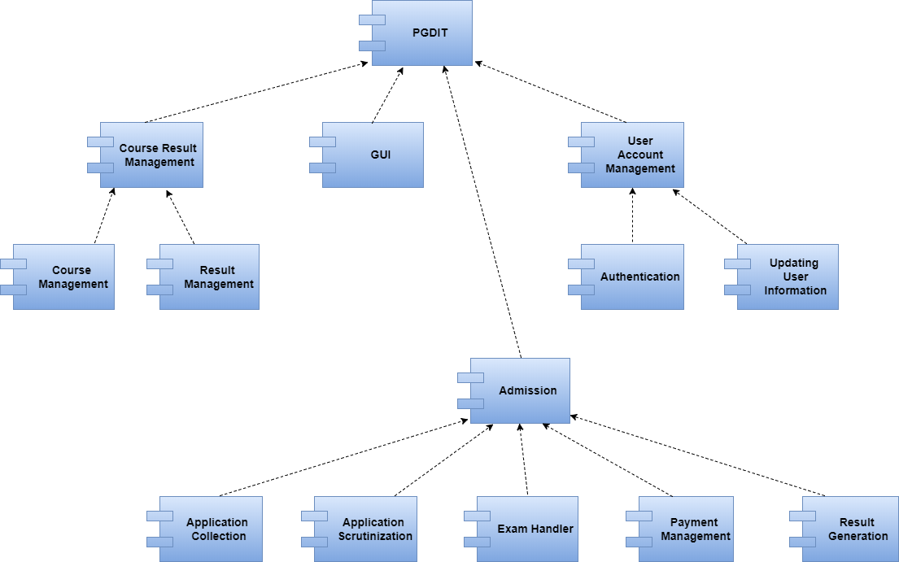

Figure 5 Overall Architectural Structure with Top-Level Components

## 2.4 Describing Instantiations of the System

Although the major software components have been identified, further refinement is still necessary. To accomplish this, an actual instantiation of the architecture is developed.

Figure 6 illustrates an instantiation of the PGDIT Automation System architecture. Components shown in Figure 5 are elaborated to show additional detail.

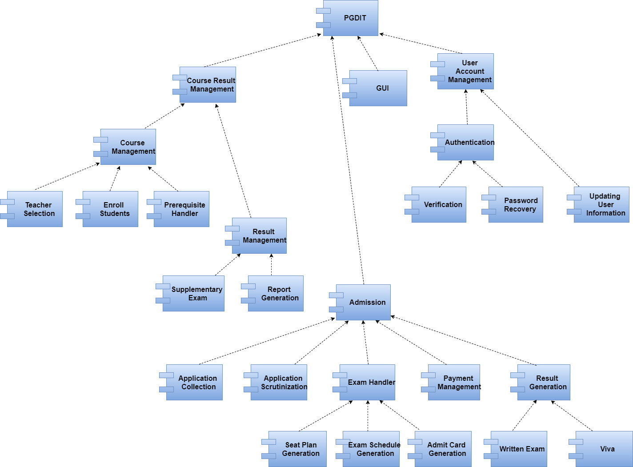

Figure 6 An Instantiation of the PGDIT Automation System Architecture

## 2.5 Architectural mapping using data flow

A mapping technique called structured design is often characterized as a data flow-oriented design method because it provides a convenient transition from a data flow diagram to software architecture. The transition from information flow to program structure is accomplished as part of a six step process:

Figure 7 Architectural Mapping

The dataflow diagrams of PGDIT Automation System are shown in figure 8-*.

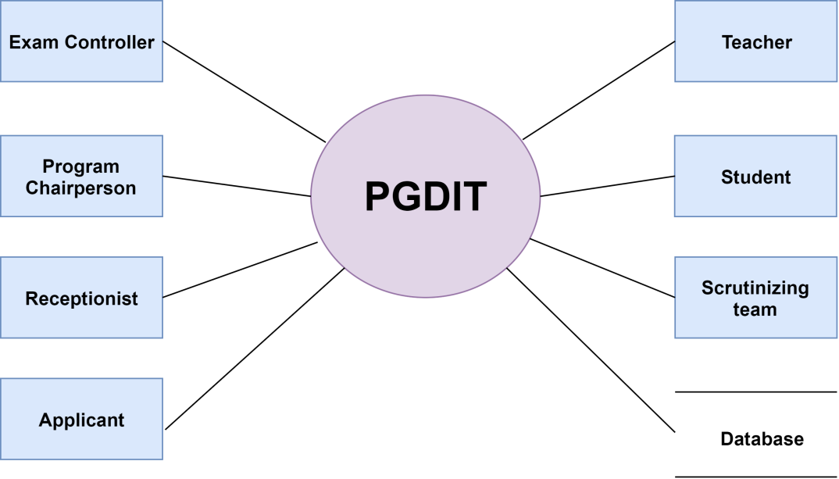

Figure 8 Level 0 Dataflow Diagram

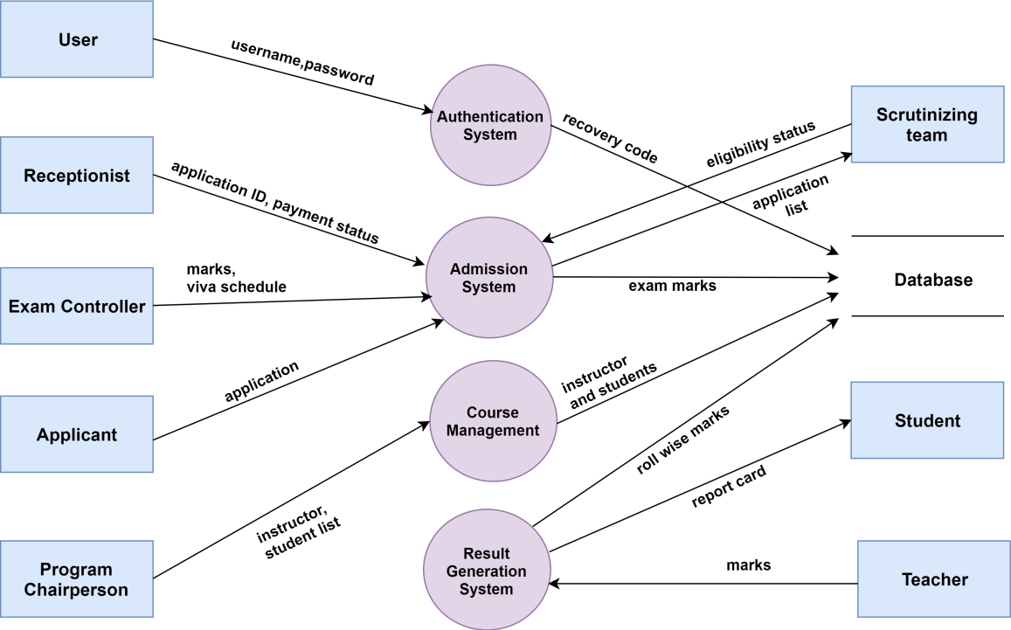

Figure 9 Level 1 Dataflow Diagram

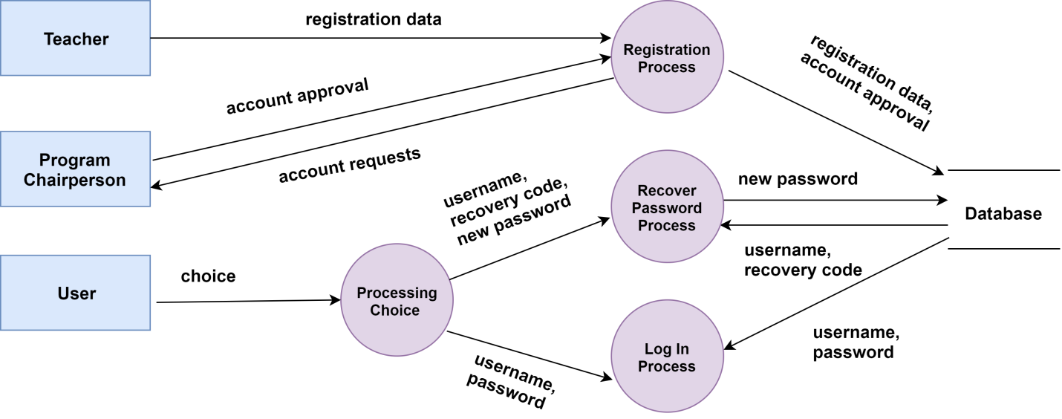

Figure 10 Dataflow Diagram of Authentication and Registration

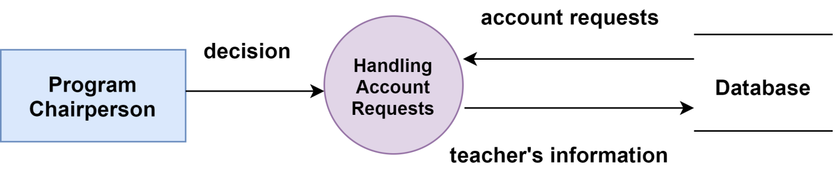

Figure 11 Program Chairperson's Dataflow Diagram of Registration

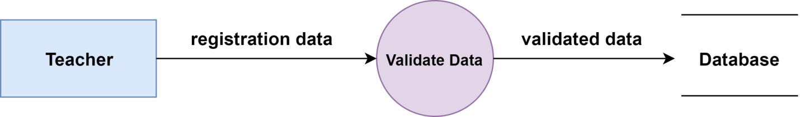

Figure 12 Teacher's Dataflow Diagram of Registration

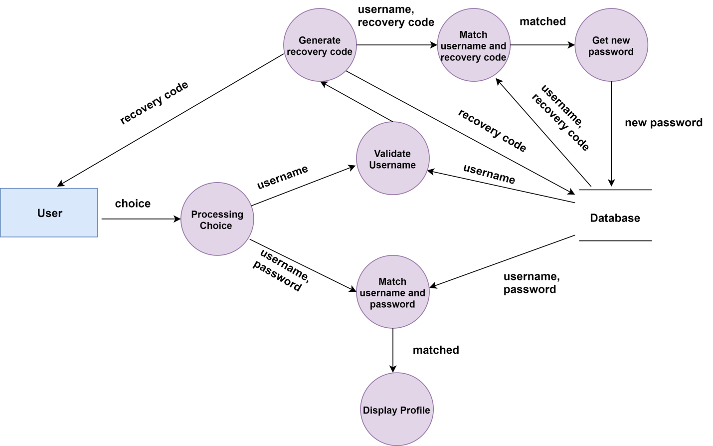

Figure 13 User's Dataflow Diagram of Authentication

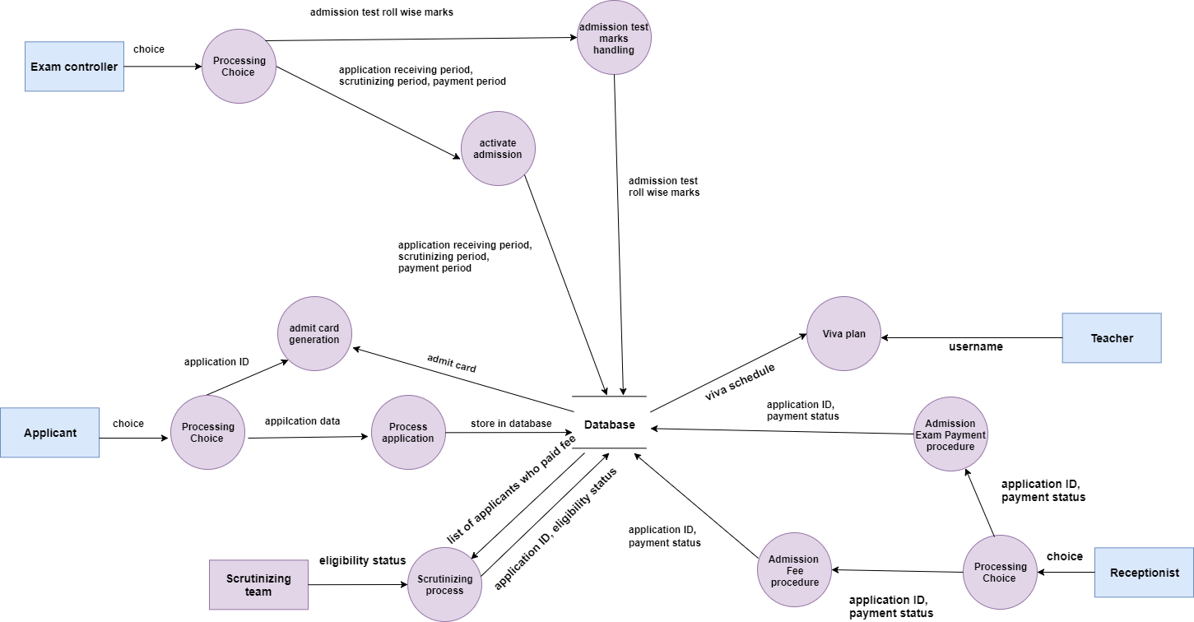

Figure 14 Dataflow Diagram of Admission System

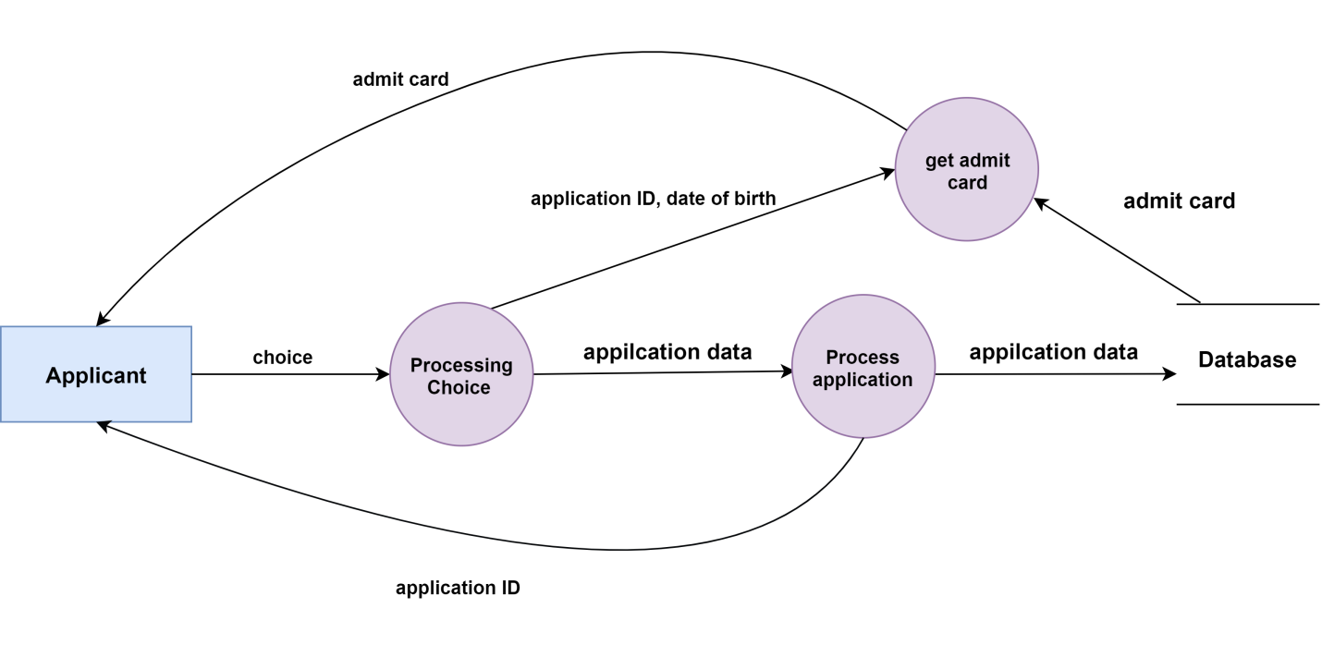

Figure 15 Applicant's Dataflow Diagram of Admission System

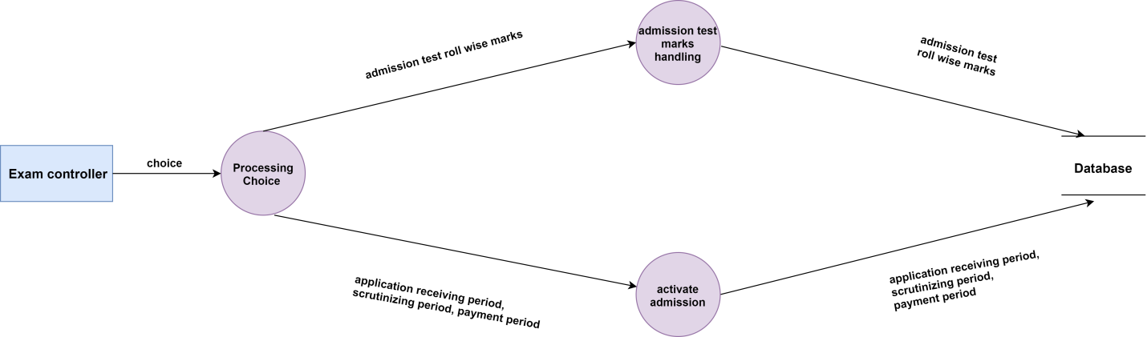

Figure 16 Exam Controller's Dataflow Diagram of Admission System

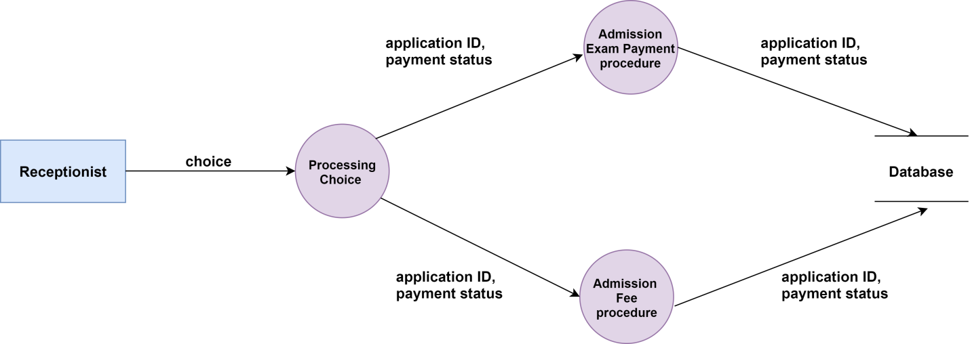

Figure 17 Receptionist's Dataflow Diagram of Admission System

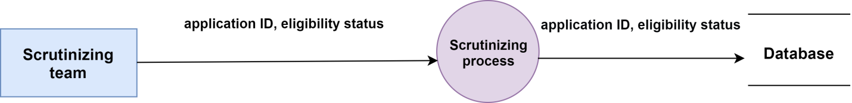

Figure 18 Scrutinizing team's Dataflow Diagram of Admission System

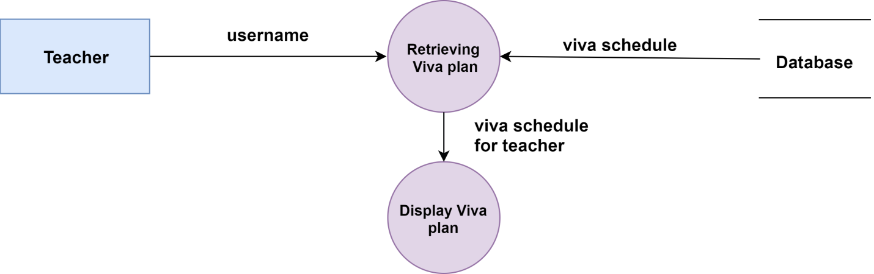

Figure 19 Teacher's Dataflow Diagram of Admission System

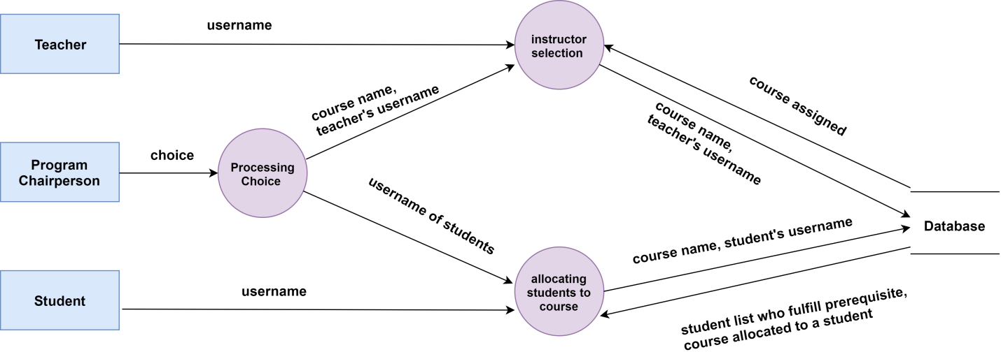

Figure 20 Dataflow Diagram of Course Management System

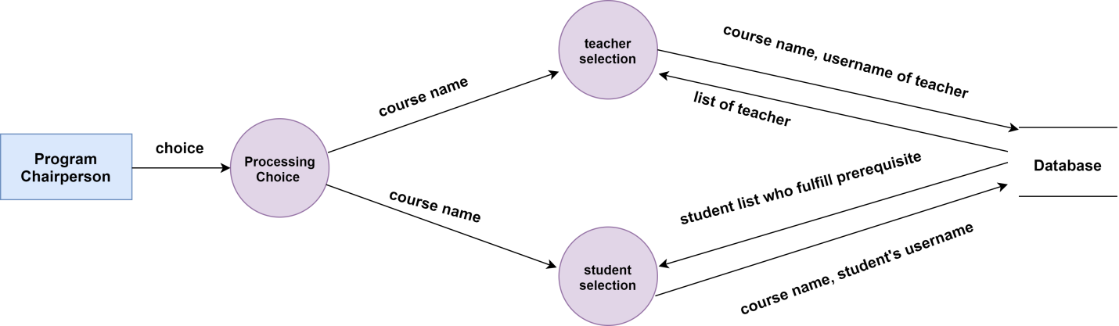

Figure 21 Program Chairperson's Dataflow Diagram of Course Management System

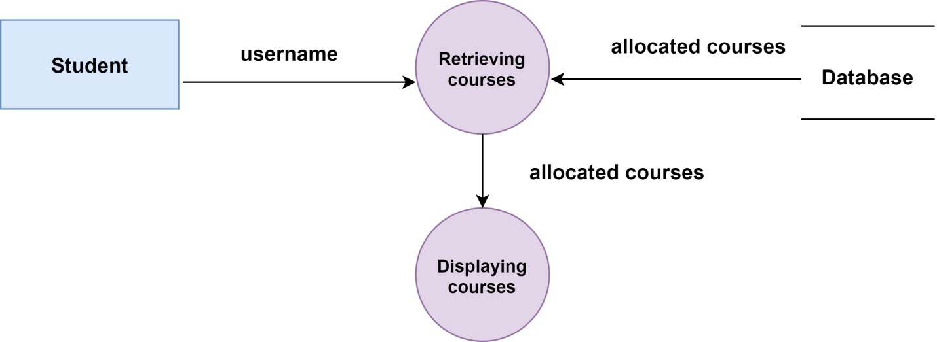

Figure 22 Student's Dataflow Diagram of Course Management System

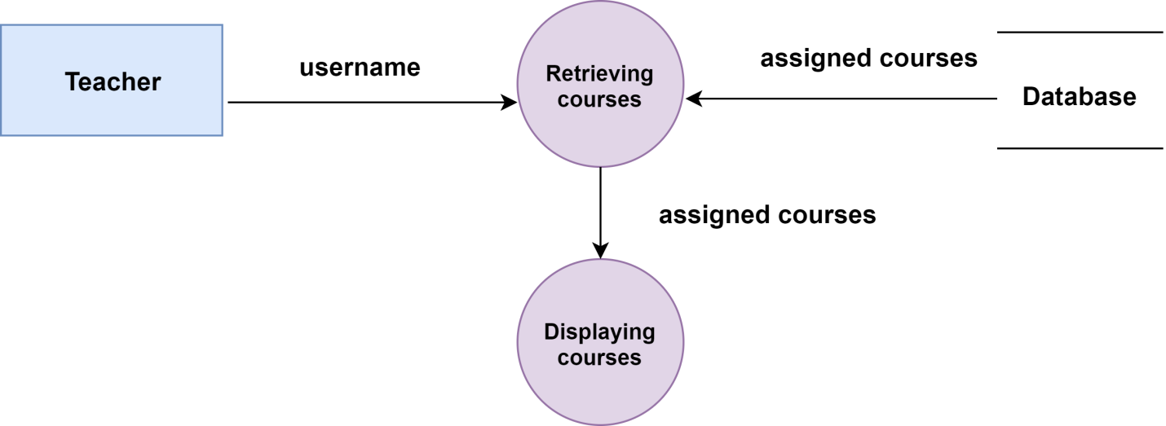

Figure 23 Teacher's Dataflow Diagram of Course Management System

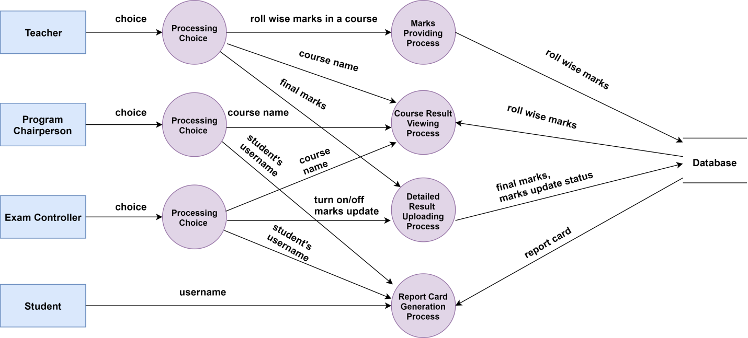

Figure 24 Dataflow Diagram of Result Generation System

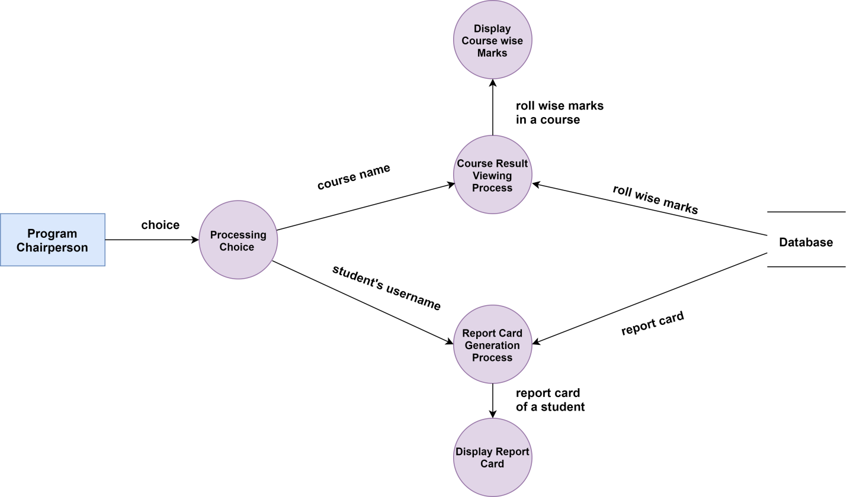

Figure 25 Program Chairperson's Dataflow Diagram of Result Generation System

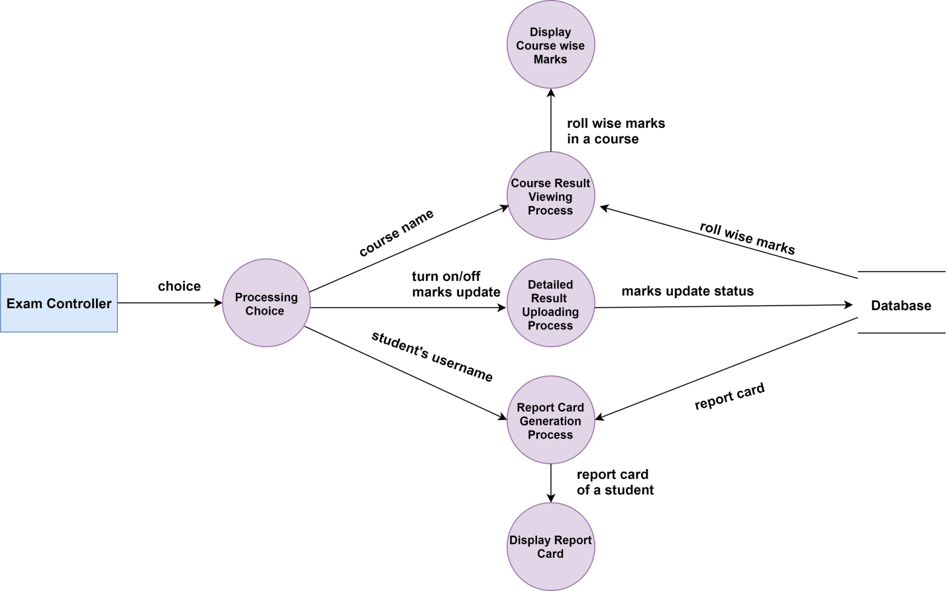

Figure 26 Exam Controller's Dataflow Diagram of Result Generation System

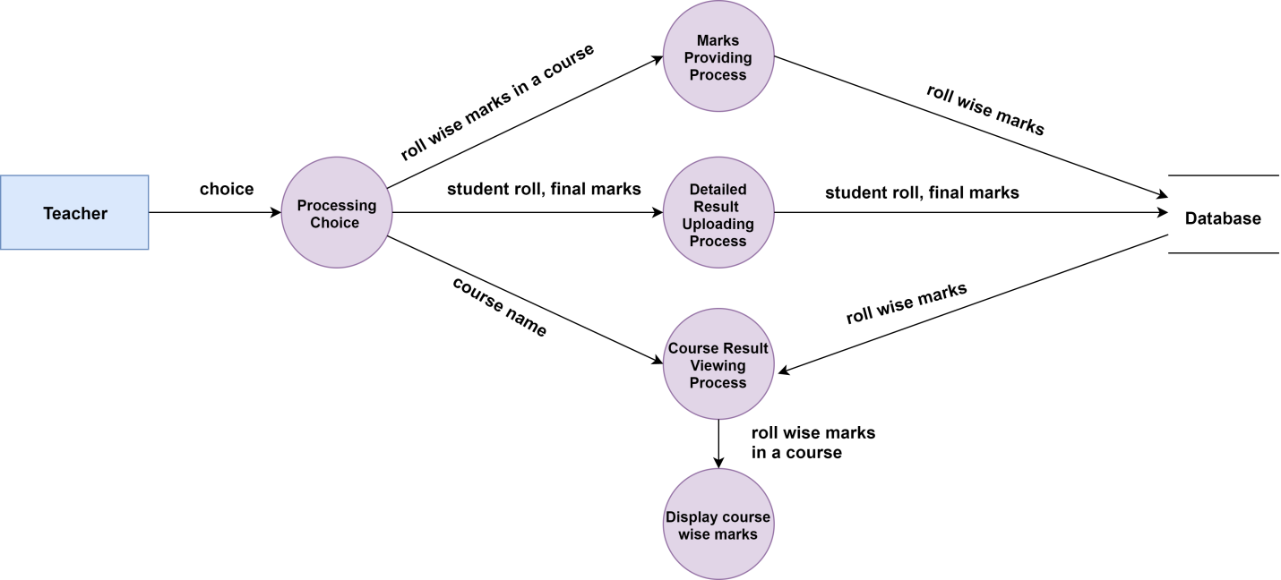

Figure 27 Teacher's Dataflow Diagram of Result Generation System

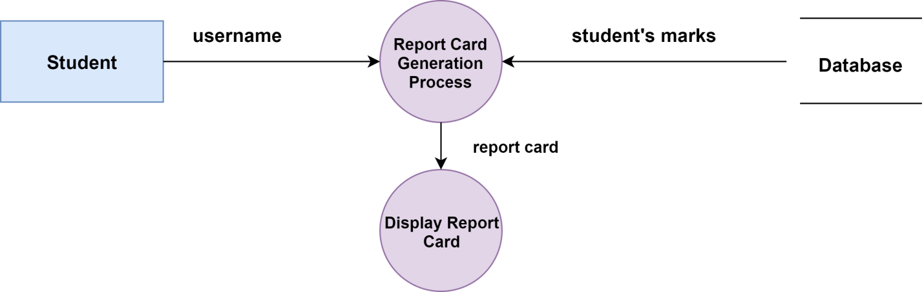

Figure 28 Student's Dataflow Diagram of Result Generation System

Figure 29 shows DFD mapping of Teacher's Dataflow Diagram of Registration.

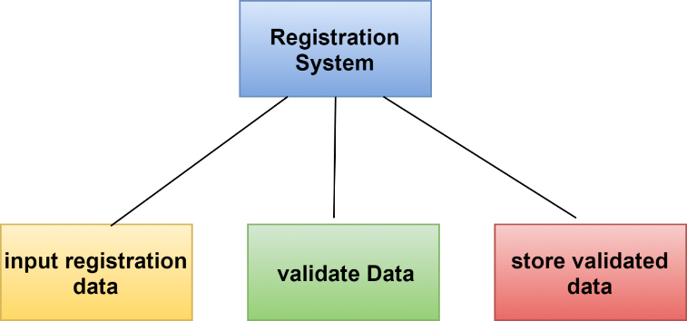

Figure 29 DFD mapping of Teacher's Dataflow Diagram of Registration

Figure 30 shows DFD mapping of Program chairperson's Dataflow Diagram of Registration.

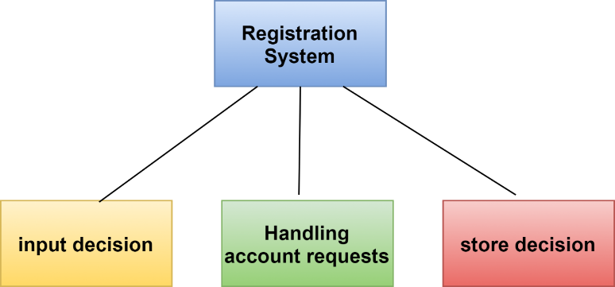

Figure 30 DFD mapping of Program chairperson's Dataflow Diagram of Registration

Figure 31 shows DFD mapping of User's Dataflow Diagram of Authentication.

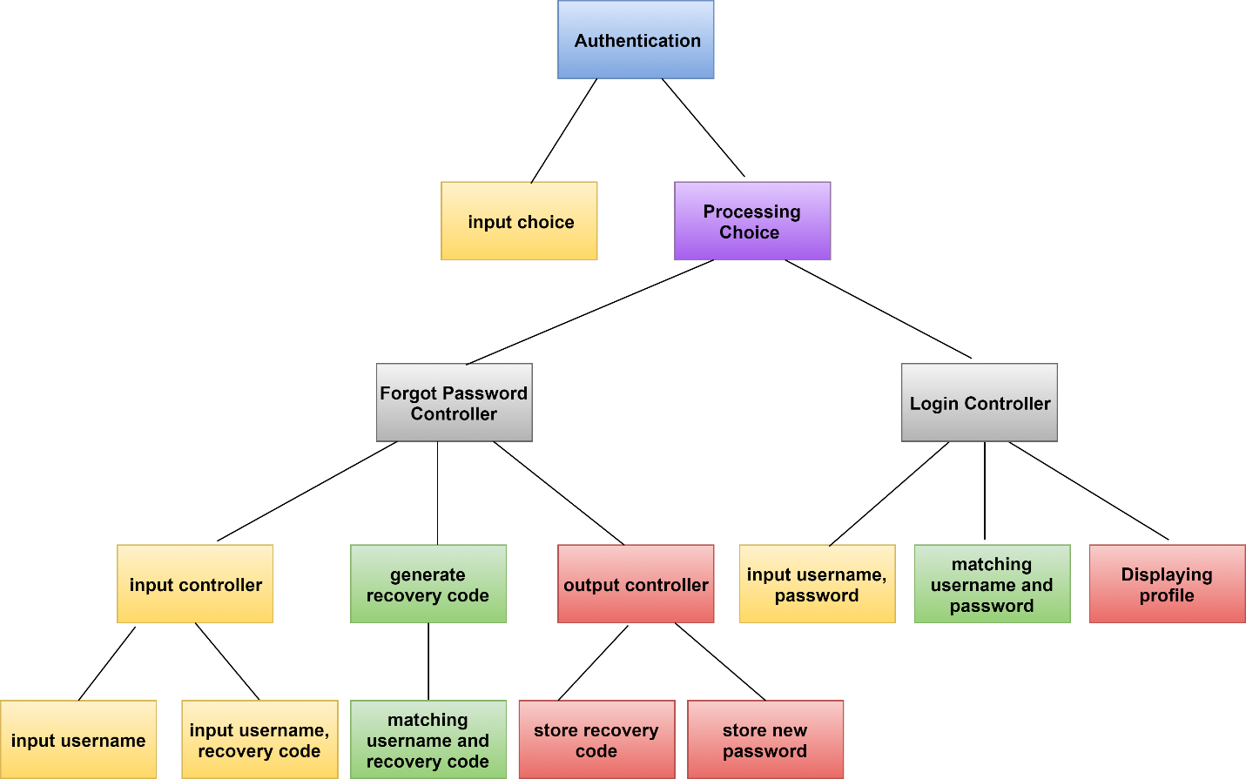

Figure 31 DFD mapping of User's Dataflow Diagram of Authentication

Figure 32 shows DFD mapping of Applicant's Dataflow Diagram of Admission System.

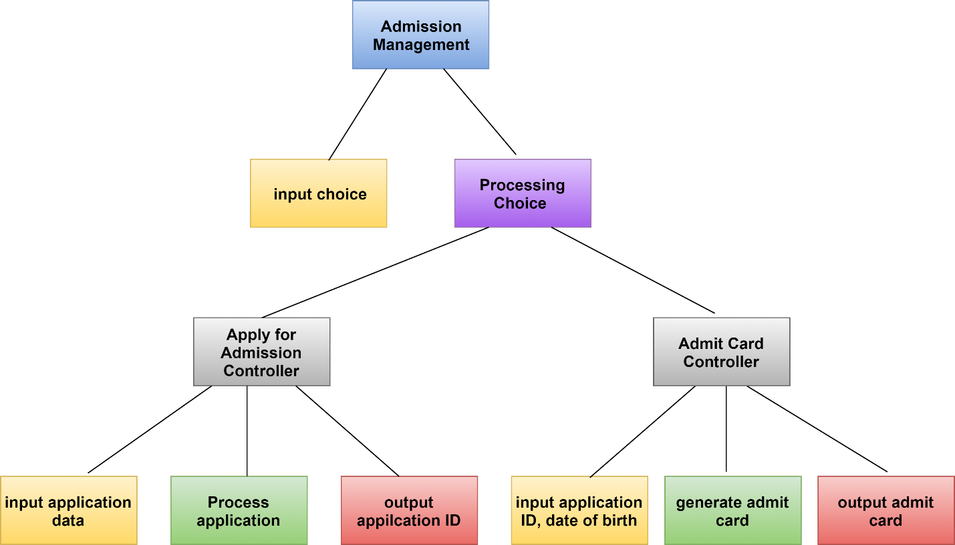

Figure 32 DFD mapping of Applicant's Dataflow Diagram of Admission System

Figure 33 shows DFD mapping of Exam Controller's Dataflow Diagram of Admission System.

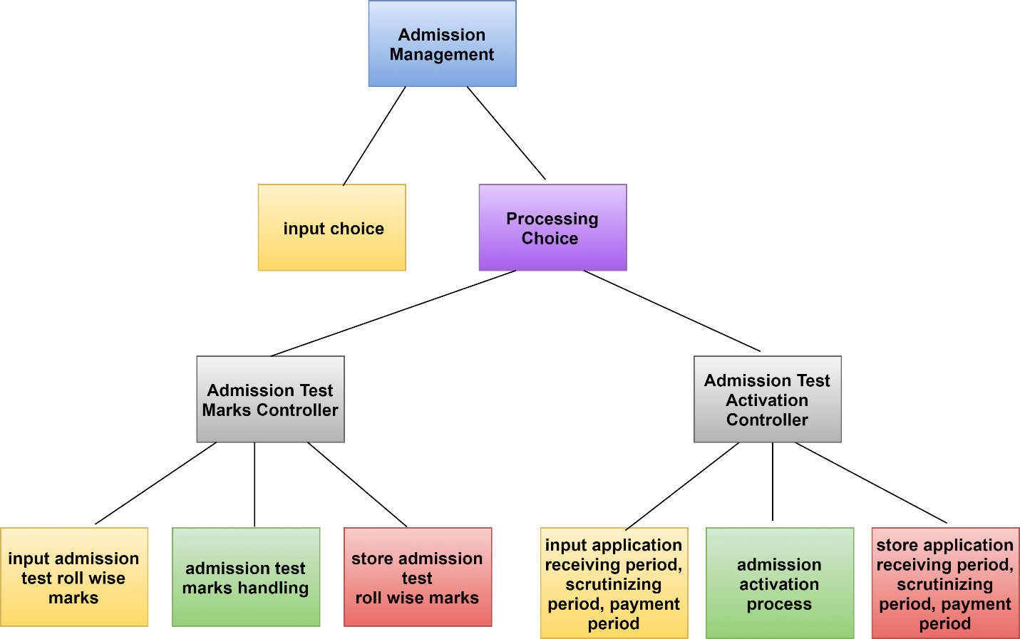

Figure 33 DFD mapping of Exam Controller's Dataflow Diagram of Admission System

Figure 34 shows DFD mapping of Receptionist's Dataflow Diagram of Admission System.

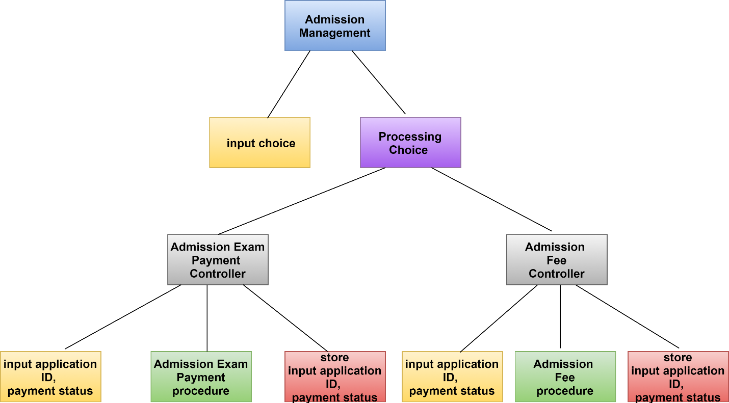

Figure 34 DFD mapping of Receptionist's Dataflow Diagram of Admission System

Figure 35 shows DFD mapping of Scrutinizer's Dataflow Diagram of Admission System.

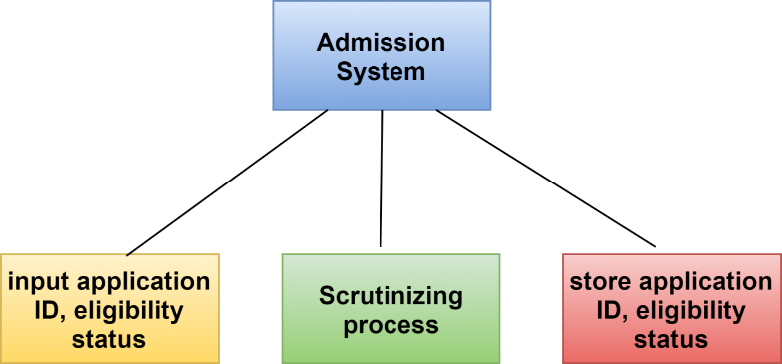

Figure 35 DFD mapping of Scrutinizer's Dataflow Diagram of Admission System

Figure 36 shows DFD mapping of Teacher's Dataflow Diagram of Admission System.

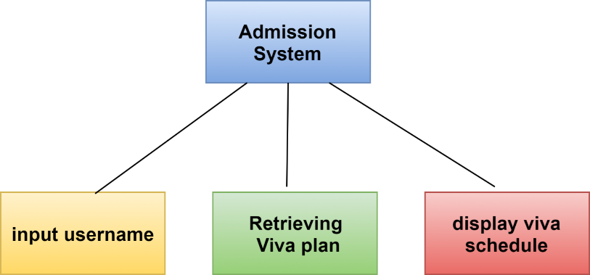

Figure 36 DFD mapping of Teacher's Dataflow Diagram of Admission System

Figure 37 shows DFD mapping of Program Chairperson’s Dataflow Diagram of Course Management System.

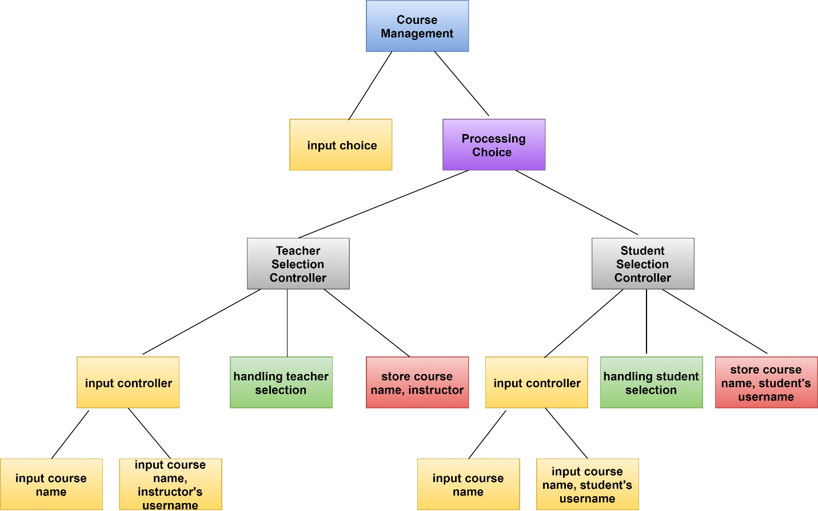

Figure 37 DFD mapping of Program Chairperson’s Dataflow Diagram of Course Management System.

Figure 38 shows DFD mapping of Teacher's Dataflow Diagram of Course Management System.

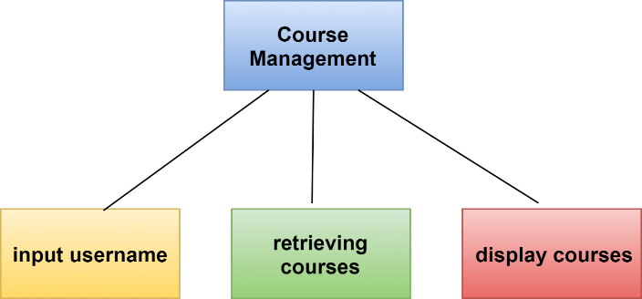

**Figure 38 Teacher's Dataflow Diagram of Course Management System**

Figure 39 shows DFD mapping of Student's Dataflow Diagram of Course Management System.

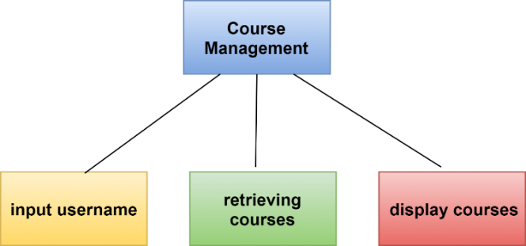

**Figure 39 DFD mapping of Student's Dataflow Diagram of Course Management System**

Figure 40 shows DFD mapping of Program Chairperson's Dataflow Diagram of Result Generation System.

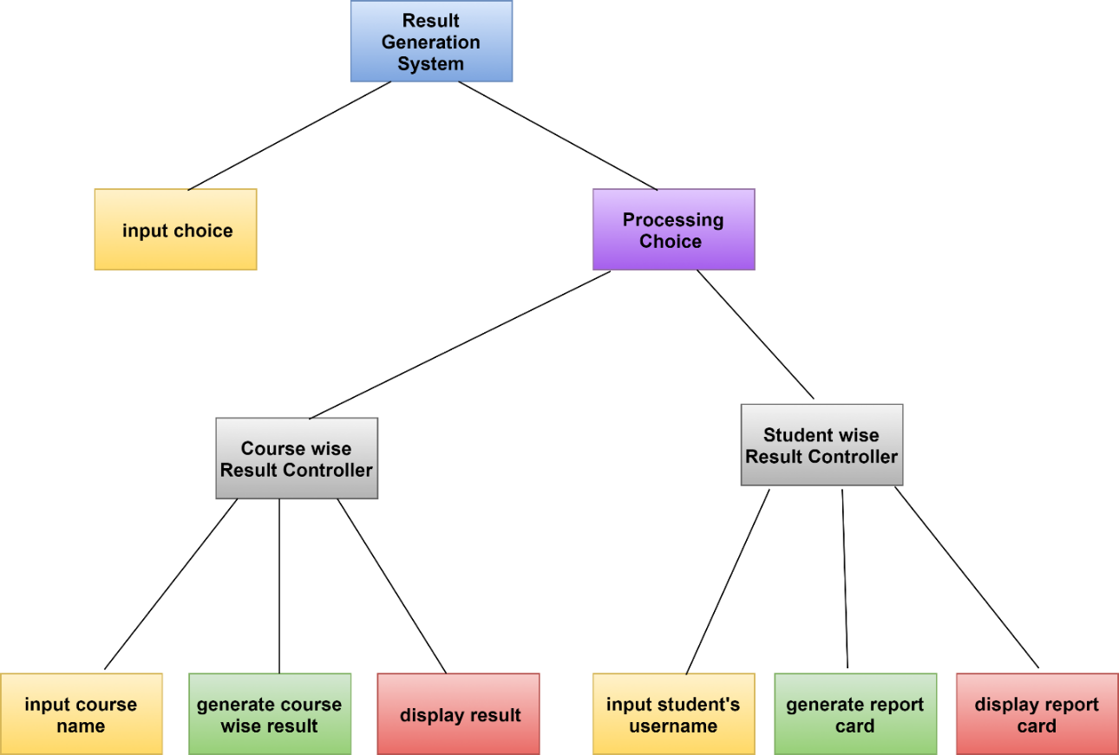

Figure 40 DFD mapping of Program Chairperson's Dataflow Diagram of Result Generation System

Figure 41 shows DFD mapping of Exam Controllers's Dataflow Diagram of Result Generation System.

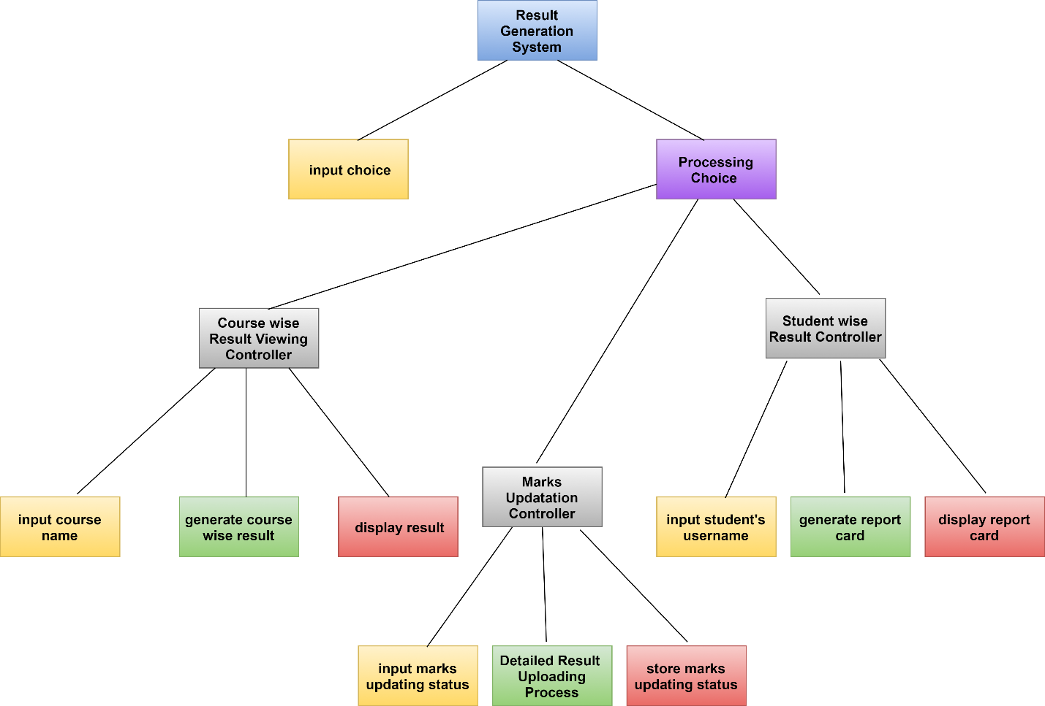

Figure 41 DFD mapping of Exam Controllers's Dataflow Diagram of Result Generation System

Figure 42 shows DFD mapping of Teacher's Dataflow Diagram of Result Generation System.

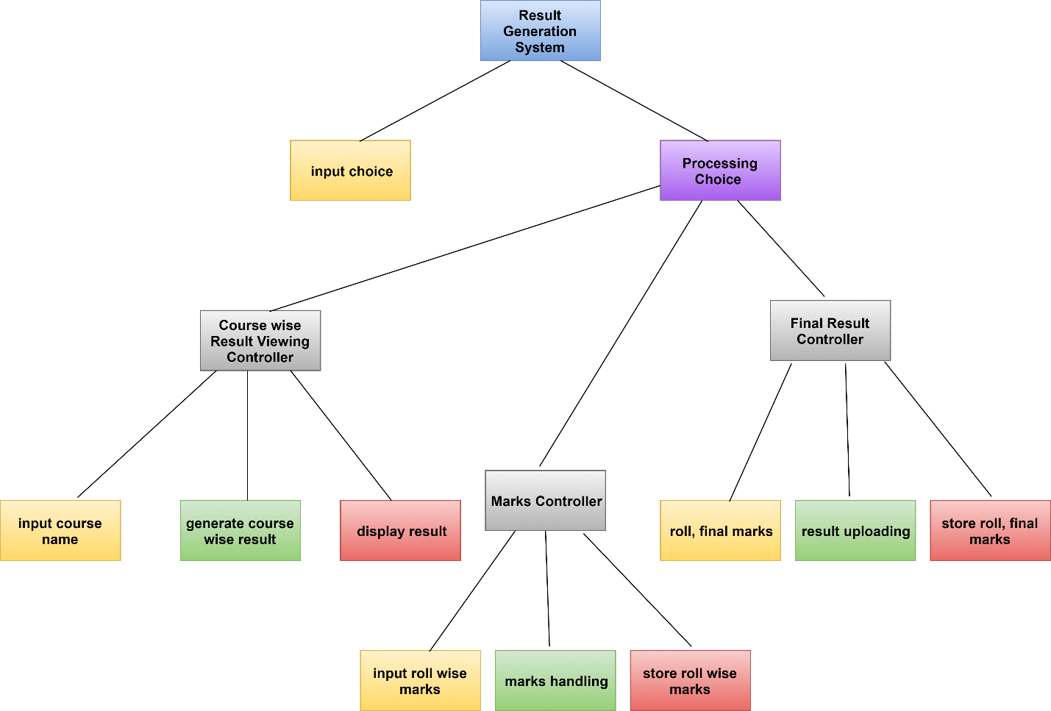

Figure 42 DFD mapping of Teacher's Dataflow Diagram of Result Generation System

Figure 43 shows DFD mapping of Student’s Dataflow Diagram of Result Generation System.

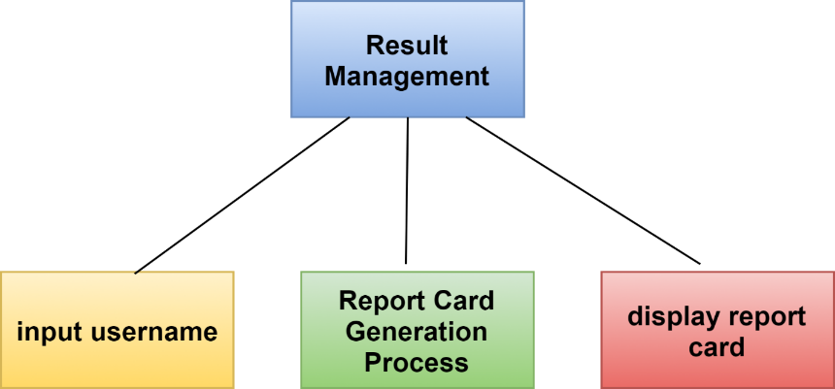

Figure 43 DFD mapping of Student’s Dataflow Diagram of Result Generation System

# Chapter 3. Component-Level Design of PGDIT Automation System

A component is a modular building block for computer software. According to OMG Unified Modeling Language Specification [OMG03a] component is a modular, deployable, and replaceable part of a system that encapsulates implementation and exposes a set of interfaces. Component-level design defines the data structures, algorithms, interface characteristics, and communication mechanisms allocated to each software component. Component-level design helps to determine whether the software will work before building it. The component-level design represents the software in a way that allows to review the details of the design for correctness and consistency with other design representations. It provides a means for assessing whether data structures, interfaces, and algorithms will work.

Component-level design comprises of the following steps:

Figure 44 Steps of Component-Level Design

## 3.1 Identify All Design Classes that Correspond to the Problem Domain

PGDIT Automation System has the following analysis class.

* Teacher
* Student
* ProgramChairperson
* ExamController
* Scrutinizer
* Applicant
* Receptionist

All analysis class and their attributes and methods are shown in figure 45.

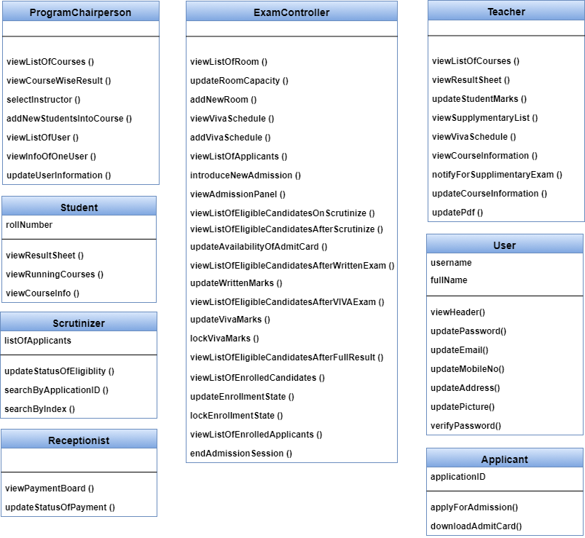

Figure 45 Analysis classes

## 3.2 Identify All Design Classes that Correspond to the Infrastructure Domain

There are some classes that are not described in the requirements model and are often missing from the architecture model. These classes have been described here. We have found 2 infrastructure domain classes.

* DatabaseHandler: for handling database operations( insert, update, delete, retrieve)
* QueryGenerator: for generationg sql query using javascript object.

Figure 46 shows infrastructure domain classes, their attributes and methods.

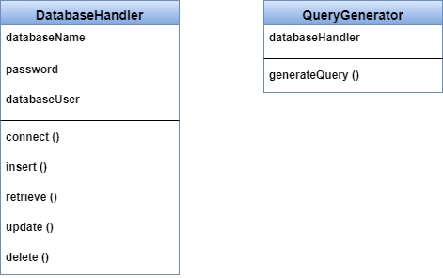

Figure 46 Design classes

## 3.3 Elaborate All Design Classes that are not Acquired as Reusable Components

Elaboration requires that all interfaces, attributes, and operations necessary to implement the class be described in detail.

Figure 47-54 show elaborated design classes. The attributes and operations defined during requirement analysis are noted at the top of the figures. The interfaces of these design classes are represented using the “lollipop” symbols shown to the left of the component boxes.

Figure 47 shows elaborated Applicant class. It has two interfaces.

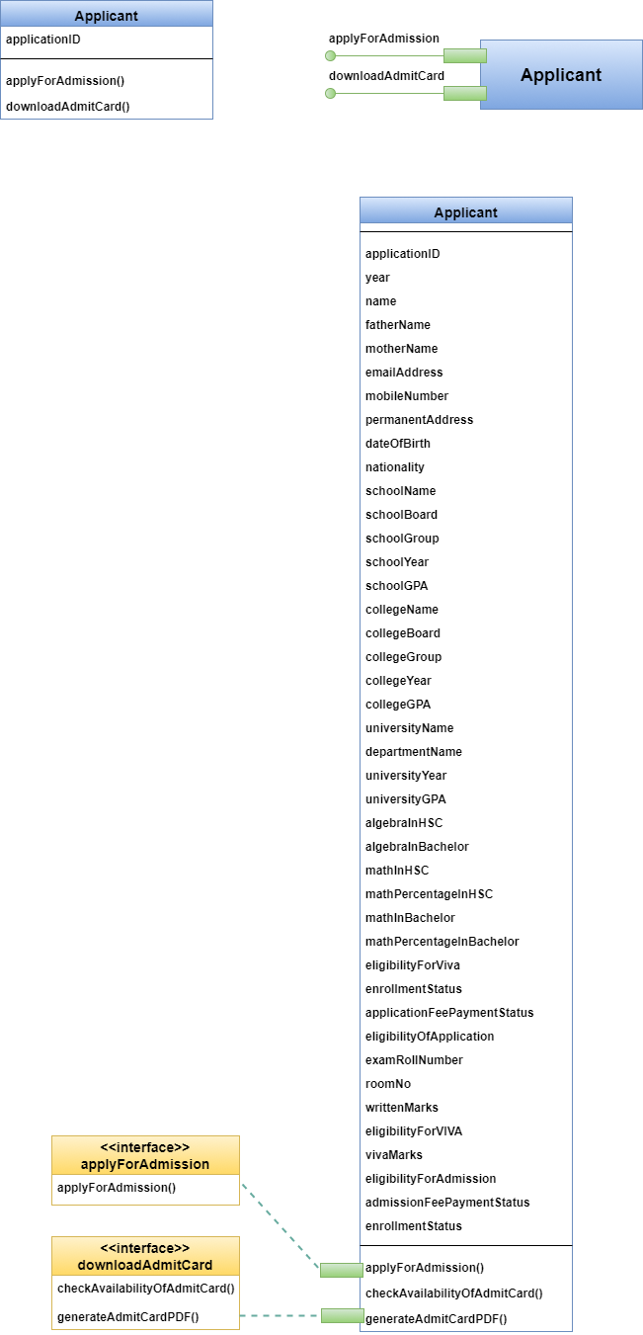

Figure 47 Elaborated Applicant class

Figure 48 shows elaborated User class. It has ten interfaces.

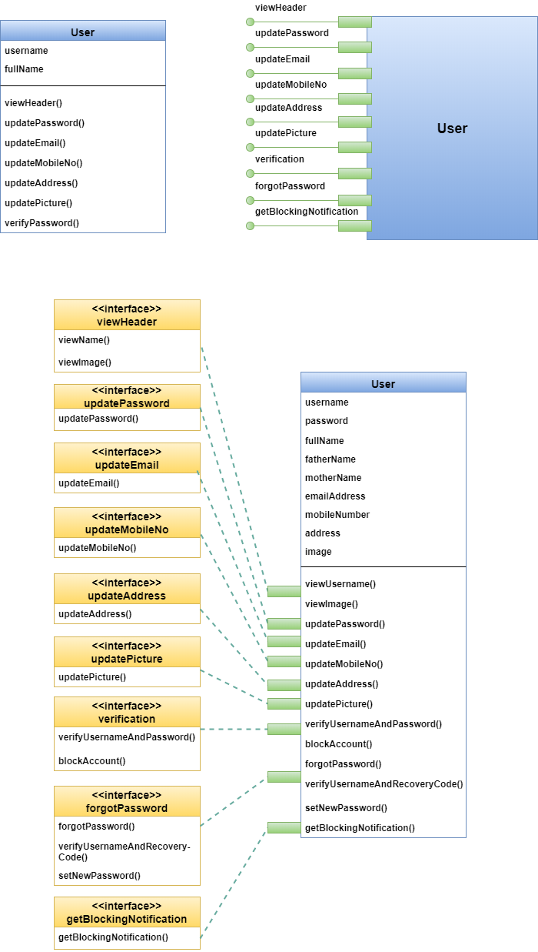

Figure 48 Elaborated User class

Figure 49 shows elaborated ProgramChairperson class. It has eleven interfaces.

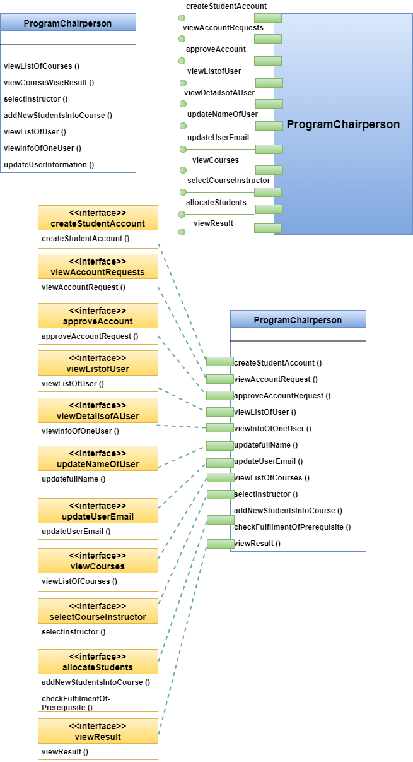

Figure 49 Elaborated ProgramChairperson class

Figure 50 shows elaborated Scrutinizer class. It has four interfaces.

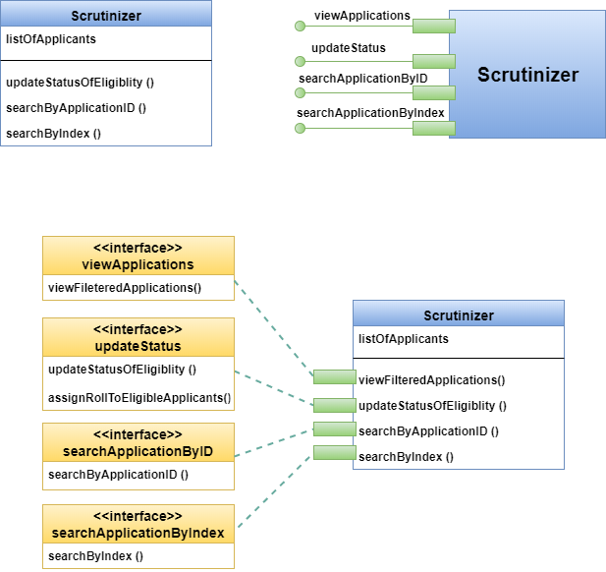

Figure 50 Elaborated Scrutinizer class

Figure 51 shows elaborated Receptionist class. It has two interfaces.

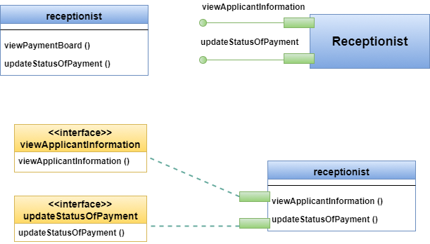

Figure 51 Elaborated Receptionist class

Figure 52 shows elaborated ExamController class. It has twenty four interfaces.

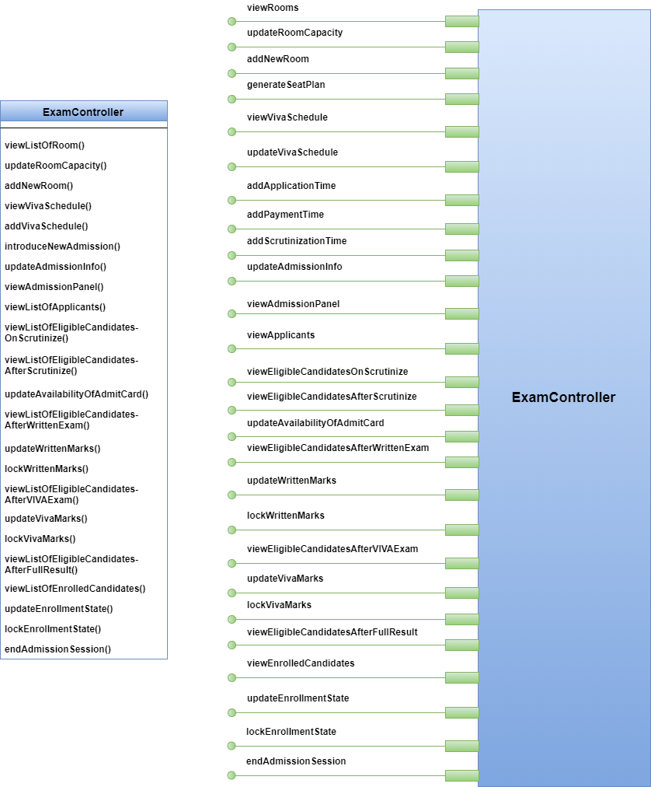

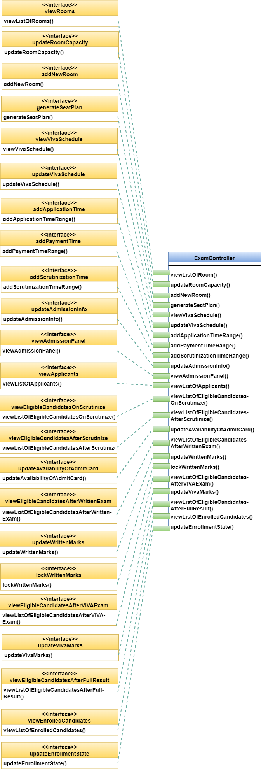

Figure 52 Elaborated ExamController class

Figure 53 shows elaborated Teacher class. It has seventeen interfaces.

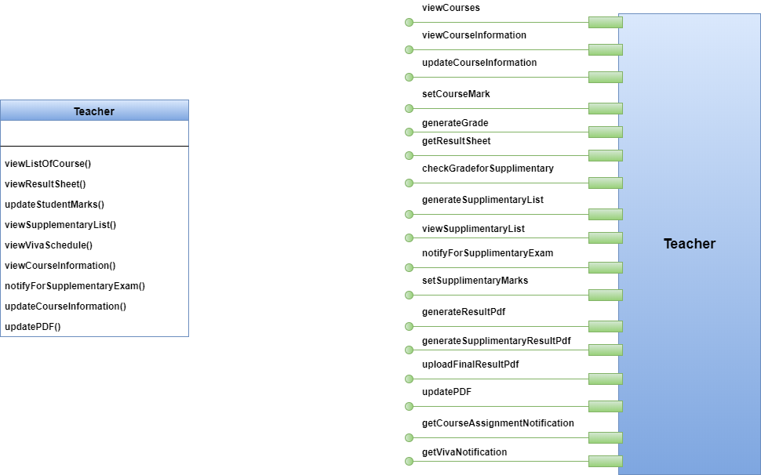

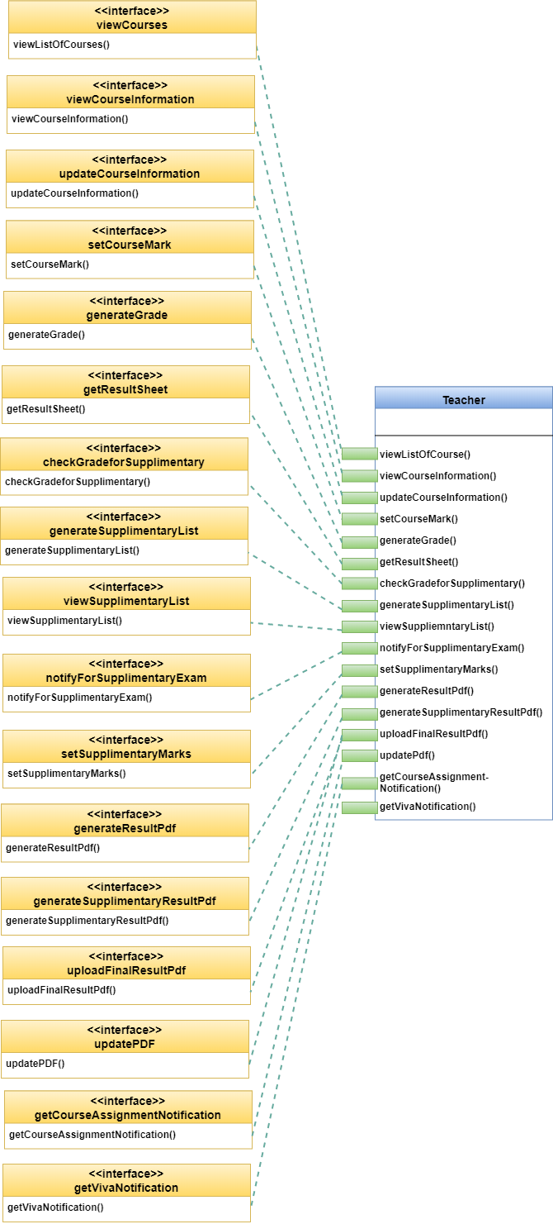

Figure 53 Elaborated Teacher class

Figure 54 shows elaborated Student class. It has four interfaces.

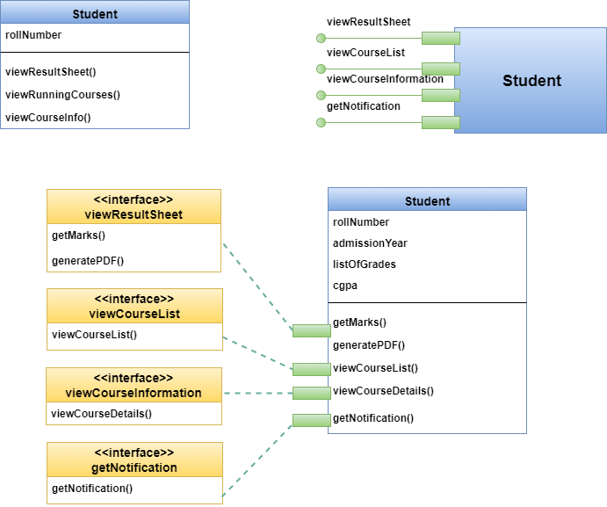

Figure 54 Elaborated Student class

### 3.3.1 Specify Message Details when Classes or Components Collaborate

The requirements model makes use of a collaboration diagram to show how analysis classes collaborate with one another. As component-level design proceeds, it is sometimes useful to show the details of these collaborations by specifying the structure of messages that are passed between objects within a system. This design activity shows how components within the system communicate and collaborate.

Figure 55-56 shows collaboration diagrams for Applicant class.

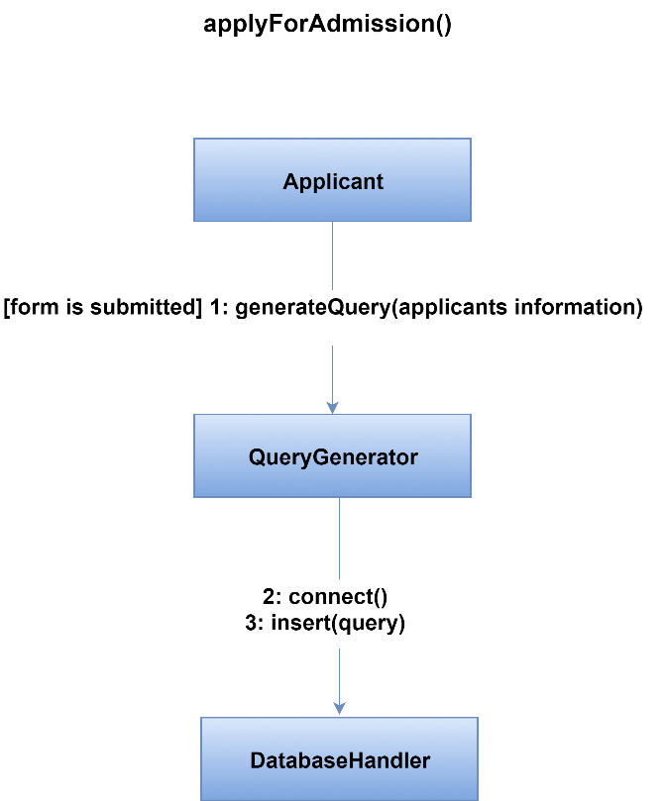

Figure 55 Method applyForAdmission() of Applicant Class

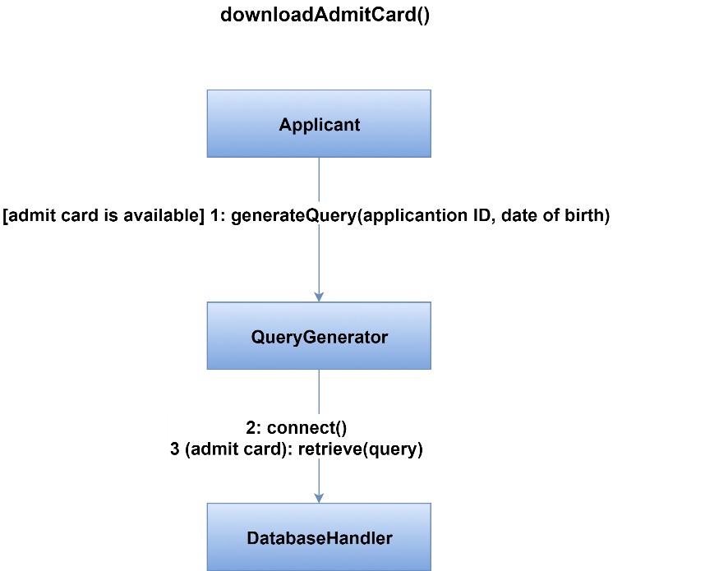

Figure 56 Method downloadAdmitCard() of Applicant Class

Figure 57-62 shows collaboration diagrams for ProgramChairperson class.

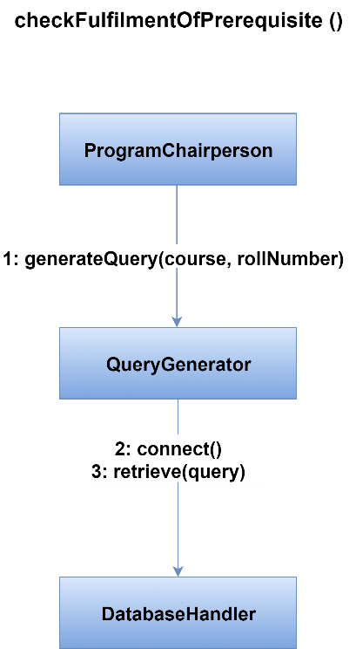

Figure 57 Method checkFulfillmentOfPrerequisites() of ProgramChairperson Class

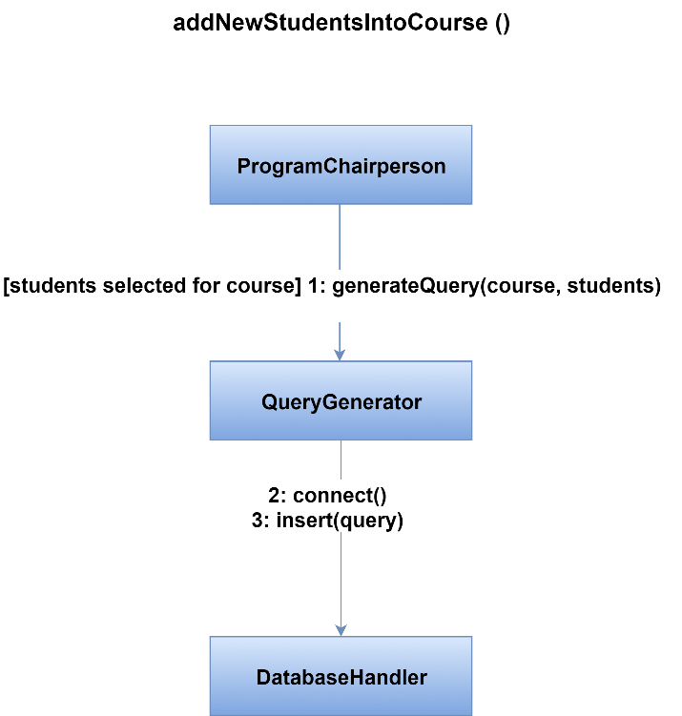

Figure 58 Method addNewStudentsIntoCourse() of ProgramChairperson Class

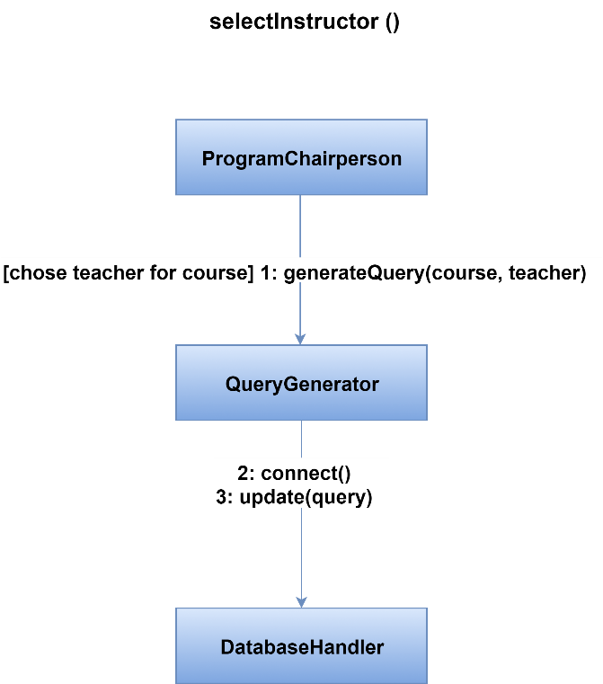

Figure 59 Method selectInstructor() of ProgramChairperson Class

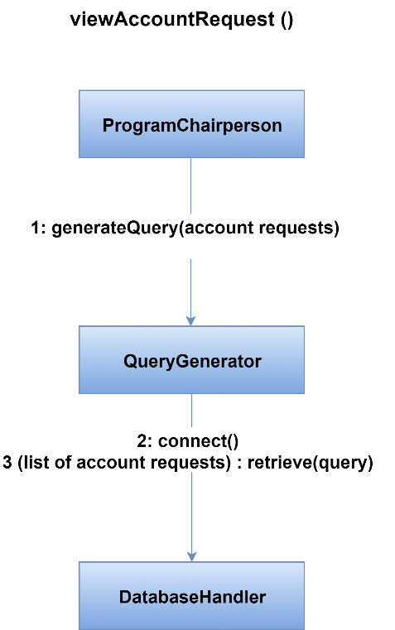

Figure 60 Method viewAccountRequest() of ProgramChairperson Class

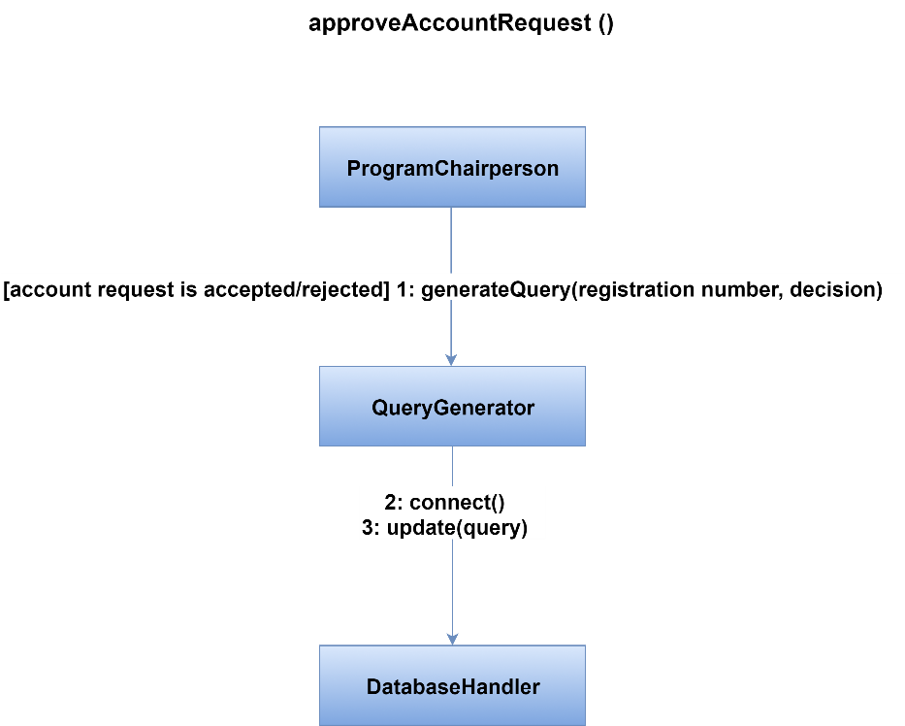

Figure 61 Method approveAccountRequest() of ProgramChairperson Class

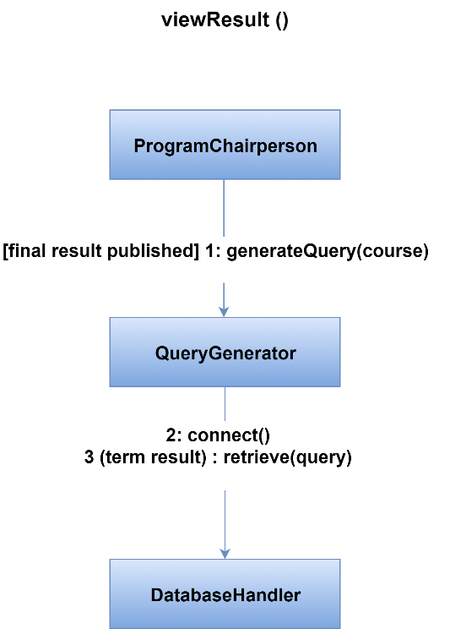

Figure 62 Method viewResult() of ProgramChairperson Class

Figure 63-64 shows collaboration diagrams for Scrutinizer class.

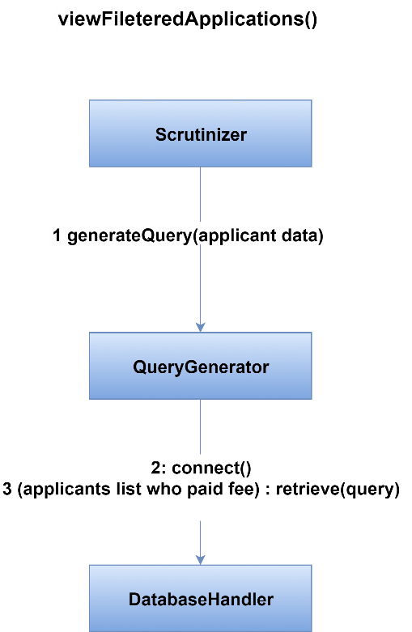

Figure 63 Method viewFilteredApplications() of Scrutinizer Class

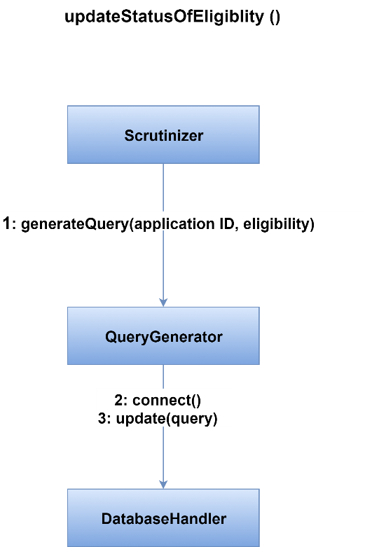

Figure 64 Method updateStatusOfEligibility() of Scrutinizer Class

Figure 65-66 shows collaboration diagrams for Receptionist class.

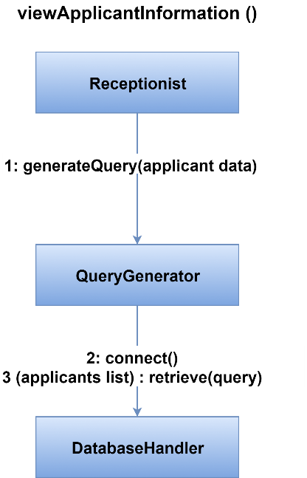

Figure 65 Method viewApplicantInformation() of Receptionist Class

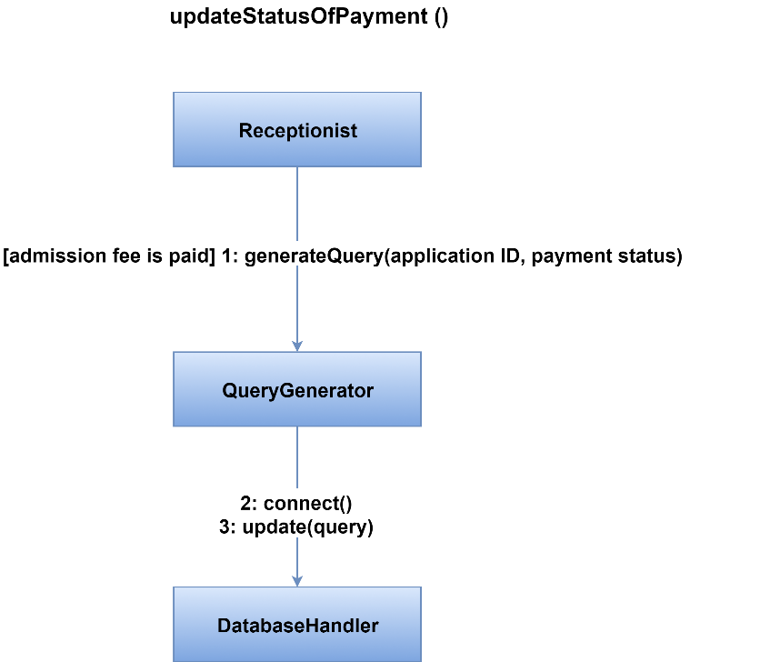

Figure 66 Method updateStatusOfPayment() of Receptionist Class

Figure 67-73 shows collaboration diagrams for ExamController class.

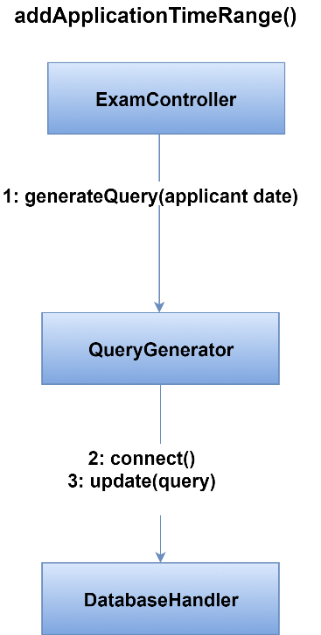

Figure 67 Method addApplicationTimeRange() of ExamController Class

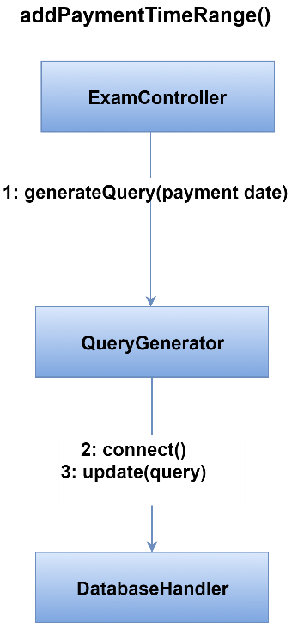

Figure 68 Method addPaymentTimeRange() of ExamController Class

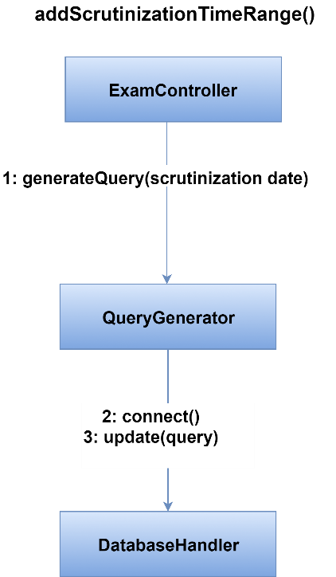

Figure 69 Method addScrutinizationTimeRange() of ExamController Class

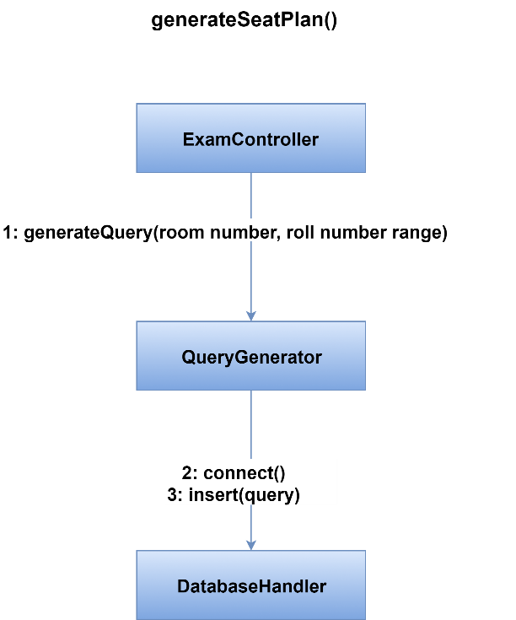

Figure 70 Method generateSeatPlan() of ExamController Class

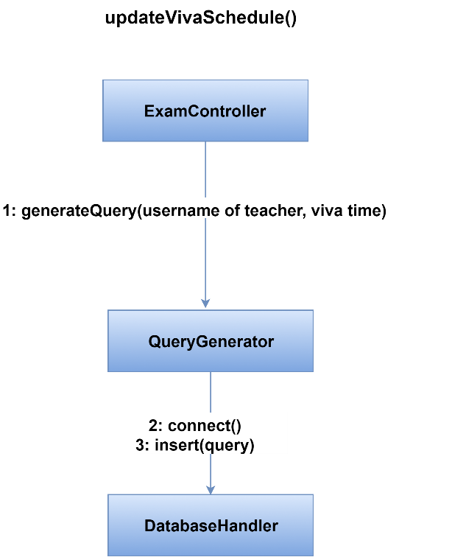

Figure 71 Method updateVivaSchedule() of ExamController Class

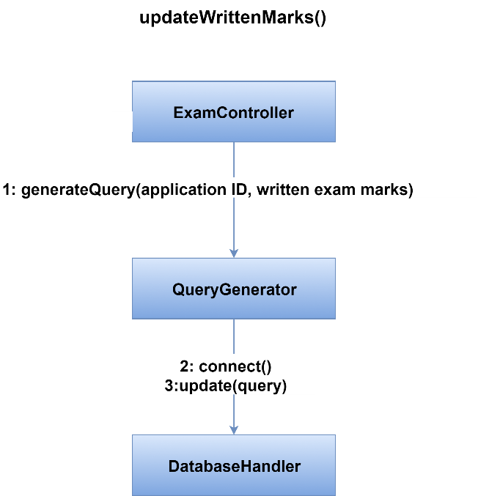

Figure 72 Method updateWrittenMarks() of ExamController Class

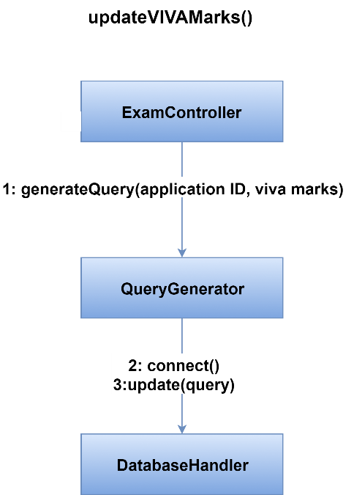

Figure 73 Method updateVIVAMarks() of ExamController Class

Figure 74-86 shows collaboration diagrams for Teacher class.

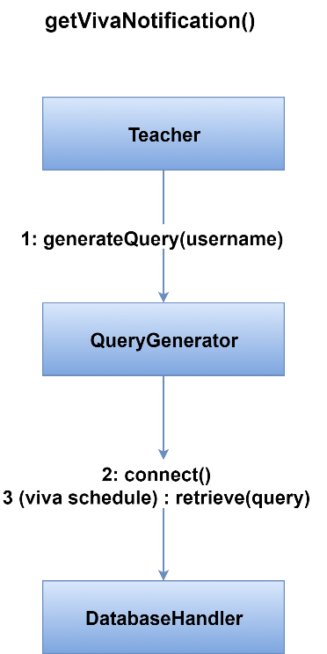

Figure 74 Method getVivaNotification() of Teacher Class

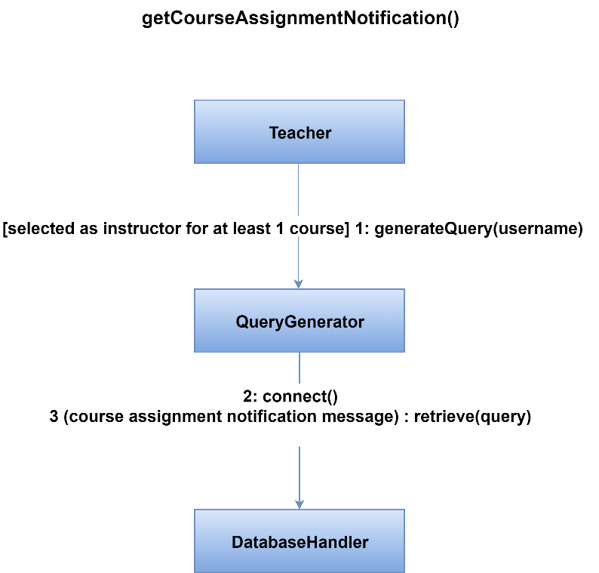

Figure 75 Method getCourseAssignmentNotification() of Teacher Class

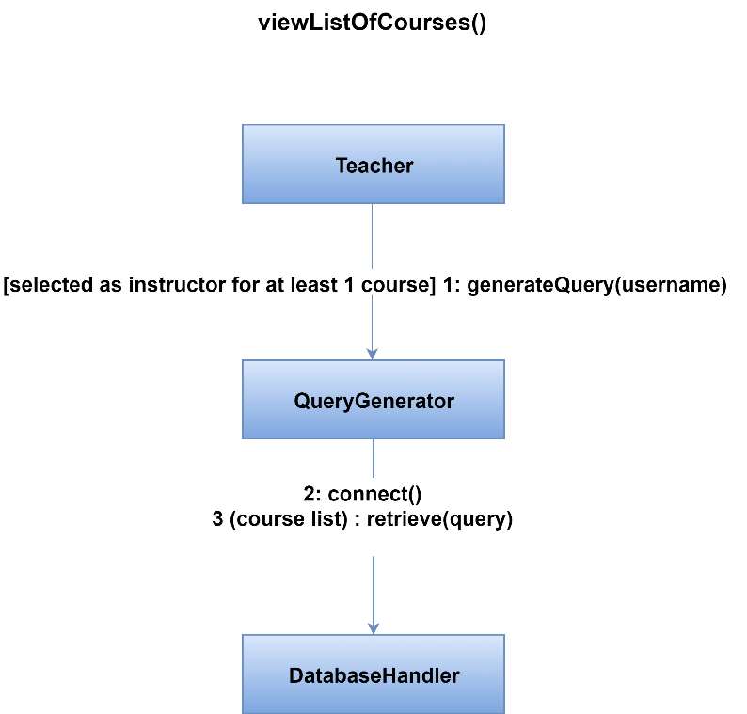

Figure 76 Method viewListOfCourses() of Teacher Class

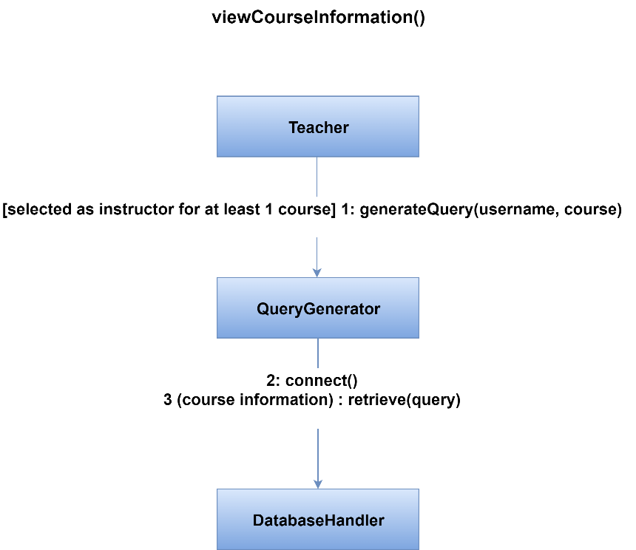

Figure 77 Method viewCourseInformation() of Teacher Class

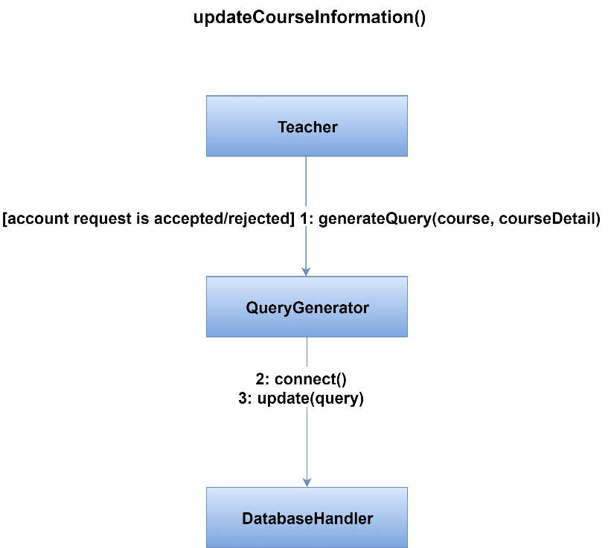

Figure 78 Method updateCourseInformation() of Teacher Class

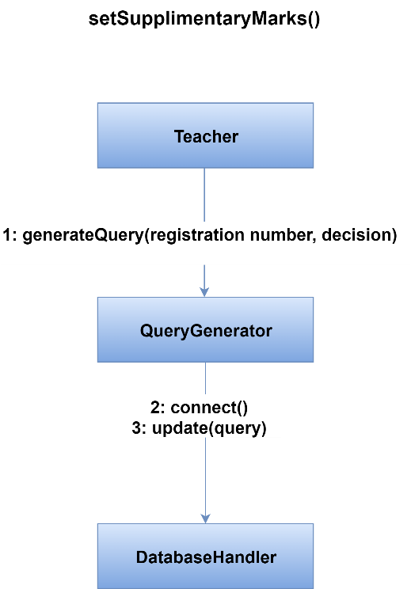

Figure 79 Method setSupplementaryMarks() of Teacher Class

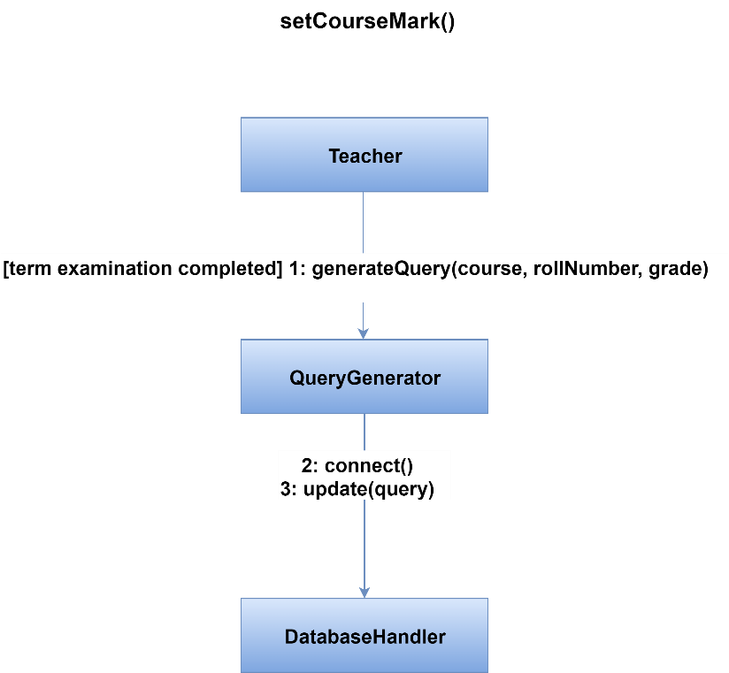

Figure 80 Method setCourseMark() of Teacher Class

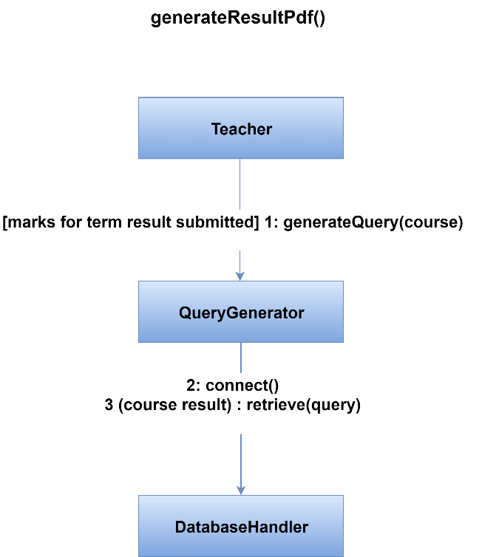

Figure 81 Method generateResultPdf() of Teacher Class

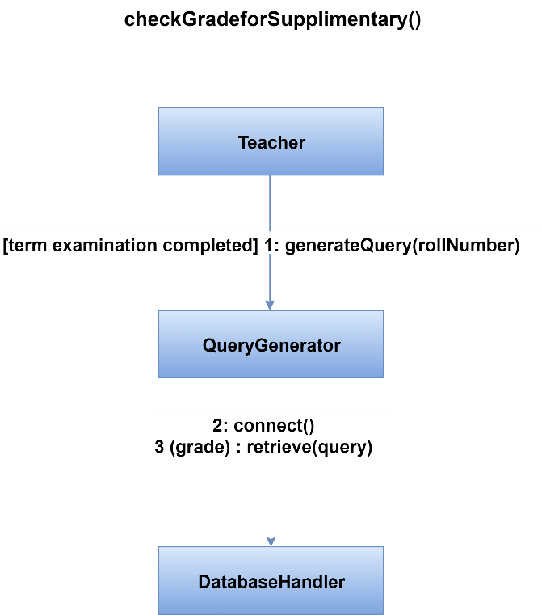

Figure 82 Method checkGradeForSupplementary() of Teacher Class

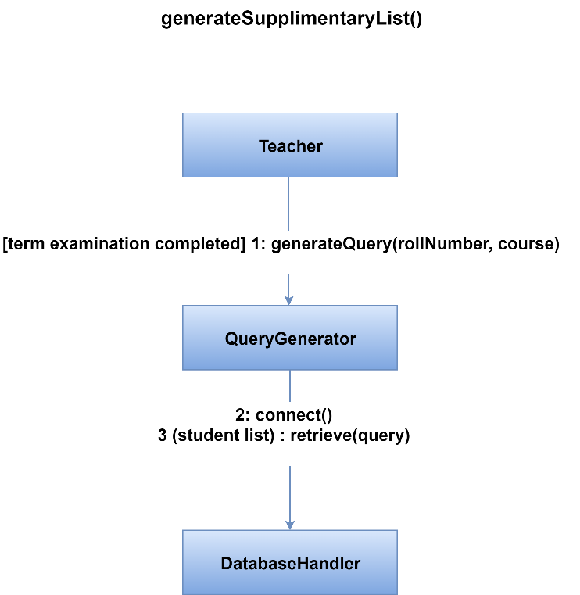

Figure 83 Method generateSupplementaryList() of Teacher Class

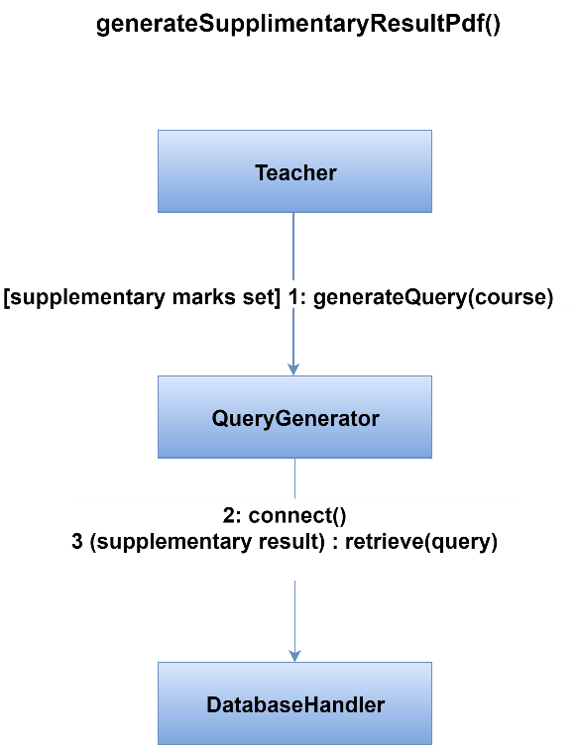

Figure 84 Method generateSupplementaryResultPdf() of Teacher Class

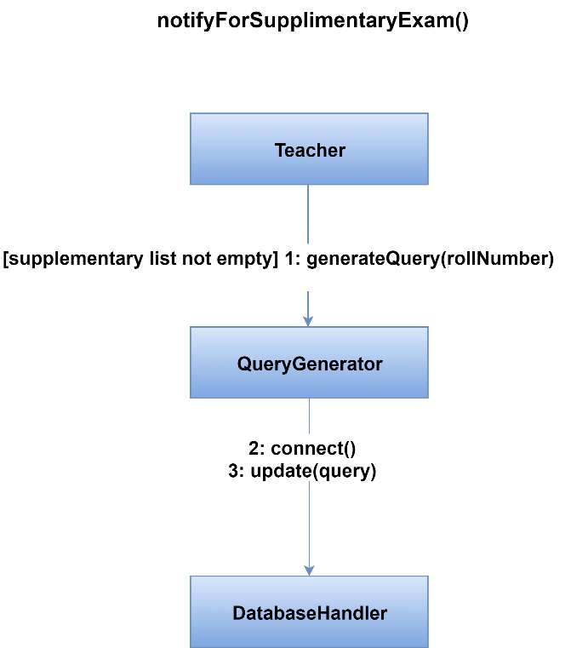

Figure 85 Method notifyForSupplementaryExam() of Teacher Class

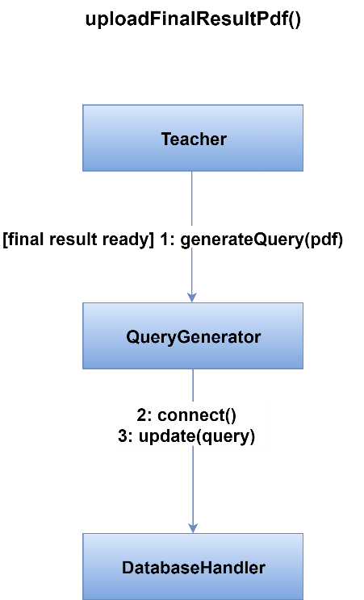

Figure 86 Method uploadFinalResultPdf() of Teacher Class

Figure 87-90 shows collaboration diagrams for Student class.

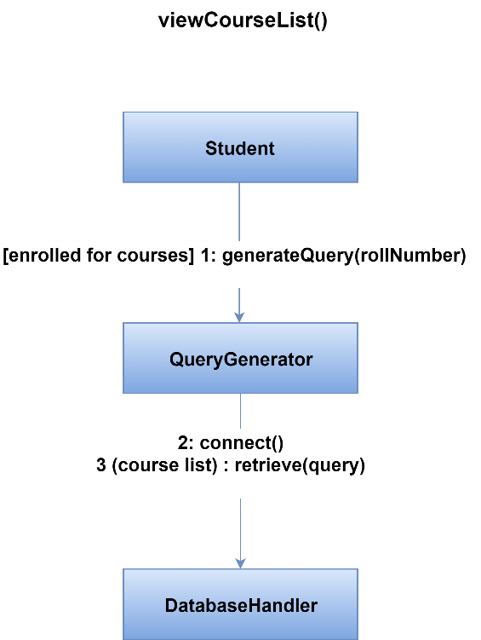

Figure 87 Method viewCourseList() of Student Class

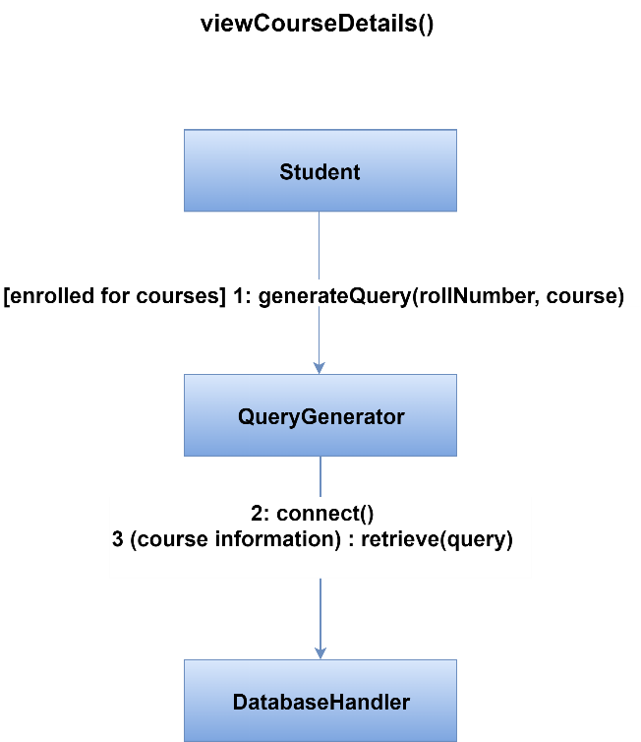

Figure 88 Method viewCourseDetails() of Student Class

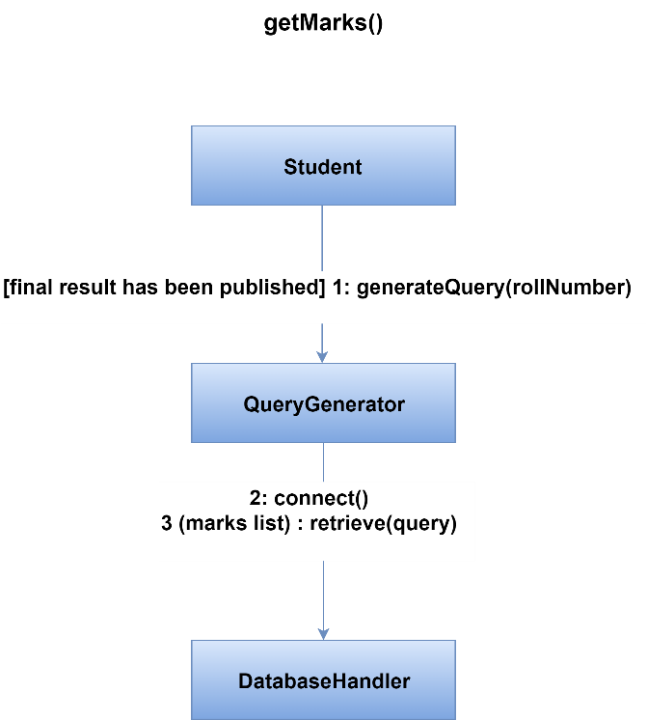

Figure 89 Method getMarks() of Student Class

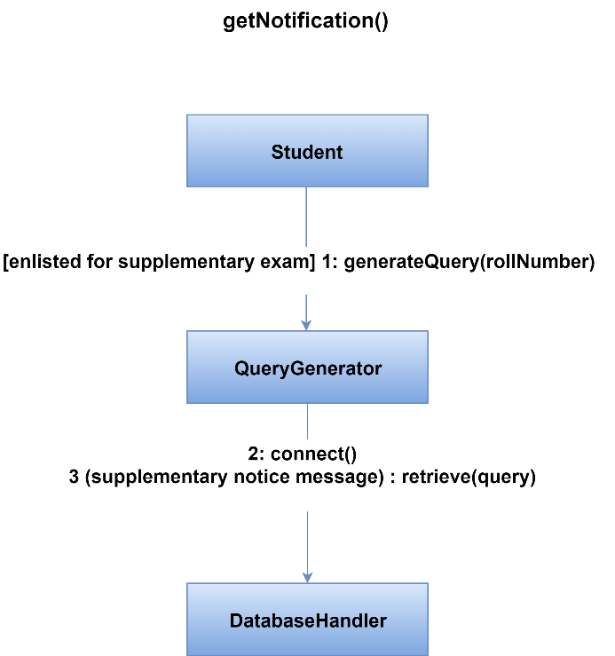

Figure 90 Method getNotification() of Student Class

### 3.3.2 Identify Appropriate Interfaces for Each Component

Within the context of component-level design, a UML interface is a group of externally visible operations.

User class has some interfaces named verification, forgot password which deal with authentication related activities. But it is not the responsibility of User class to handle authentication. So we have defined a new class named Authentication which will be responsible for handling authentication. Figure 91 shows Authentication class.

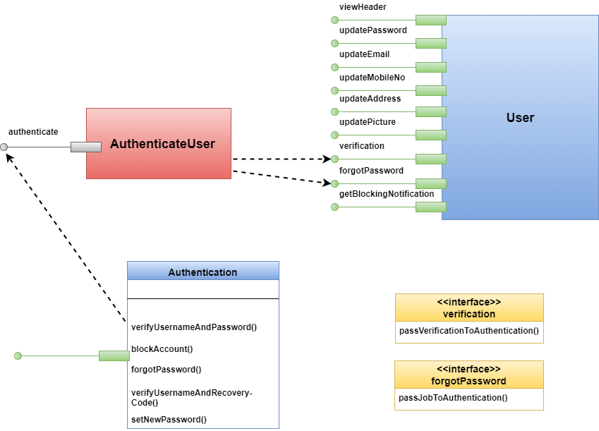

Figure 91 Authentication class

It is not the responsibility of Scrutinizer class to generate roll number for applicants. So a new class RollGenerator has been defined for handling this activity. Figure 92 shows RollGenerator class.

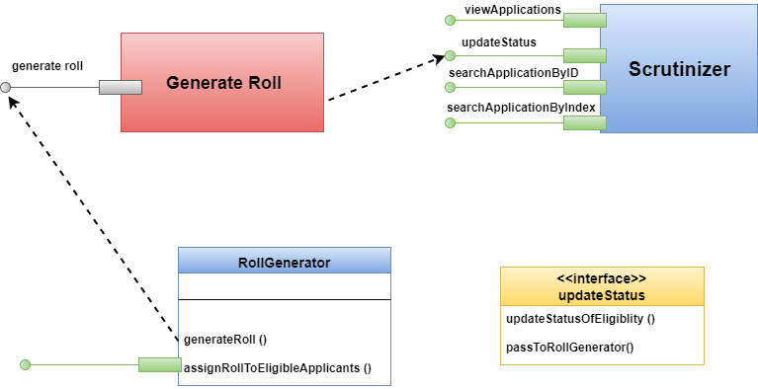

Figure 92 RollGenerator class

Student class has an interface named viewResultSheet which deals with result geenration process. But it is not the responsibility of Student class. So we have defined a new class named ReportCard which will be responsible for generation report card. Figure 93 shows ReportCard class.

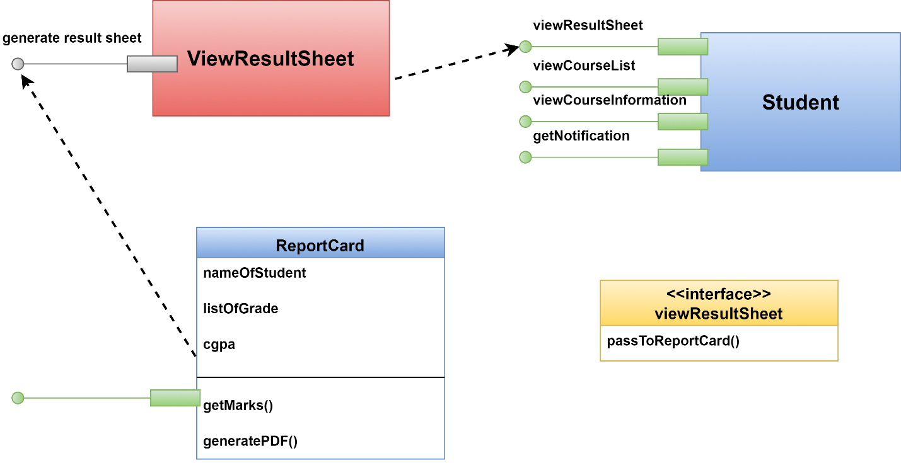

Figure 93 ReportCard class

It is not the responsibility of ExamController class to generate seat plan for applicants. So a new class RoomHandler has been introduced for handling this activity. Figure 94 shows RoomHandler class.

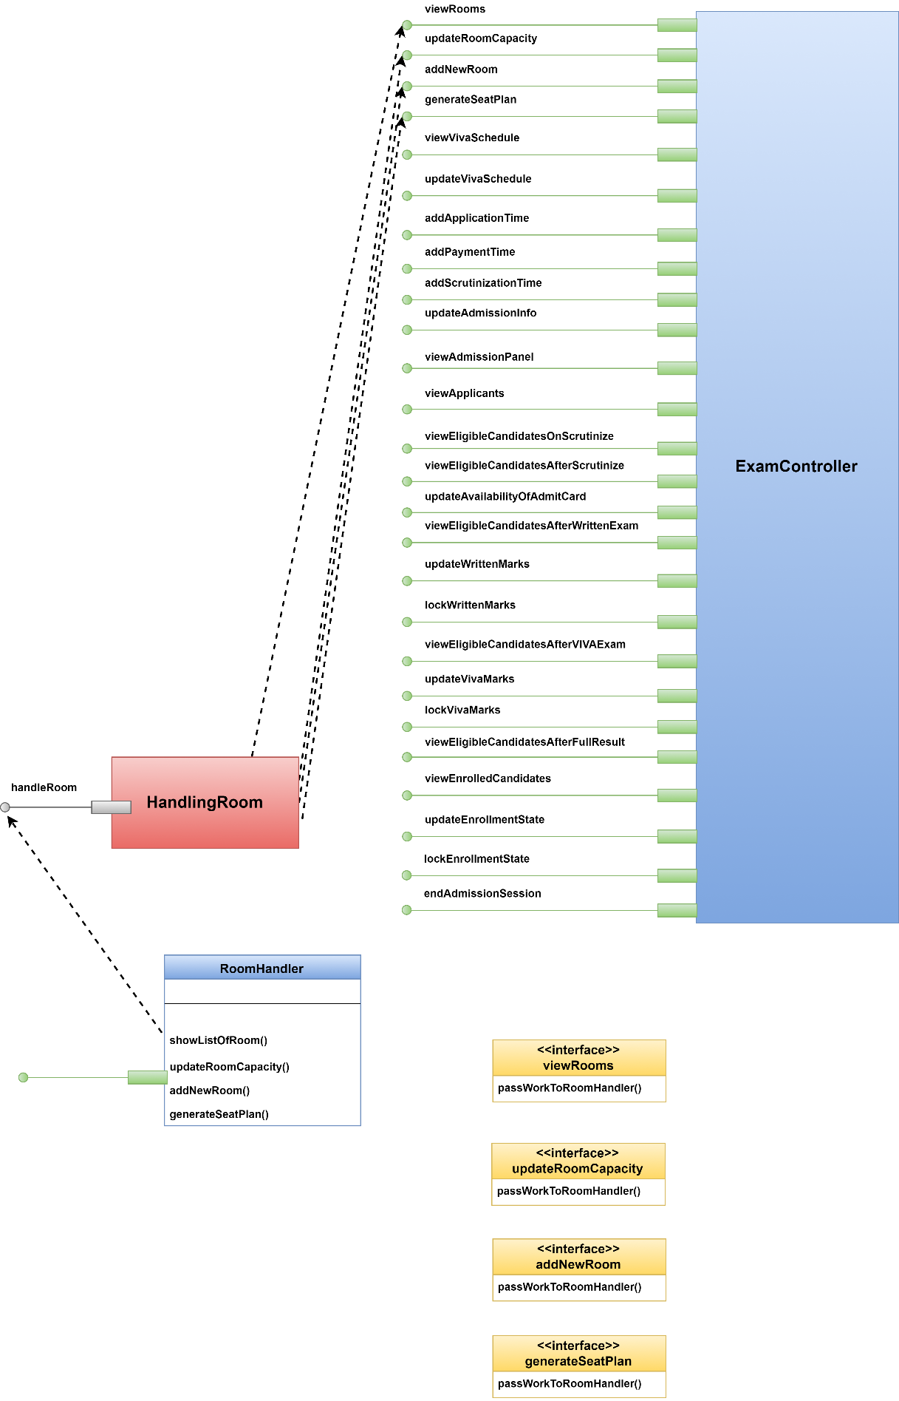

Figure 94 RoomHandler Class

It is not the responsibility of User class to retrieve and display name and image. So a new class DisplayHeader has been introduced for handling this activity. Figure 95 shows DisplayHeader class.

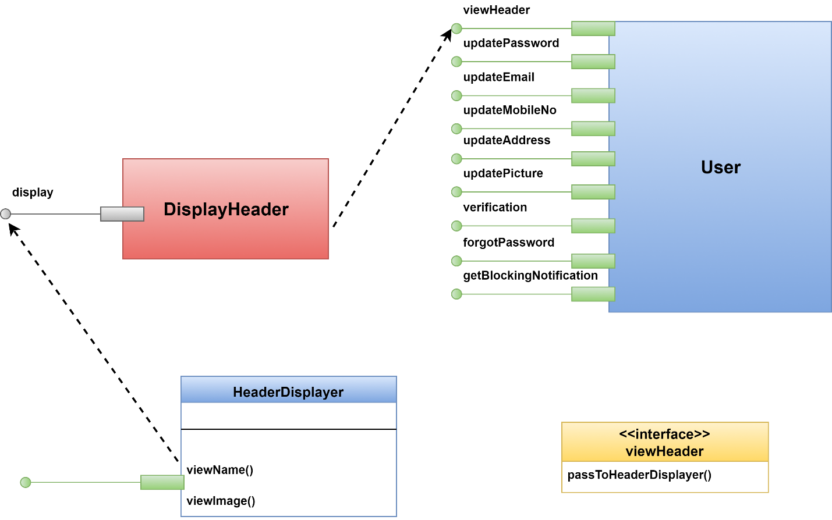

Figure 95 HeaderDisplayer class

It is not the task of Teacher class to generate PDF. So PDFHandler class has been introduced which is shown in figure 96.

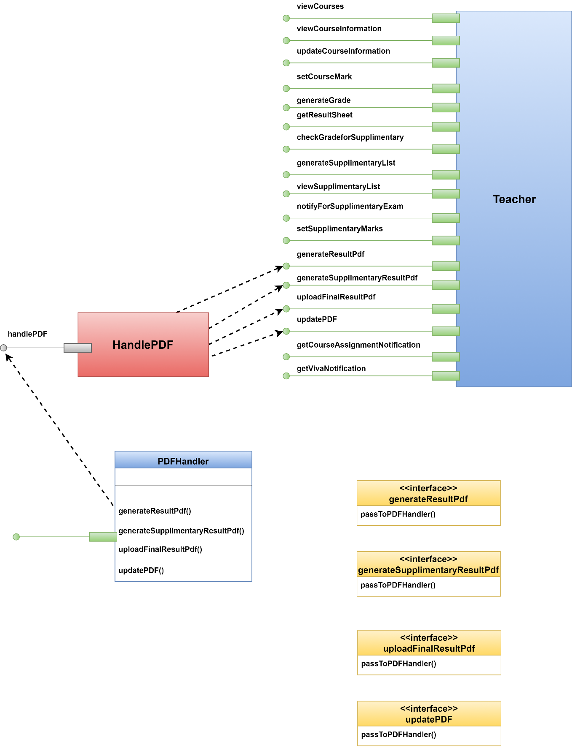

Figure 96 PDFHandler class

### 3.3.3 Elaborate Attributes and Define Data Types and Data Structures required to Implement Them

Generally data structures and types used to define attributes are defined within the context of the programming language that is to be used for implementation.

Table 1 elaborates all attributes of design classes.

Table 1 Elaborated Attributes of Design classes

|  |  |  |  |  |  |
| --- | --- | --- | --- | --- | --- |
| No | Attribute Name | Class | Data Type | Initial Value | Property String |
| 1 | username | User | String | null | [a-zA-Z ]{1,20} |
| 2 | password | User | String | null | ^(?=.*[A-Za-z])(?=.*\d)[A-Za-z\d]{8,30}$ |
| 3 | fullName | User, Applicant, ReportCard | String | null | [a-z A-Z ]{1,50} |
| 4 | fatherName | User, Applicant | String | null | [a-z A-Z ]{1,50} |
| 5 | motherName | User, Applicant | String | null | [a-z A-Z ]{1,50} |
| 6 | mobileNumber | User, Applicant | String | null | [0-9]{11} |
| 7 | emailAddress | User, Applicant | String | null | Maximum length = 50 characters |
| 8 | address | User, Applicant | String | null | Maximum length = 250 characters |
| 9 | rollNumber | Student | int | 0 | [0-9]{6} |
| 10 | year | Student, Applicant | int | 2017 | [0-9]{4} |
| 11 | listOfGrade | ReportCard | Associative array | 0.00 | 0.00 ≤ grade of a course ≤ 4.00 |
| 12 | cgpa | ReportCard | float | 0.00 | 0.00 ≤ cgpa ≤ 4.00 |
| 13 | applicationID | Applicant | String | null | [0-9]{6} |
| 14 | dateOfBirth | Applicant | Date | Current date | Minimum date 01-01-1990 |
| 15 | nationality | Applicant | String | null | [a-zA-Z ]{1,20} |
| 16 | schoolName | Applicant | String | null | [a-zA-Z ]{1,50} |
| 17 | schoolBoard | Applicant | String | null | [a-zA-Z ]{1,50} |
| 18 | schoolGroup | Applicant | String | null | [a-zA-Z ]{1,50} |
| 19 | schoolYear | Applicant | int | 2010 | [0-9]{4} |
| 20 | schoolGPA | Applicant | float | 0.00 | 0.00 ≤ value ≤ 5.00 |
| 21 | collegeName | Applicant | String | null | [a-zA-Z ]{1,50} |
| 22 | collegeBoard | Applicant | String | null | [a-zA-Z ]{1,50} |
| 23 | collegeGroup | Applicant | String | null | [a-zA-Z ]{1,50} |
| 24 | collegeYear | Applicant | int | 2012 | [0-9]{4} |
| 25 | collegeGPA | Applicant | float | 0.00 | 0.00 ≤ value ≤ 5.00 |
| 26 | universityName | Applicant | String | null | [a-zA-Z ]{1,50} |
| 27 | departmentName | Applicant | String | null | [a-zA-Z ]{1,50} |
| 28 | universityYear | Applicant | int | 2016 | [0-9]{4} |
| 29 | universityGPA | Applicant | float | 0.00 | 0.00 ≤ value ≤ 4.00 |
| 30 | algebraInHSC | Applicant | boolean | false | Either true or false |
| 31 | algebraIn  Bachelor | Applicant | boolean | false | Either true or false |
| 32 | mathInHSC | Applicant | boolean | false | Either true or false |
| 33 | mathPercentage  InHSC | Applicant | float | 0.00 | 0.00 ≤ value ≤ 100.00 |
| 34 | mathInBachelor | Applicant | boolean | false | Either true or false |
| 35 | mathPercentage  InBachelor | Applicant | float | 0.00 | 0.00 ≤ value ≤ 100.00 |
| 36 | eligibilityForViva | Applicant | boolean | false | Either true or false |
| 37 | enrollmentStatus | Applicant | boolean | false | Either true or false |
| 38 | applicationFee  PaymentStatus | Applicant | boolean | false | Either true or false |
| 39 | eligibilityOf  Application | Applicant | boolean | false | Either true or false |
| 40 | roomNo | Applicant | int | 0 | [0-9]{3} |
| 41 | writtenMarks | Applicant | float | 0.00 | 0.00 ≤ value ≤ 100.00 |
| 42 | eligibilityForVIVA | Applicant | boolean | false | Either true or false |
| 43 | VIVAmarks | Applicant | float | 0.00 | 0.00 ≤ value ≤ 100.00 |
| 44 | eligibilityFor  Admission | Applicant | boolean | false | Either true or false |
| 45 | admissionFee  PaymentStatus | Applicant | boolean | false | Either true or false |
| 46 | enrollmentStatus | Applicant | boolean | false | Either true or false |

### 3.3.4 Describe Processing Flow within Each Operation in Detail

This may be accomplished using UML activity diagram.

Figure 97-100 show UML activity diagrams for Authentication class.

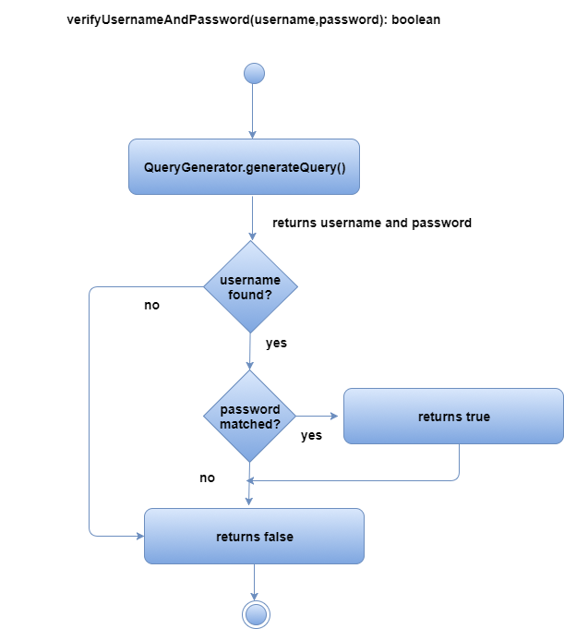

Figure 97 verifyUsernameAndPassword() of Authentication

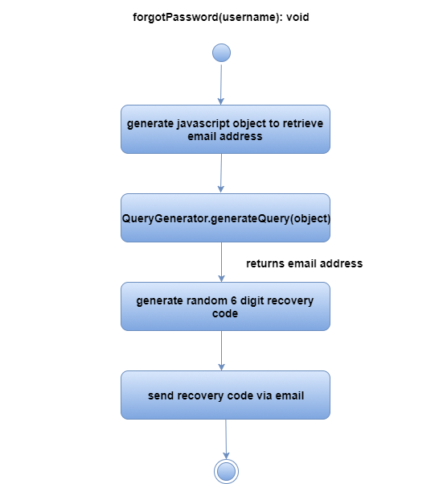

Figure 98 forgotPassword() of Authentication

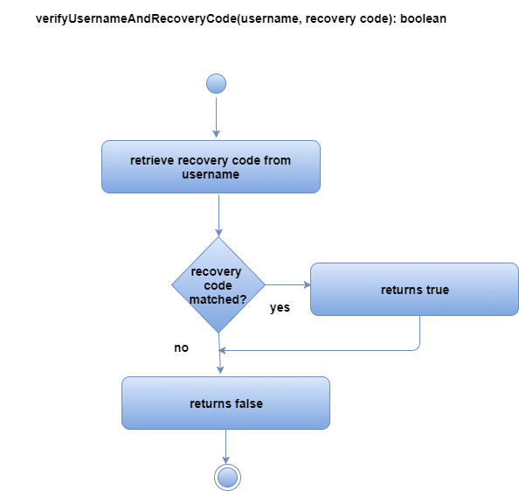

Figure 99 verifyUsernameAndRecoveryCode() of Authentication

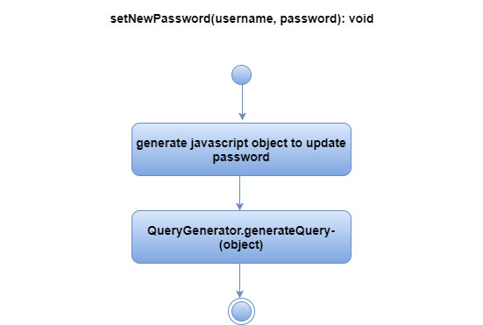

Figure 100 setNewPassword() of Authentication

Figure 101-103 show UML activity diagrams for Applicant class.

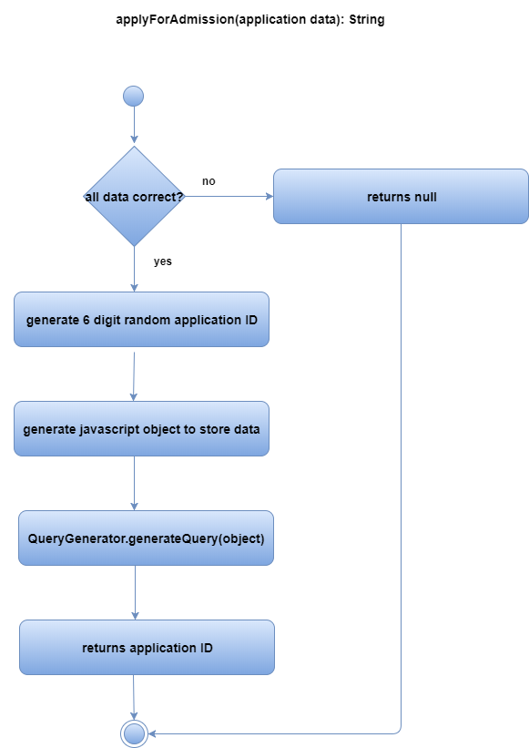

Figure 101 applyForAdmission() of Applicant

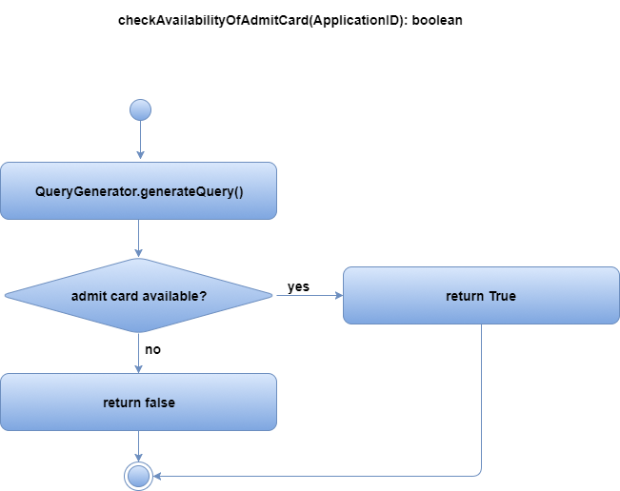

Figure 102 checkAvailabilityOfAdmitCard() of Applicant

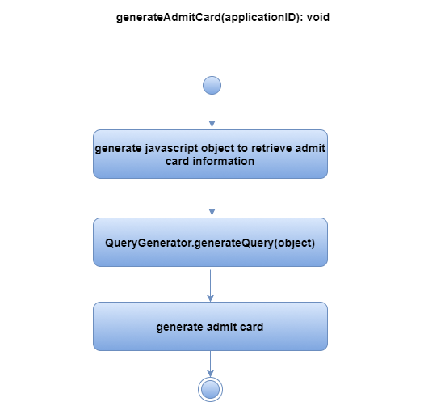

Figure 103 generateAdmitCard() of Applicant

Figure 104 shows UML activity diagram for QueryGenerator class.

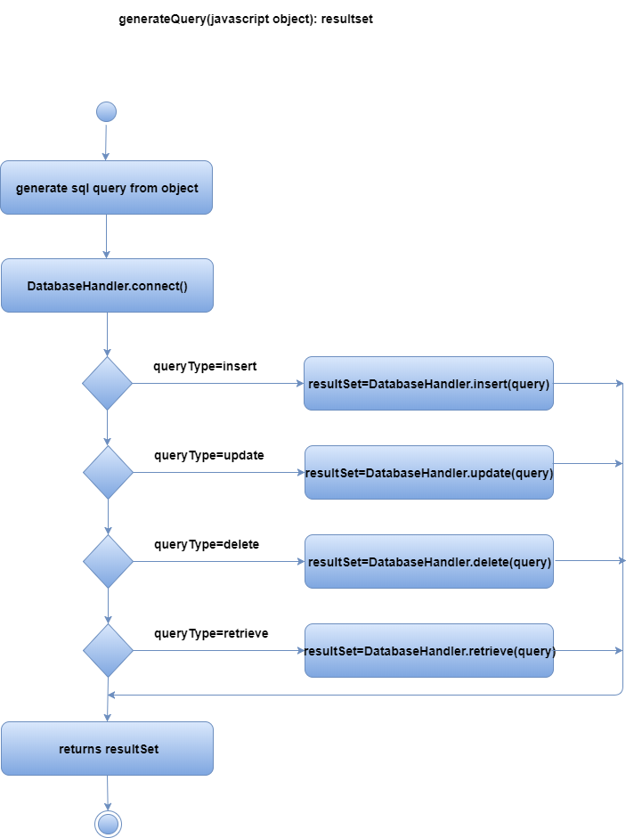

Figure 104 generateQuery() of QueryGenerator

Figure 105-108 show UML activity diagrams for User class.

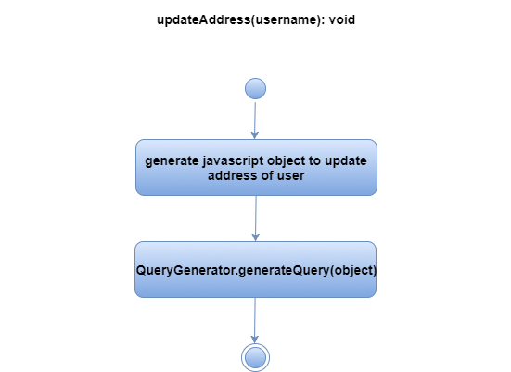

Figure 105 updateAddress() of User

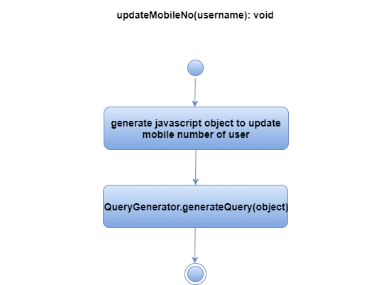

Figure 106 updateMobileNo() of User

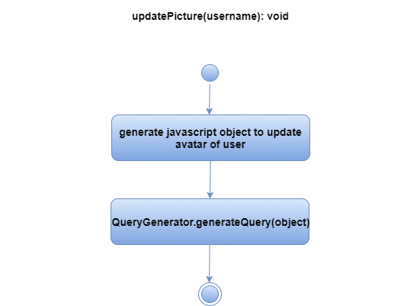

Figure 107 updatePicture() of User

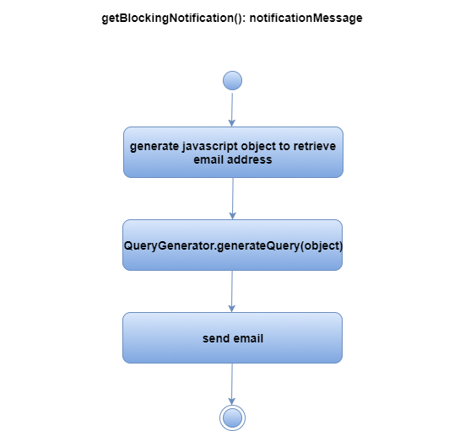

Figure 108 getBlockingNotification() of User

Figure 109-110 show UML activity diagrams for HeaderDisplayer class.

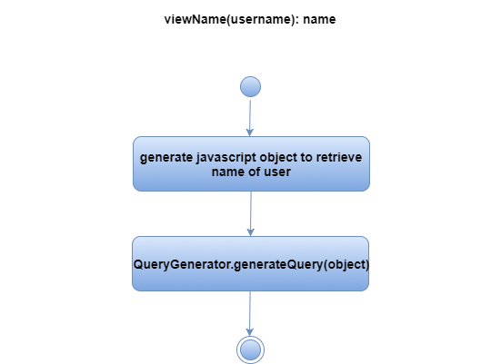

Figure 109 viewName() of HeaderDisplayer

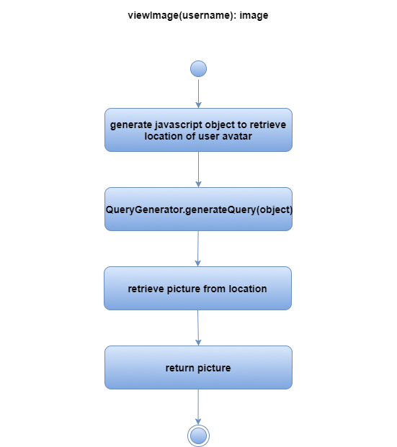

Figure 110 viewImage() of HeaderDisplayer

Figure 111-121 show UML activity diagrams for ProgramChairperson class.

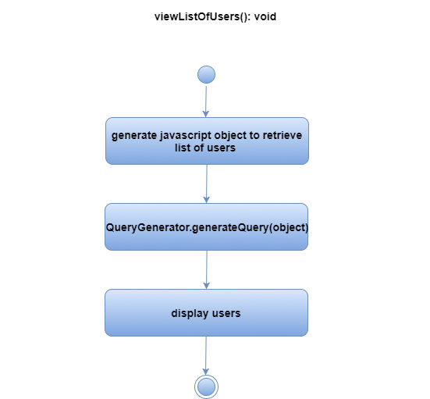

Figure 111 viewListOfUsers() of ProgramChairperson

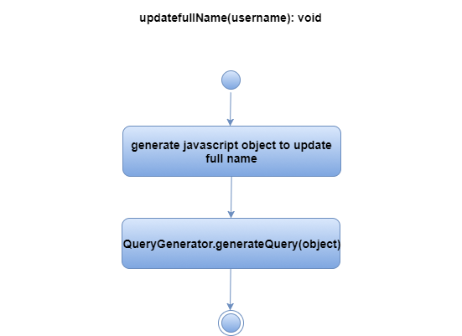

Figure 112 updateFullName() of ProgramChairperson

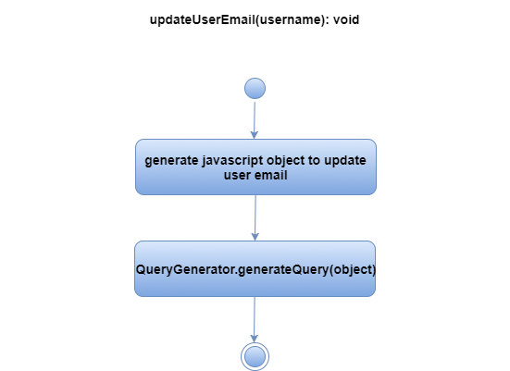

Figure 113 updateUserEmail () of ProgramChairperson

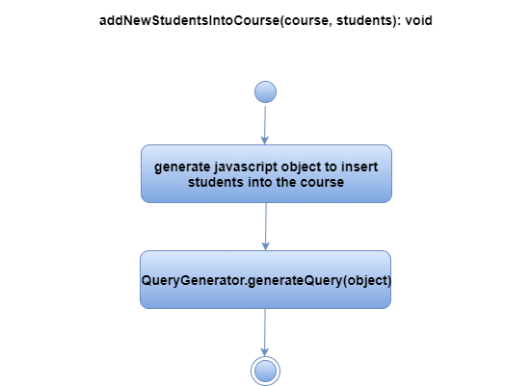

Figure 114 addNewStudentsIntoCourse() of ProgramChairperson

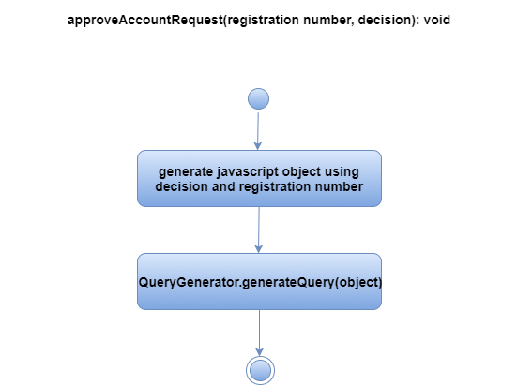

Figure 115 approveAccountRequest() of ProgramChairperson

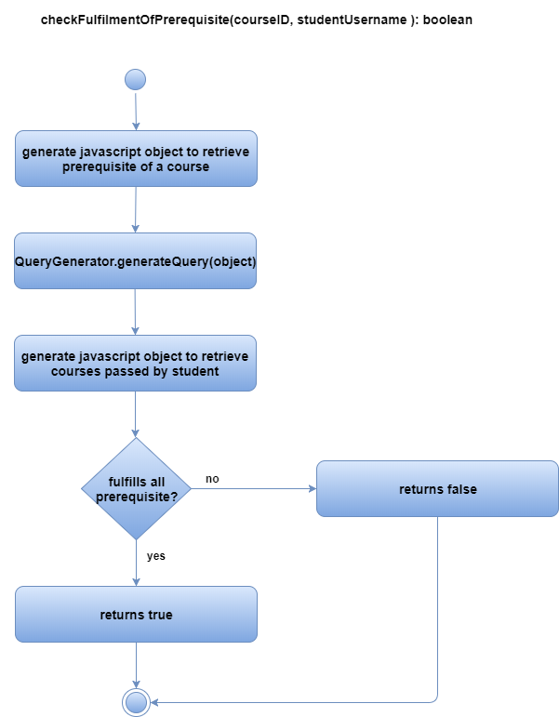

Figure 116 checkFulfillmentOfPayment() of ProgramChairperson

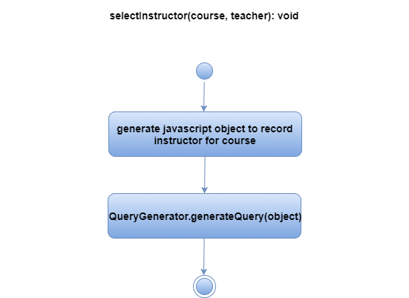

Figure 117 selectInstructor() of ProgramChairperson

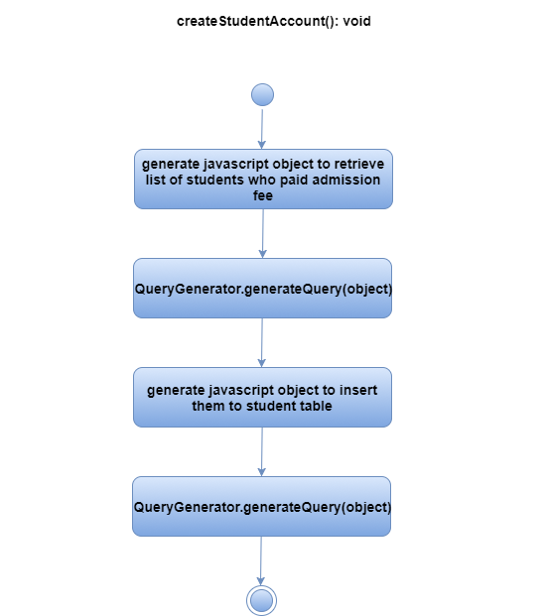

Figure 118 createStudentAccount() of ProgramChairperson

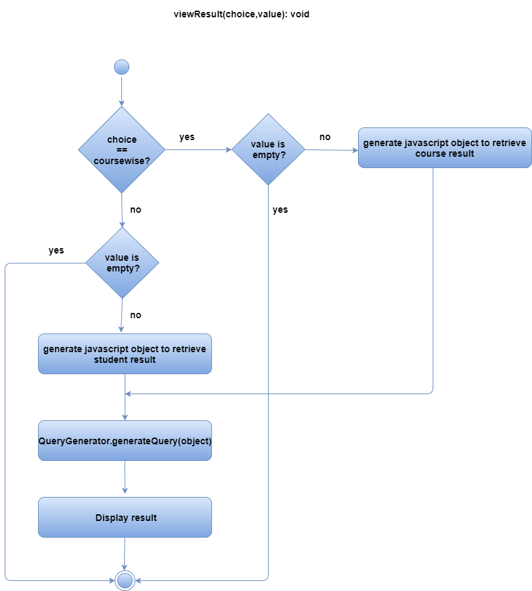

Figure 119 viewResult() of ProgramChairperson

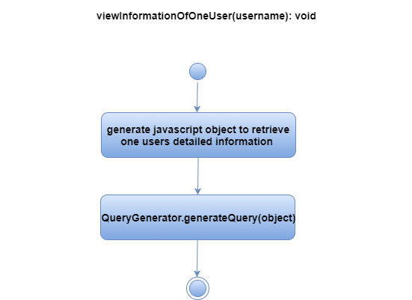

Figure 120 viewInformationOfOneUser() of ProgramChairperson

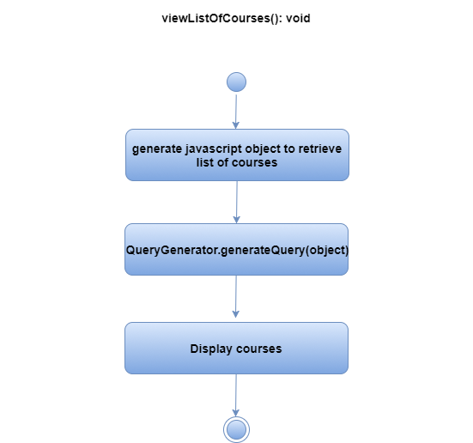

Figure 121 viewListOfCourses () of ProgramChairperson

Figure 122-134 show UML activity diagrams for Teacher class.

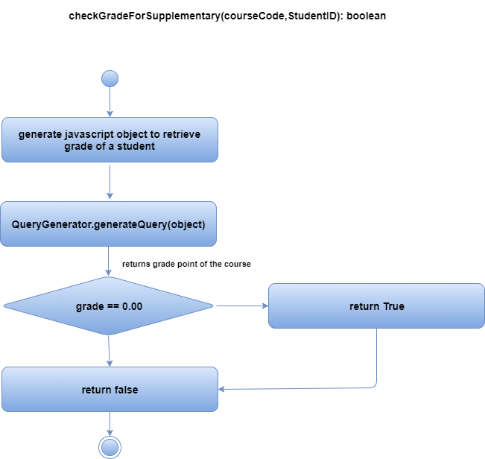

Figure 122 checkGradeForSupplementary() of Teacher

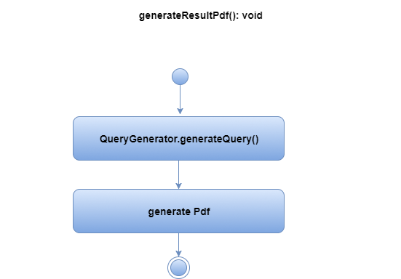

Figure 123 generateResultPdf() of Teacher

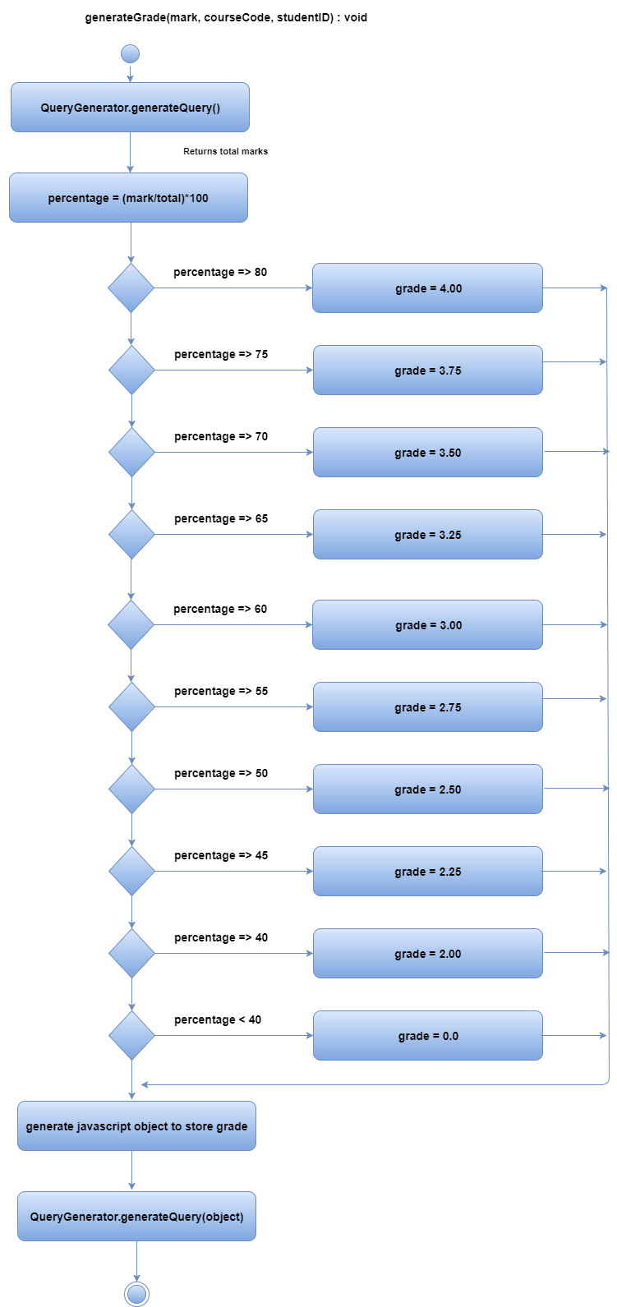

Figure 124 generateGrade() of Teacher

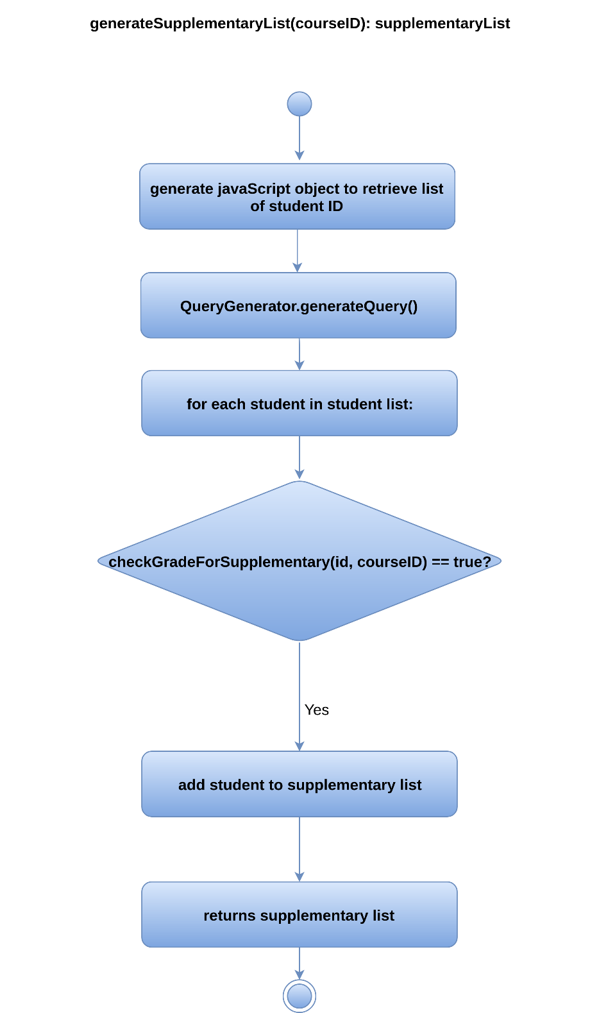

Figure 125 generateSupplementaryList() of Teacher

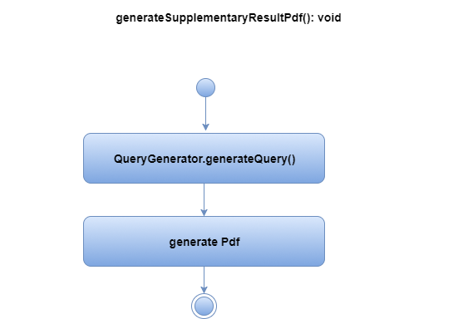

Figure 126 generateSupplementaryResultPdf() of Teacher

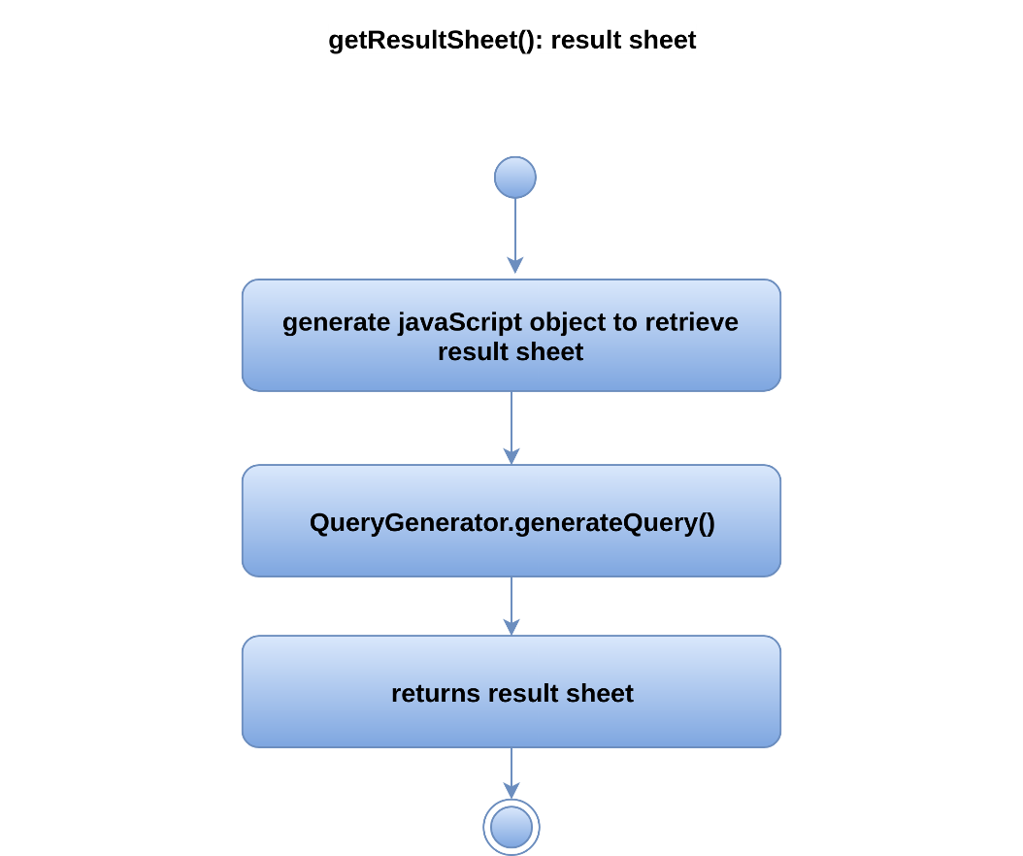

Figure 127 getResultSheet() of Teacher

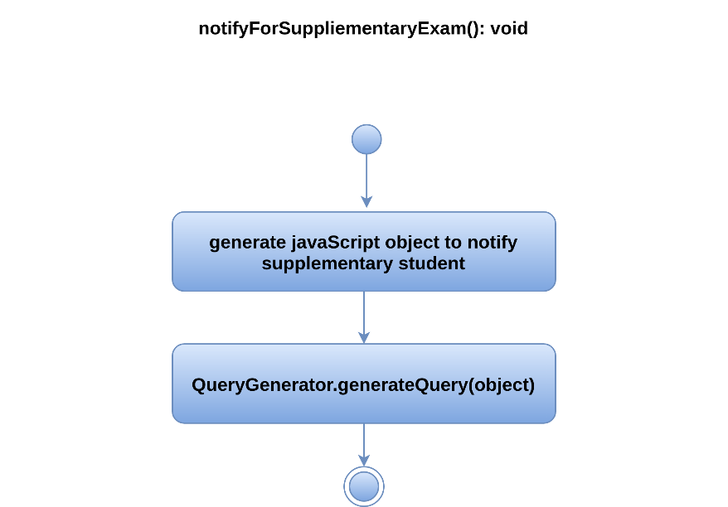

Figure 128 notifyForSupplementaryExam() of Teacher

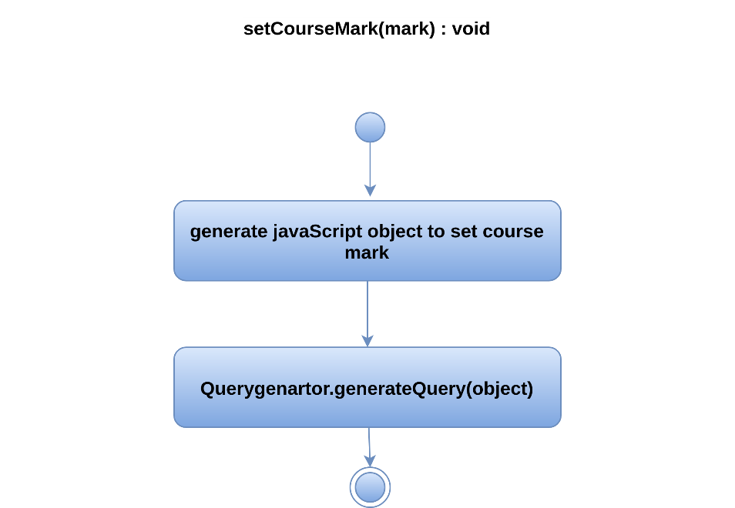

Figure 129 setCourseMark() of Teacher

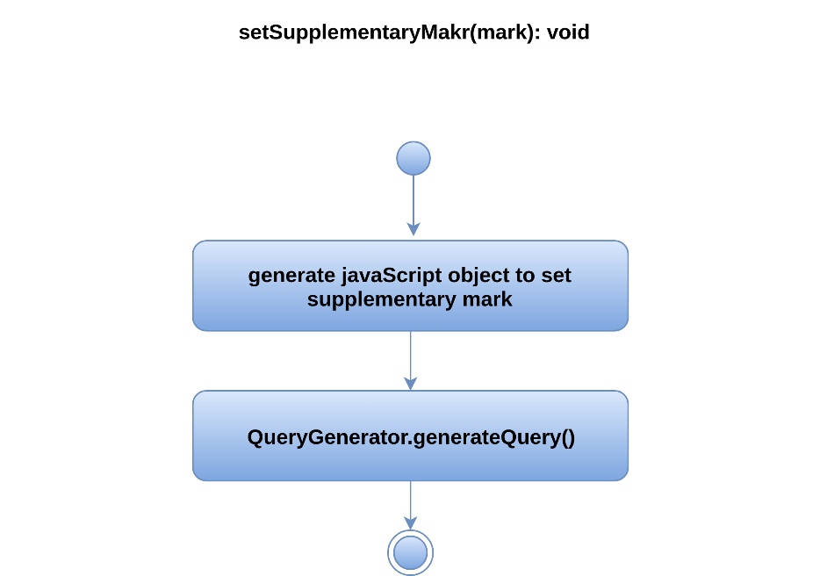

Figure 130 setSupplementaryMark() of Teacher

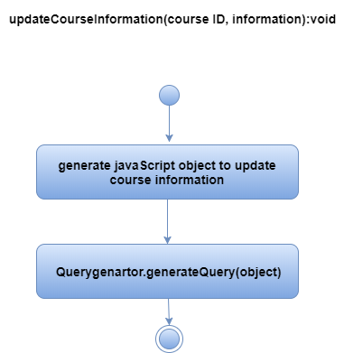

Figure 131 updateCourseInformation() of Teacher

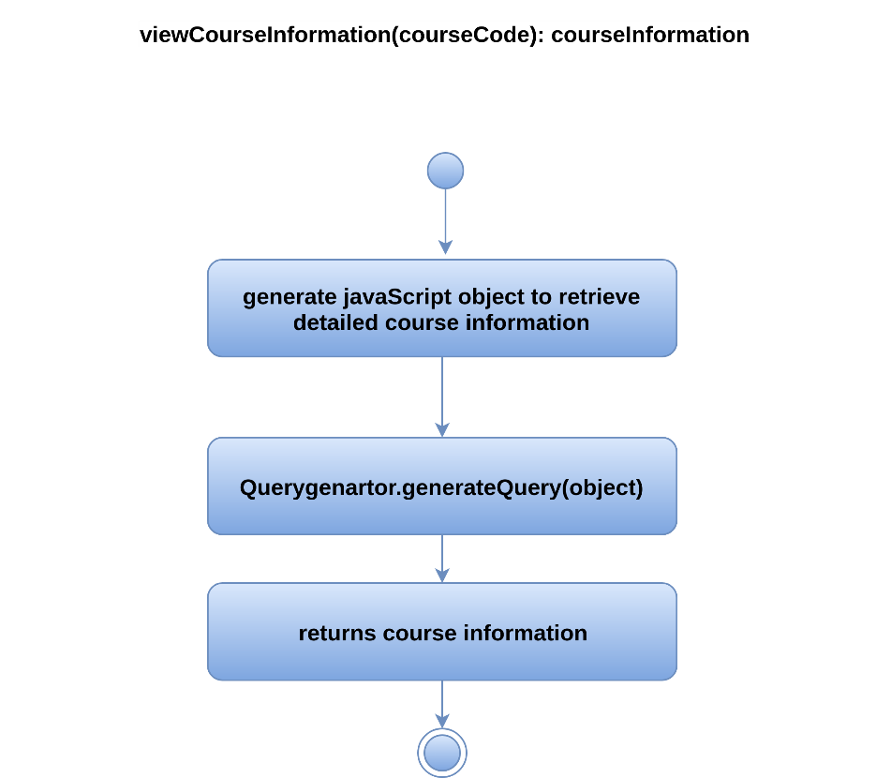

Figure 132 viewCourseInformation() of Teacher

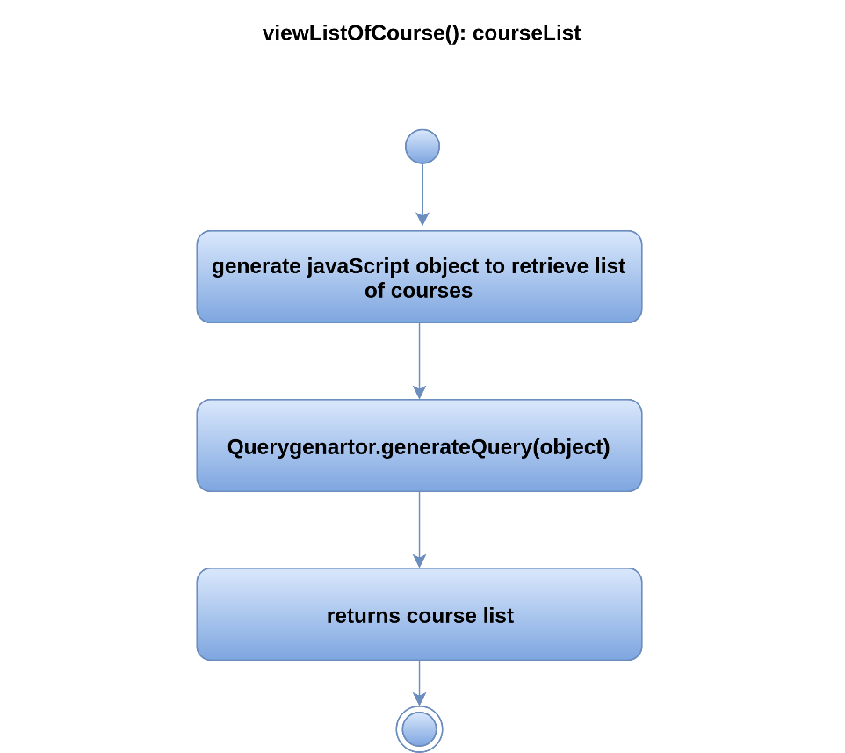

Figure 133 viewListOfCourse() of Teacher

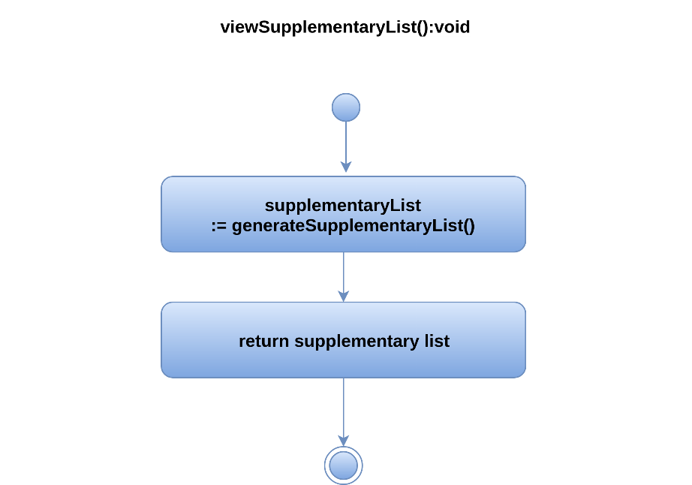

Figure 134 viewSupplementaryList() of Teacher

Figure 135-138 show UML activity diagrams for PDFHandler class.

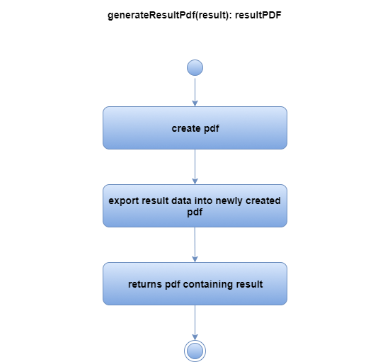

Figure 135 generateResultPdf() of PDFHandler

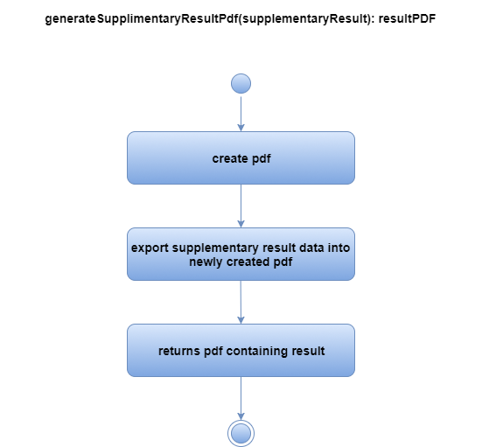

Figure 136 generateSupplementaryResultPdf() of PDFHandler

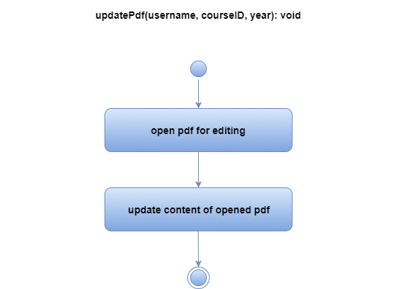

Figure 137 updatePdf() of PDFHandler

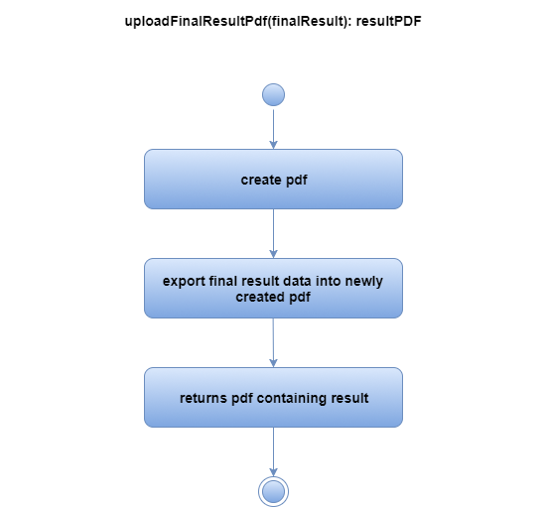

Figure 138 uploadFinalResultPdf() of PDFHandler

Figure 139-141 show UML activity diagrams for Student class.

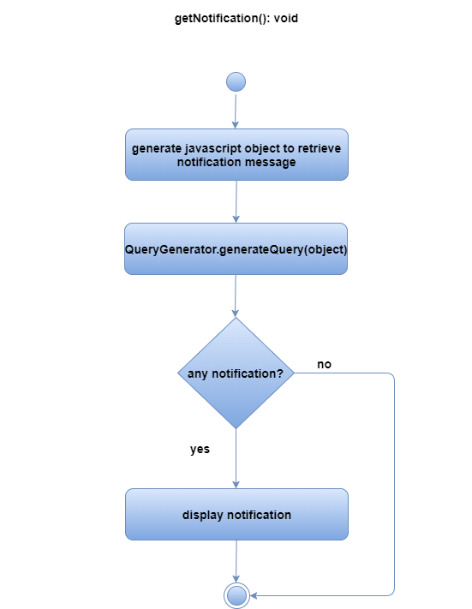

Figure 139 getNotification() of Student

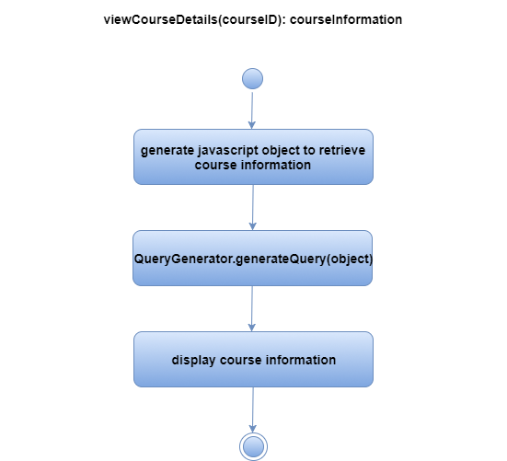

Figure 140 viewCourseDetails() of Student

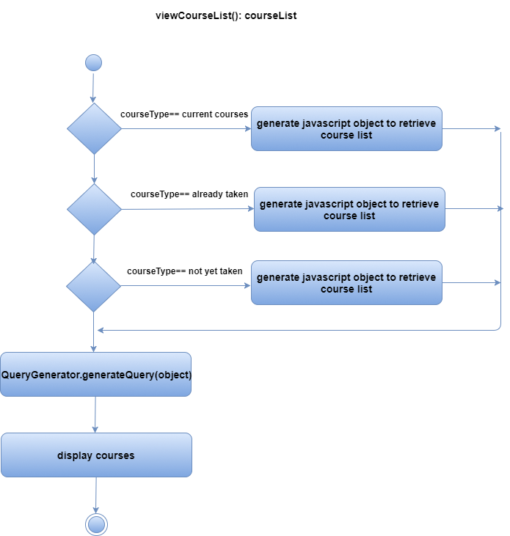

Figure 141 viewCourseList() of Student

Figure 142-143 show UML activity diagrams for ReportCard class.

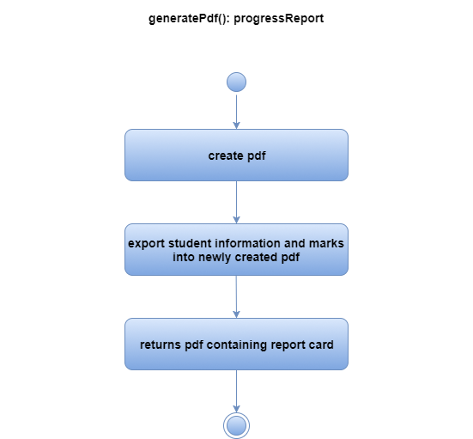

Figure 142 generatePdf() of ReportCard

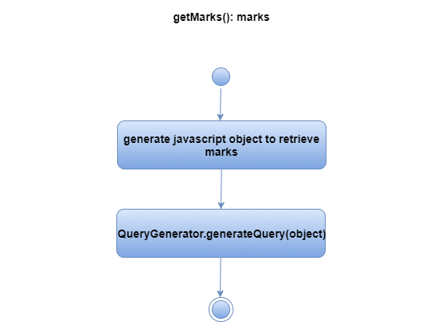

Figure 143 getMarks() of ReportCard

Figure 144-156 show UML activity diagrams for ExamController class.

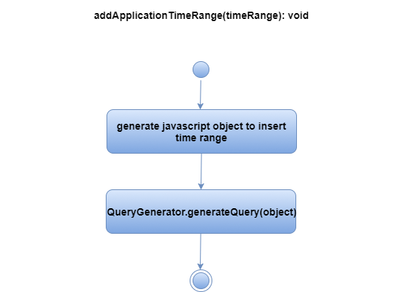

Figure 144 addApplicationTimeRange() of Exam Controller

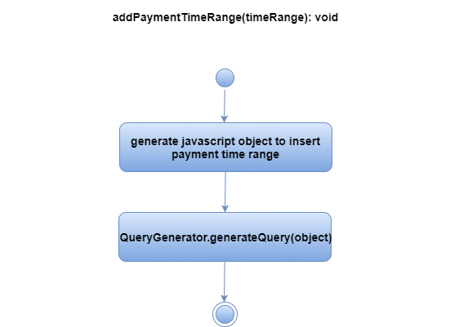

Figure 145 addPaymentTimeRange() of Exam Controller

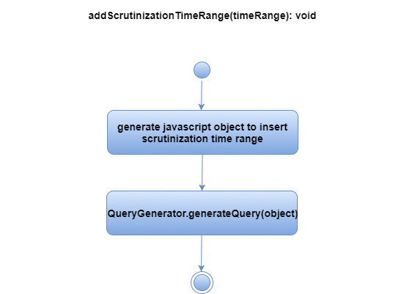

Figure 146 addScrutinizationTimeRange() of Exam Controller

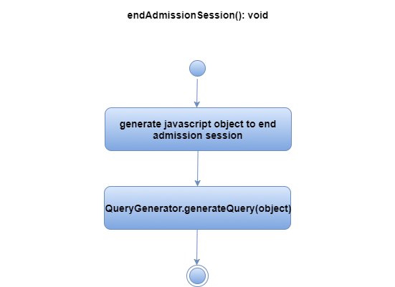

Figure 147 endAdmissionSession() of ExamController

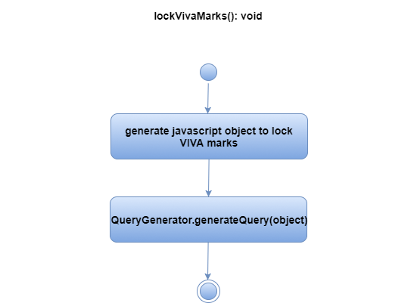

Figure 148 lockVivaMarks() of ExamController

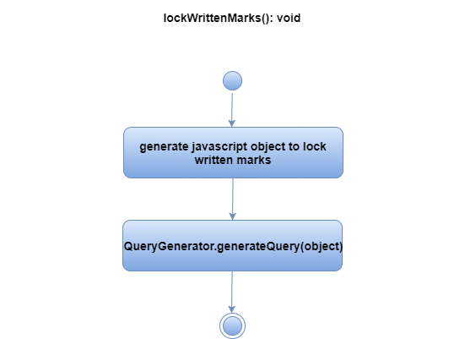

Figure 149 lockWrittenMarks() of ExamController

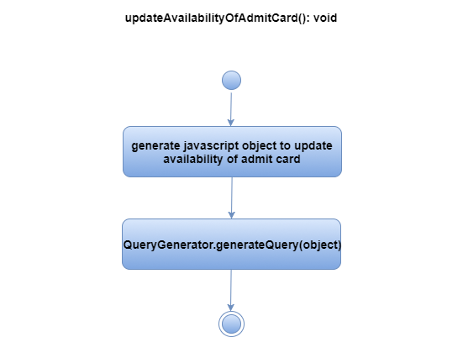

Figure 150 updateAvailabilityOfAdmitCard() of ExamController

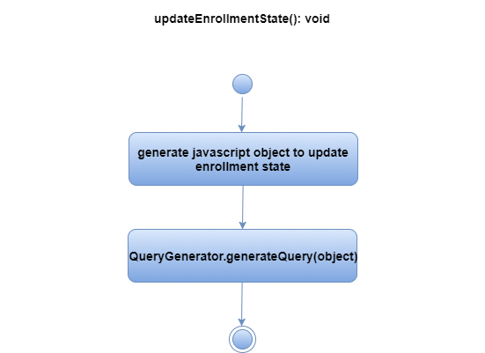

Figure 151 updateEnrollmentState() of ExamController

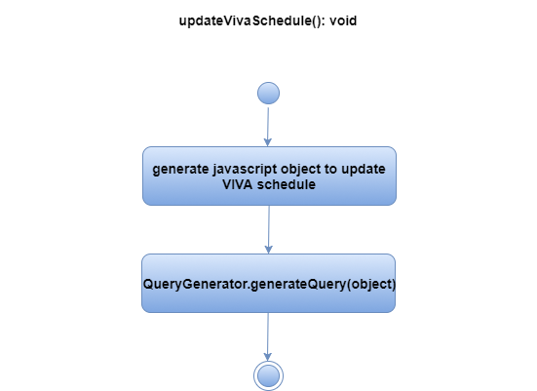

Figure 152 updateVivaSchedule() of ExamController

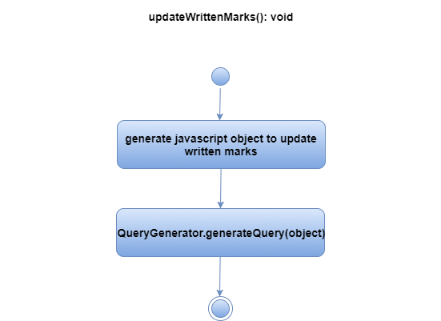

Figure 153 updateWrittenMarks() of ExamController

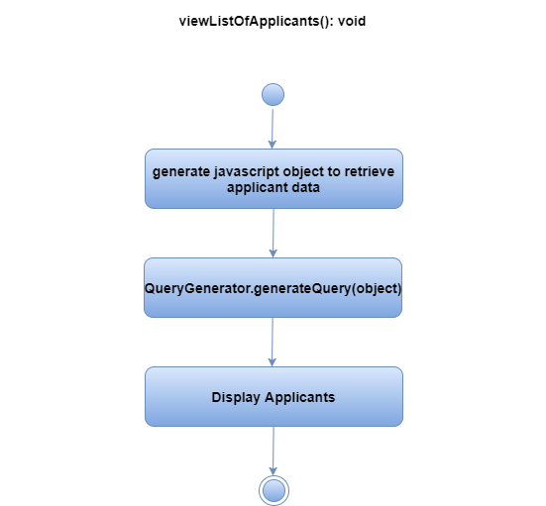

Figure 154 viewListOfApplicants() of ExamController

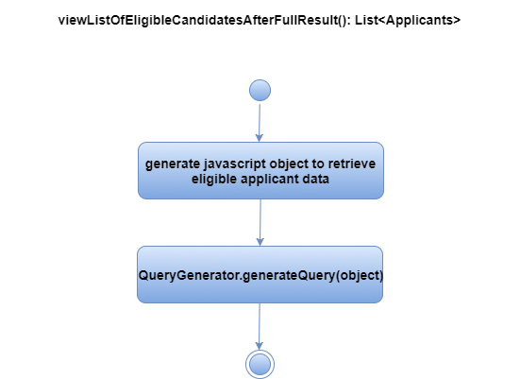

Figure 155 viewListOfEligibleCandidateAfterFullResult() of ExamController

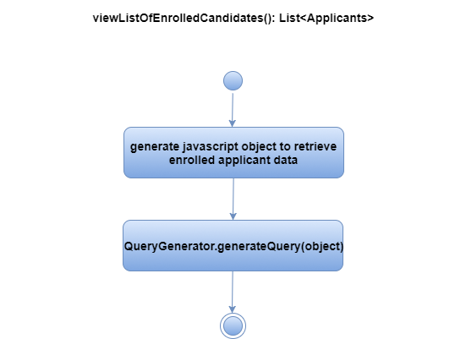

Figure 156 viewListOfEnrolledCandidates() of ExamController

Figure 157-160 show UML activity diagrams for RoomHandler class.

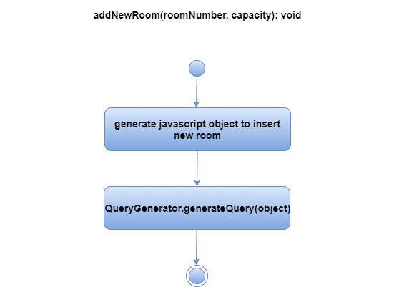

Figure 157 addNewRoom() of RoomHandler

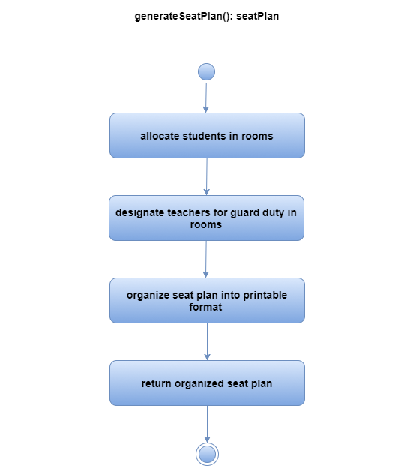

Figure 158 generateSeatPlan() of RoomHandler

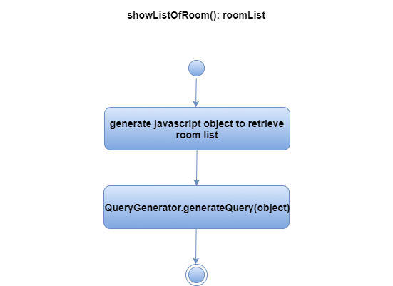

Figure 159 showListOfRoom() of RoomHandler

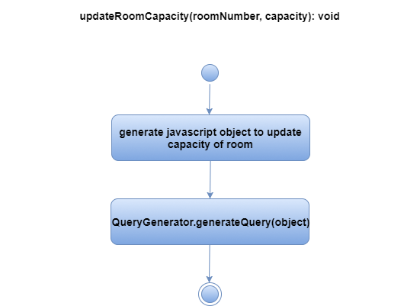

Figure 160 updateRoomCapacity() of RoomHandler

Figure 161-163 show UML activity diagrams for Scrutinizer class.

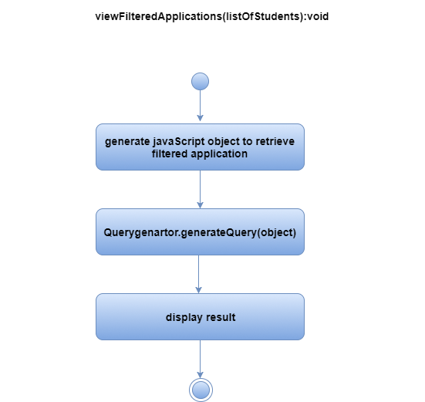

Figure 161 viewFilteredApplcations() of Scrutinizer

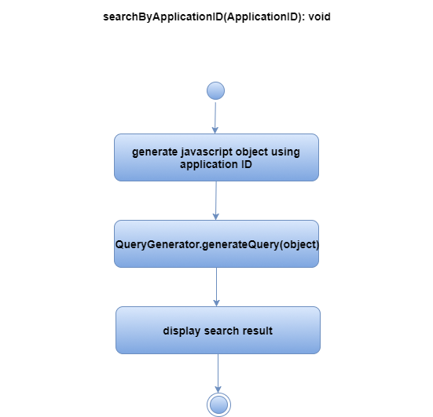

Figure 162 searchByApplicationID () of Scrutinizer

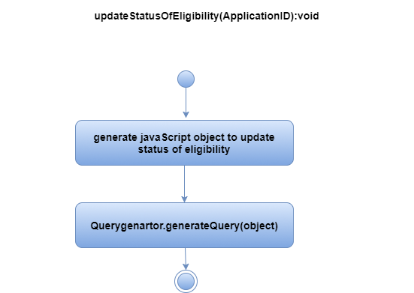

Figure 163 updateStatusOfEligibility() of Scrutinizer

Figure 164-165 show UML activity diagrams for RollGenerator class.

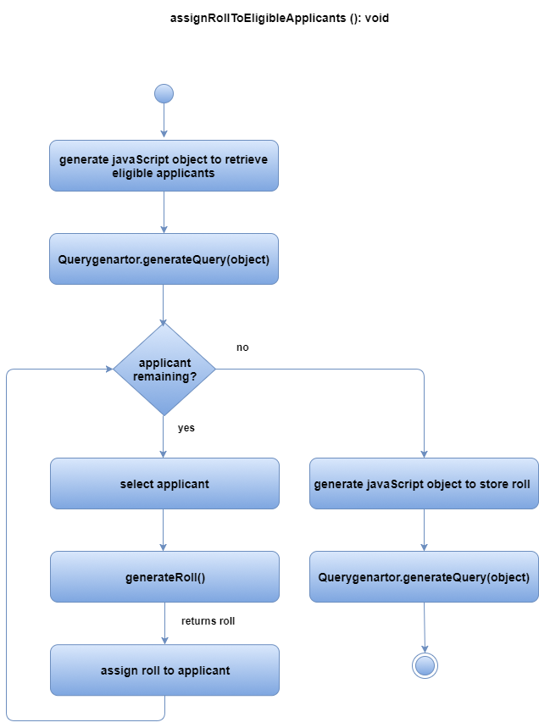

Figure 164 assignRollToEligibleApplicants() of RollGenerator

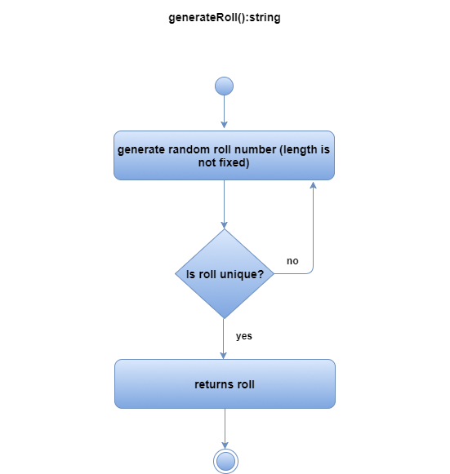

Figure 165 generateRoll() of RollGenerator

Figure 166-167 show UML activity diagrams for Receptionist class.

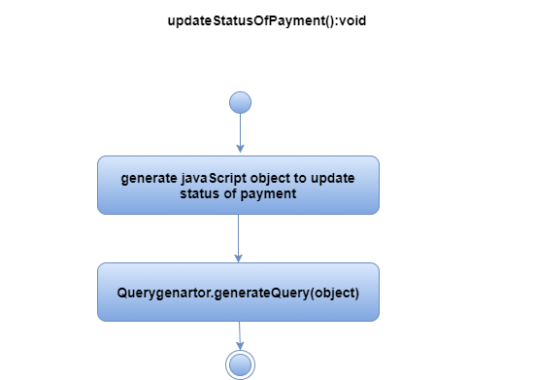

Figure 166 updateStatusOfPayment() of Receptionist

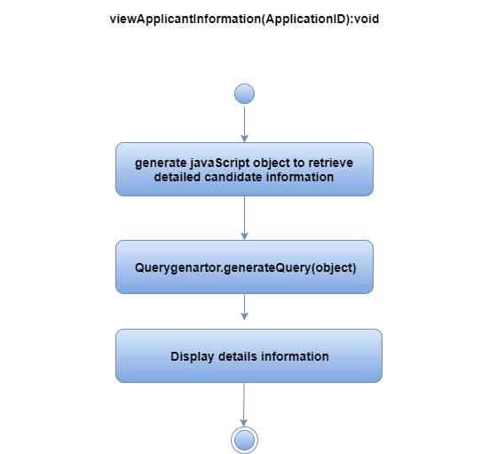

Figure 167 viewApplicantInformation() of Receptionist

## 3.4 Describe Persistent Data Sources and Identify the Classes required to Manage Them

For PGDIT Automation System we will use MySQL Database as data source and DatabaseHandler class is required to manage the database (shown in figure 168).

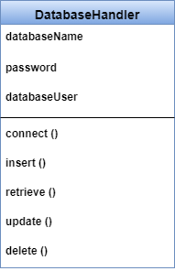

Figure 168 DatabaseHandler class

## 3.5 Develop and Elaborate Behavioral Representations for a Class or Component

During component-level design, it is sometimes necessary to model the behavior of a design class. For this purpose state diagram can be used. A state diagram is an illustration of the states an object can attain as well as the transitions between those states

Figure 169 shows state diagram of the Applicant class.

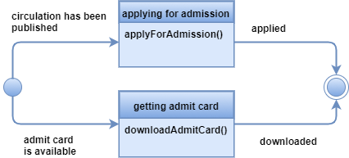

Figure 169 State Diagram of the Applicant class

Figure 170 shows state diagram of the Authentication class.

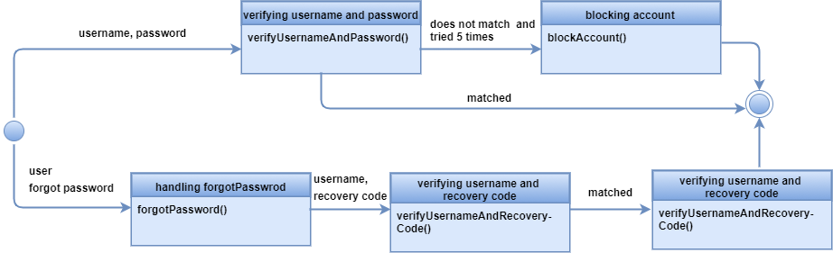

Figure 170 State Diagram of the Authentication class

Figure 171 shows state diagram of the User class.

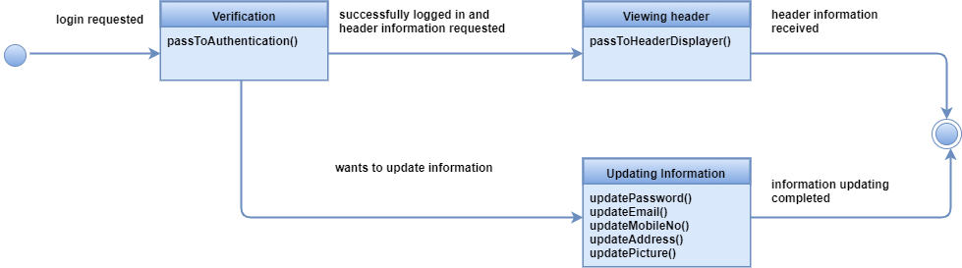

Figure 171 state diagram of the Authentication class

Figure 172 shows state diagram of the HeaderDisplayer class.

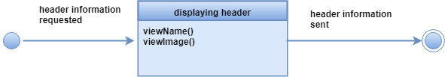

Figure 172 State Diagram of the HeaderDisplayer class

Figure 173 shows state diagram of the ProgramChairperson class.

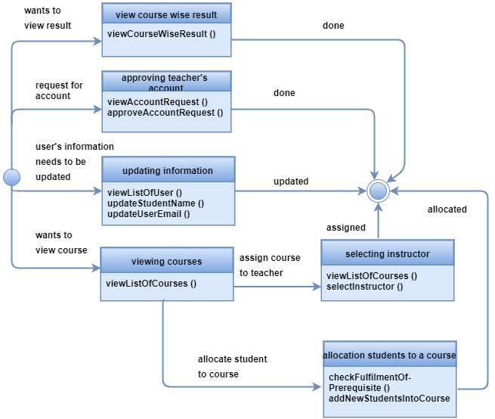

Figure 173 State Diagram of the ProgramChairperson class

Figure 174 shows state diagram of the ExamController class.

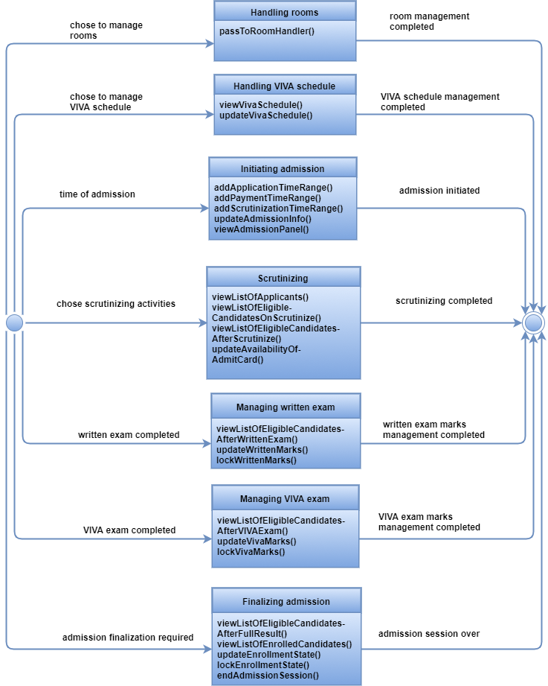

Figure 174 State Diagram of the ExamController class

Figure 175 shows state diagram of the RoomHandler class.

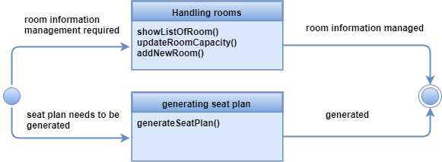

Figure 175 State Diagram of the RoomHandler class

Figure 176 shows state diagram of the Receptionist class.

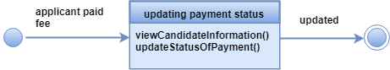

Figure 176 State Diagram of the Receptionist class

Figure 177 shows state diagram of the Scrutinizer class.

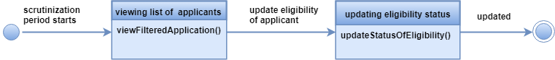

Figure 177 State Diagram of the Scrutinizer class

Figure 178 shows state diagram of the RollGenerator class.

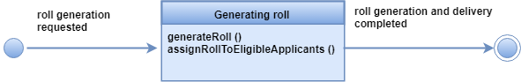

Figure 178 State Diagram of the RollGenerator class

Figure 179 shows state diagram of the Teacher class.

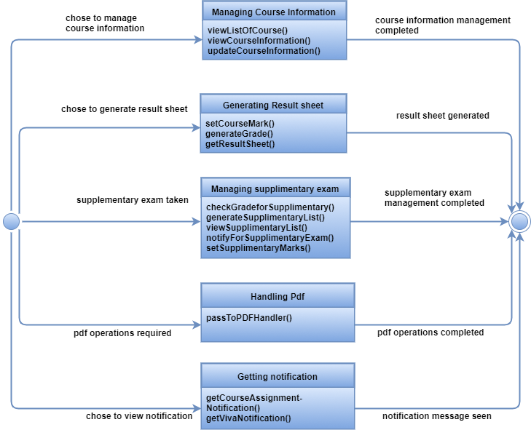

Figure 179 State Diagram of the Teacher class

Figure 180 shows state diagram of the PDFHandler class.

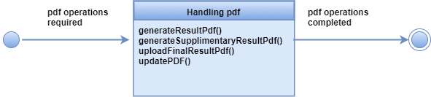

Figure 180 State Diagram of the PDFHandler class

Figure 181 shows state diagram of the Student class.

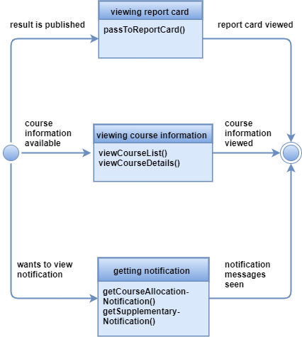

Figure 181 State Diagram of the Student class

Figure 182 shows state diagram of the ReportCard class.

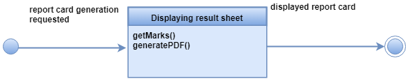

Figure 182 State Diagram of the ReportCard class

## 3.6 Elaborate Deployment Diagrams to Provide Additional Implementation Detail

Deployment diagrams are represented in descriptor form. In this form, major system functions are represented within the context of the computing environment that will house them.

Figure 183 shows deployment diagram of PGDIT Automation System.

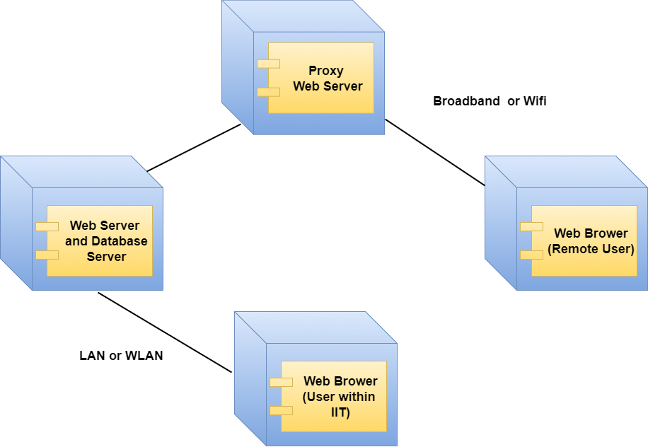

Figure 183 Deployment Diagram of PGDIT Automation System

# Chapter 4. User Interface Design

User interface design creates an effective communication medium between a human and a computer. User Interface (UI) Design focuses on anticipating what users might need to do and ensuring that the interface has elements that are easy to access, understand, and use to facilitate those actions.

## 4.1 Interface Analysis

We divide interface analysis into following parts:

1. User Analysis
2. Task Analysis

### 4.1.1 User Analysis

User analysis helps us to know who the end users are, what is likely to motivate and please them, how they can be grouped into different user classes or profiles, what their mental models of the system are, and how the user interface must be characterized to meet their needs. From the requirements specification, we have found the following users for PGDIT Automation System:

* Teacher
* Student
* Program Chairperson
* Applicant
* Exam Controller
* Scrutinizer
* Receptionist

Table 2 Analyzing Teacher

|  |  |
| --- | --- |
| Teacher | |
| Work type | Trained Professionals |
| Educational Level | Masters |
| Learning capability | Training |
| Skills | Above Average |
| Age | 25-65 |
| Domain expert | Yes |
| Application expert | No |
| Office hour | Normal |
| Frequency of use | Occasionally |
| Consequence of a mistake | Low |
| General computer experience | Yes |
| Want to know about technology that sits behind the interface | No |

Table 3 Analyzing Student

|  |  |
| --- | --- |
| Student | |
| Educational Level | Honors |
| Learning capability | Training |
| Skills | Average |
| Age | 22-40 |
| Application expert | No |
| Frequency of use | Occasionally |
| Consequence of a mistake | Low |
| General computer experience | Yes |
| Want to know about technology that sits behind the interface | No |

Table 4 Analyzing Program Chairperson

|  |  |
| --- | --- |
| Program Chairperson | |
| Work type | Trained Professionals |
| Educational Level | Masters |
| Learning capability | Training |
| Skills | Above Average |
| Age | 25-65 |
| Domain expert | Yes |
| Application expert | No |
| Office hour | Normal |
| Frequency of use | Occasionally |
| Consequence of a mistake | Low |
| General computer experience | Yes |
| Want to know about technology that sits behind the interface | No |

Table 5 Analyzing Applicant

|  |  |
| --- | --- |
| Applicant | |
| Educational Level | Honors |
| Learning capability | Training |
| Skills | Average |
| Age | 22-40 |
| Application expert | No |
| Frequency of use | Occasionally |
| Consequence of a mistake | Low |
| General computer experience | Yes |
| Want to know about technology that sits behind the interface | No |

Table 6 Analyzing Exam Controller

|  |  |
| --- | --- |
| Exam Controller | |
| Work type | Trained Professionals |
| Educational Level | Masters |
| Learning capability | Training |
| Skills | Above Average |
| Age | 25-65 |
| Domain expert | Yes |
| Application expert | No |
| Office hour | Normal |
| Frequency of use | Occasionally |
| Consequence of a mistake | High |
| General computer experience | Yes |
| Want to know about technology that sits behind the interface | No |

Table 7 Analyzing Scrutinizer

|  |  |
| --- | --- |
| Scrutinizer | |
| Work type | Trained Professionals |
| Educational Level | Masters |
| Learning capability | Training |
| Skills | Above Average |
| Age | 25-65 |
| Domain expert | Yes |
| Application expert | No |
| Office hour | Normal |
| Frequency of use | Occasionally |
| Consequence of a mistake | Medium |
| General computer experience | Yes |
| Want to know about technology that sits behind the interface | No |

Table 8 Analyzing Receptionist

|  |  |
| --- | --- |
| Receptionist | |
| Work type | Clerical |
| Educational Level | Masters |
| Learning capability | Training |
| Skills | Average |
| Age | 25-50 |
| Domain expert | Yes |
| Application expert | No |
| Office hour | Normal |
| Frequency of use | Occasionally |
| Consequence of a mistake | Low |
| General computer experience | Yes |
| Want to know about technology that sits behind the interface | No |

### 4.1.2 Task Analysis

In this step we identify and analyze the tasks of every users separately.

* Applicants: The tasks of applicants are given below:

1. Apply for admission

Goal: Apply for admission by filling up application form.  
Precondition: Submission of application has been activated.   
Sub-tasks:

1. fill up form
2. receive application ID
3. Download admit card

Goal: Download admit card of admission test.  
Precondition:

1. eligible for admission test
2. application ID and date of birth are valid
3. admit card is available

Sub-tasks:

1. provide application ID and date of birth
2. get admit card

* Program Chairperson: Program Chairperson has following tasks:

1. Create student account

Goal: Create account for new students.  
Precondition: Must be logged in as program chairperson.   
Sub-tasks:

1. view list of students who paid admission fee
2. create account
3. Enroll student in course

Goal: Allocate course to a student.  
Precondition: Must be logged in as program chairperson.   
Sub-tasks:

1. check students who fulfill prerequisite
2. select students
3. notify selected students
4. Assign course to teacher

Goal: Select a teacher as instructor of a course.  
Precondition: Must be logged in as program chairperson.   
Sub-tasks:

1. view list of teachers
2. select teacher
3. notify teacher

1. Update user’s email

Goal: Update any user’s email address.  
Precondition: Must be logged in as program chairperson.   
Sub-tasks:

1. select user
2. update email
3. Update student’s name

Goal: Update any student’s name.  
Precondition: Must be logged in as program chairperson.   
Sub-tasks:

1. select student
2. update name
3. Approve teacher’s account

Goal: Approve teacher’s account request.  
Precondition: Must be logged in as program chairperson.   
Sub-tasks:

1. check account requests
2. approve requests
3. View result

Goal: View course wise marks or result of a particular student.  
Precondition: Must be logged in as program chairperson.   
Sub-tasks:

1. select category
2. view result

* Exam Controller: The tasks of Exam Controller are given below:

1. Introduce new admission  
   Goal: Setup new admission session and publish circular.  
   Precondition: Must be logged in.  
   Sub-tasks:
2. provide timeline for applying online
3. provide timeline for payment
4. provide timeline for scrutinization
5. Manage room information

Goal: Keep information about rooms of the institution up-to-date.

Precondition: Must be logged in.

Sub-tasks:

1. view information of all rooms
2. change capacity of a room
3. add new room
4. Initiate written admission exam

Goal: Generate seat plan and make admit cards available for download.

Precondition: Must be logged in.

Sub-tasks:

1. generate seat plan for written exam
2. turn off scrutinizing process
3. make admit cards available for download
4. End written admission exam

Goal: Prepare result of written admission exam.

Precondition: Must be logged in.

Sub-tasks:

1. provide marks of written exam
2. lock marks of written exam
3. Initiate VIVA admission exam

Goal: Generate seat plan and VIVA schedule.

Precondition: Must be logged in.

Sub-tasks:

1. generate seat plan for VIVA exam
2. generate VIVA schedule
3. notify teachers about VIVA shift
4. End VIVA admission exam

Goal: Prepare result of VIVA admission exam.

Precondition: Must be logged in.

Sub-tasks:

1. provide marks of VIVA exam
2. lock marks of VIVA exam
3. Finalize admission exam

Goal: Finalize admission examination and complete enrollment of students.

Precondition: Must be logged in.

Sub-tasks:

1. publish merit and waiting list
2. enroll students
3. end enrollment session
4. end admission session
5. Finalize term examination result

Goal: Finalize term examination results.

Precondition: Must be logged in.

Sub-tasks:

1. lock marks providing session
2. upload final result for Exam Controller and Program Chairperson

* Teacher: Teacher has following tasks:

1. Edit Course Information

Goal: Change existing information or introduce new information about the course.  
Precondition: Must be logged in.  
Sub-tasks:

1. view course list
2. select Course
3. change information
4. lock course information
5. Generate Result Sheet

Goal: Generate result sheet of students with marks obtained in the respective teacher’s course.

Precondition: Must be logged in.

Sub-tasks:

1. input marks obtained by individual students
2. generate Result sheet
3. lock result sheet
4. Take Supplementary Exam

Goal: Provide supplementary Exam results

Precondition: Must be logged in. Exam result sheet must be available.

Sub-tasks:

1. set-up a criteria for supplementary exam.
2. view supplementary candidates’ list
3. notify candidates
4. input marks of supplementary exam
5. generate supplementary result sheet
6. lock supplementary result sheet
7. Upload Result Sheet PDF

Goal: Upload pdf of result sheet in respective course and make it available for download.

Precondition:

1. Must be logged in.
2. Exam result sheet must be available.
3. Supplementary result sheet are to be available if any student had been required to appear.

Sub-tasks:

1. generate Result Sheet PDF
2. generate Supplementary Result Sheet PDF
3. upload PDF to the server
4. make PDF’s available for download

* Student: Student has following tasks:

1. View result sheet

Goal: View report card of semesters completed so far.

Precondition: Must be logged in.

Sub-tasks:

1. invoke generation of report card
2. download report card
3. View course information

Goal: View information of all courses in the program.

Precondition: Must be logged in.

Sub-tasks:

1. view list of courses
2. view information of a specific course
3. Get notifications

Goal: Get course allocation and supplementary notification

Precondition: Must be logged in

Sub-tasks:

1. get course allocation notification
2. get supplementary notification

* Receptionist: The tasks of Receptionist are given below:

1. Update payment status

Goal: Update payment status of applications

Precondition: Must be logged in

Sub-tasks:

1. retrieve applications
2. update payment status of applications
3. View candidate information

Goal: View information of an application

Precondition: Must be logged in

Sub-tasks:

1. retrieve application
2. view details of application

## 4.2 Interface Design Steps

Interface design steps are shown in figure 184.

Figure 184 Interface Design Steps

### 4.2.1 Define Interface Objects and Actions

We identified following objects and actions for the user interface.

* External
  + Home

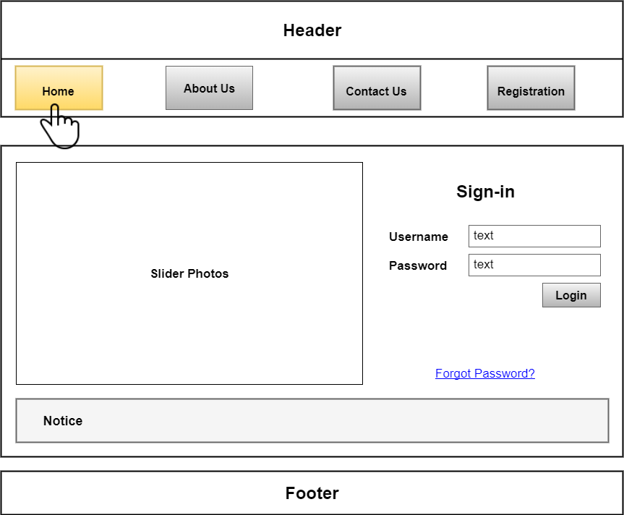

Figure 185 Home

* + About us

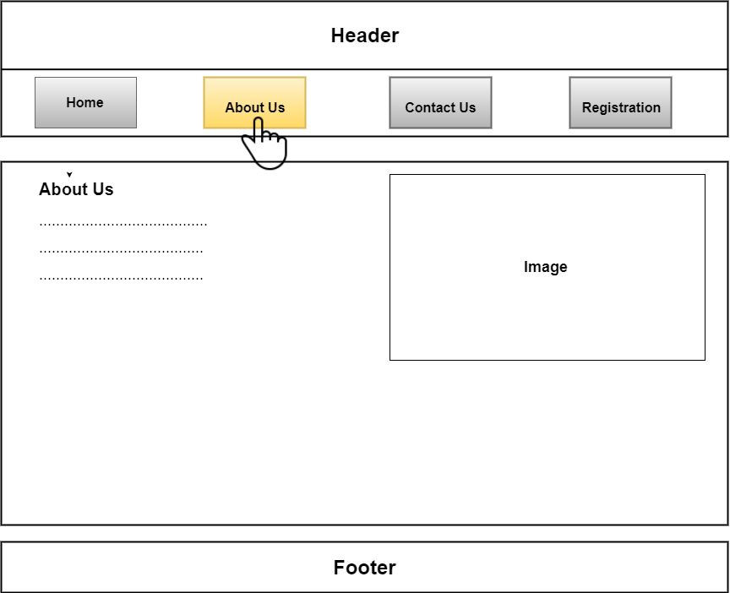

Figure 186 About us

* + Contact us

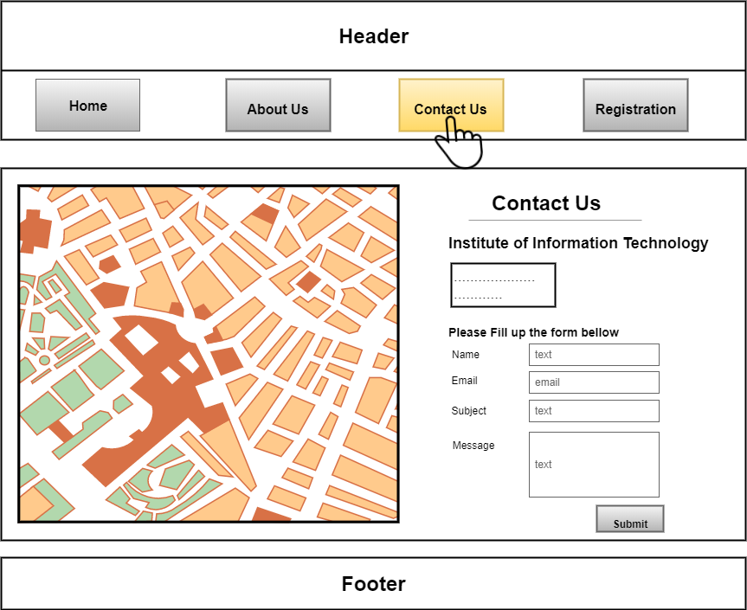

Figure 187 Contact us

* + Registration

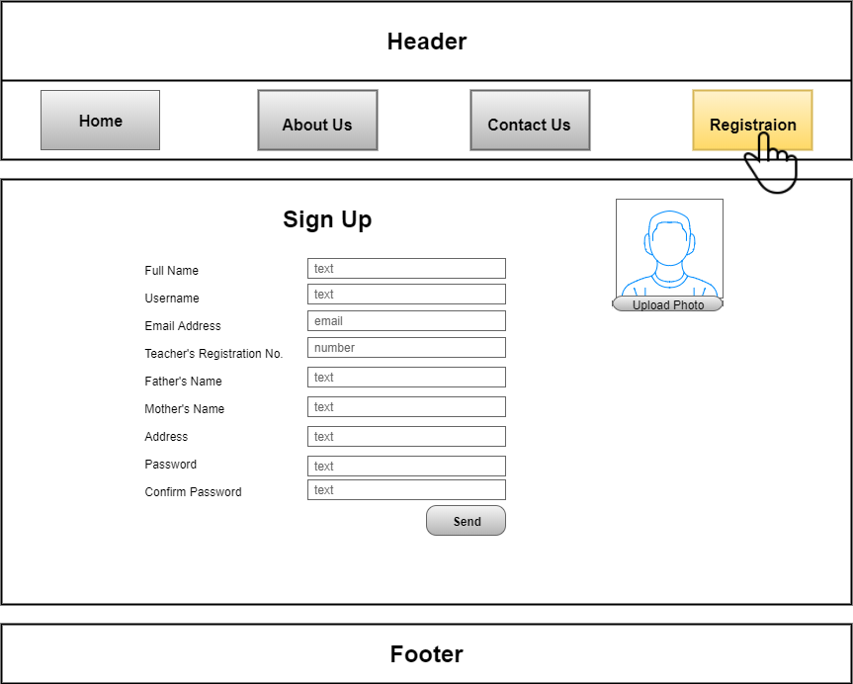

Figure 188 Registration

* + Forgot Password

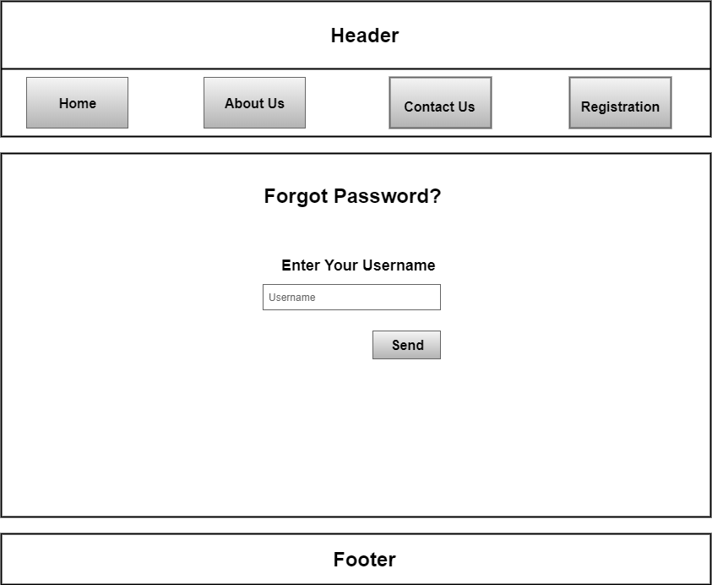

Figure 189 Forgot Password

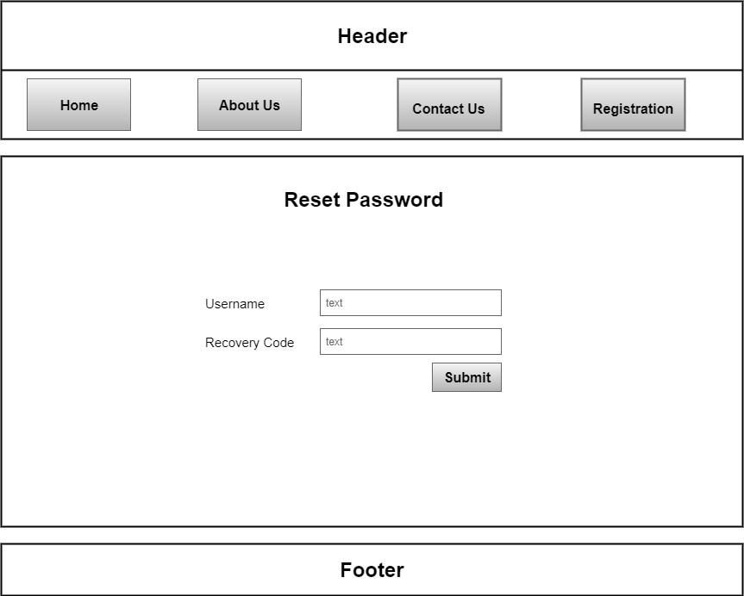

Figure 190 Reset Password

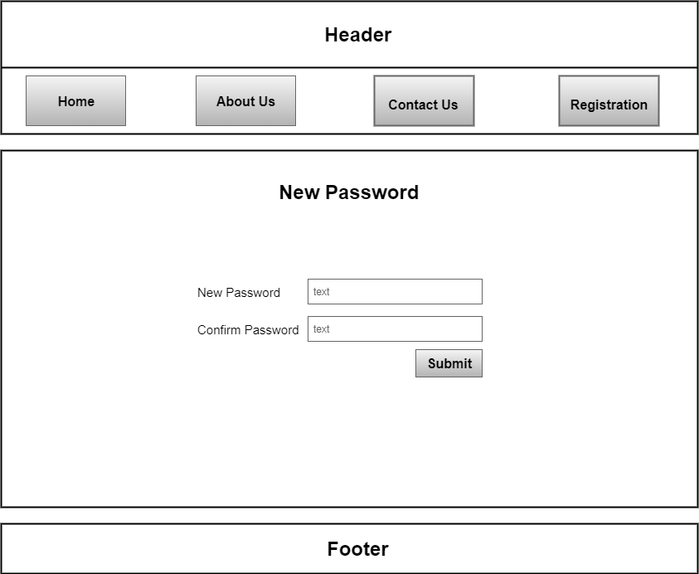

Figure 191 New Password

* + Apply For Admission

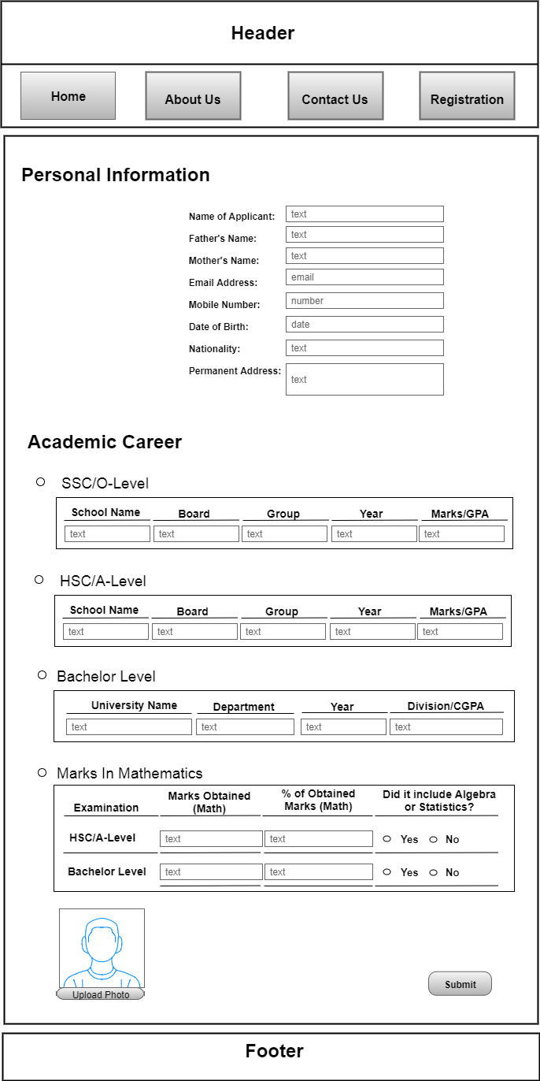

Figure 192 Admission form

* + Download Admit card

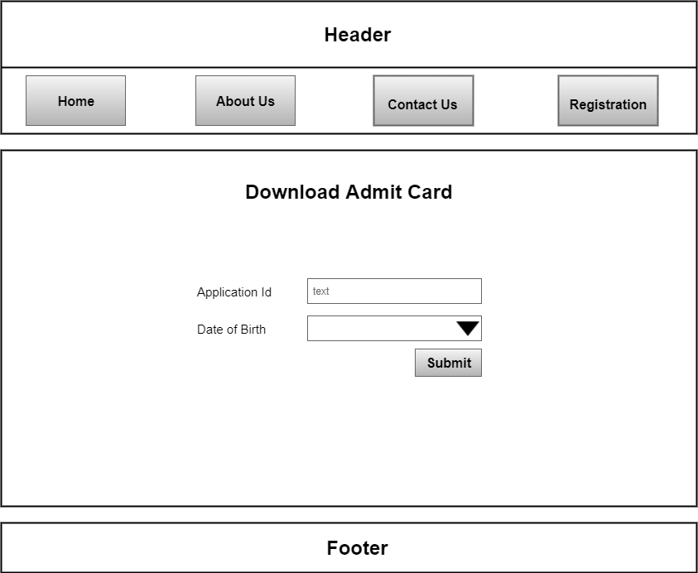

Figure 193 Download Admit Card

* Internal
  + Program Chairperson
    - Profile

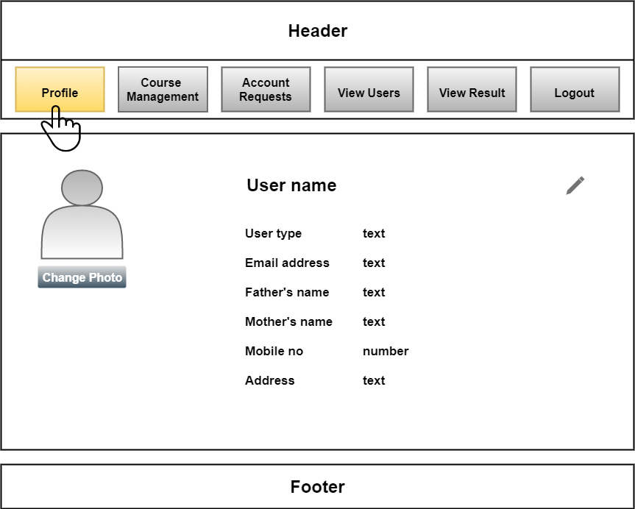

Figure 194 Profile of Program Chairperson

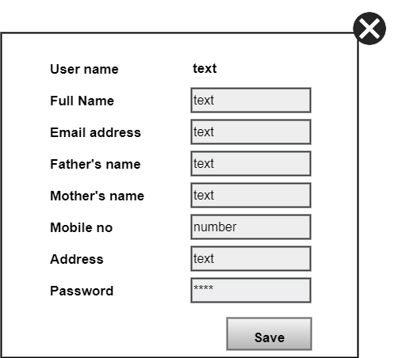

Figure 195 Update Profile

* + - Course Management

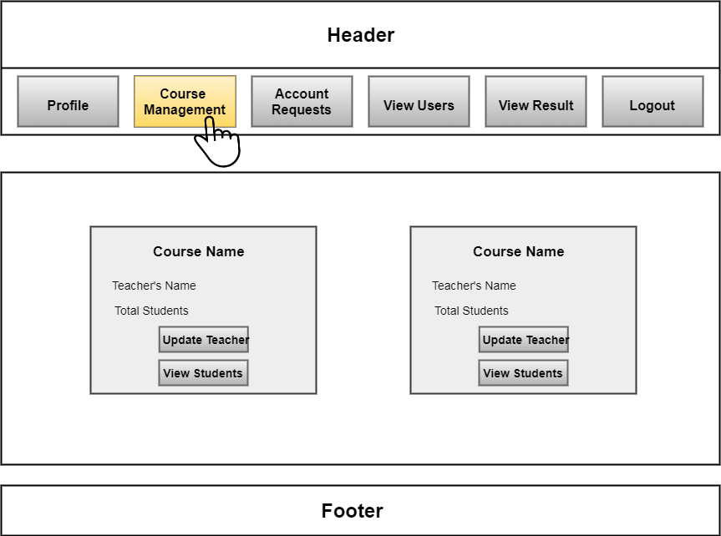

Figure 196 Course Management

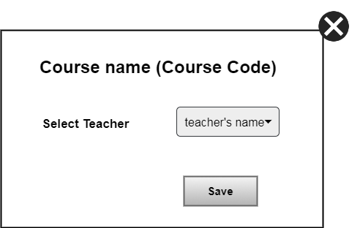

Figure 197 Select Teacher

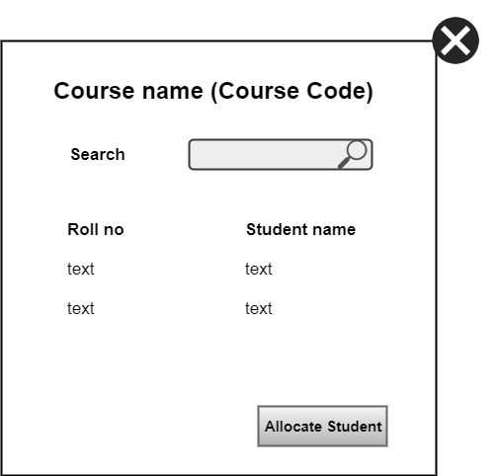

Figure 198 View Students of a Course

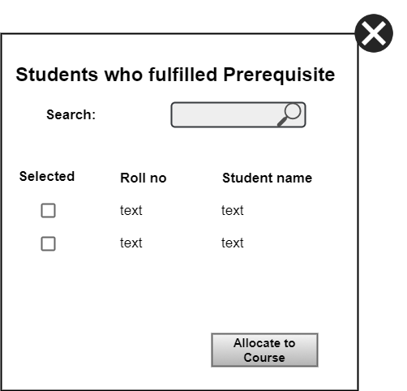

Figure 199 Allocate Students

* + - Account Requests

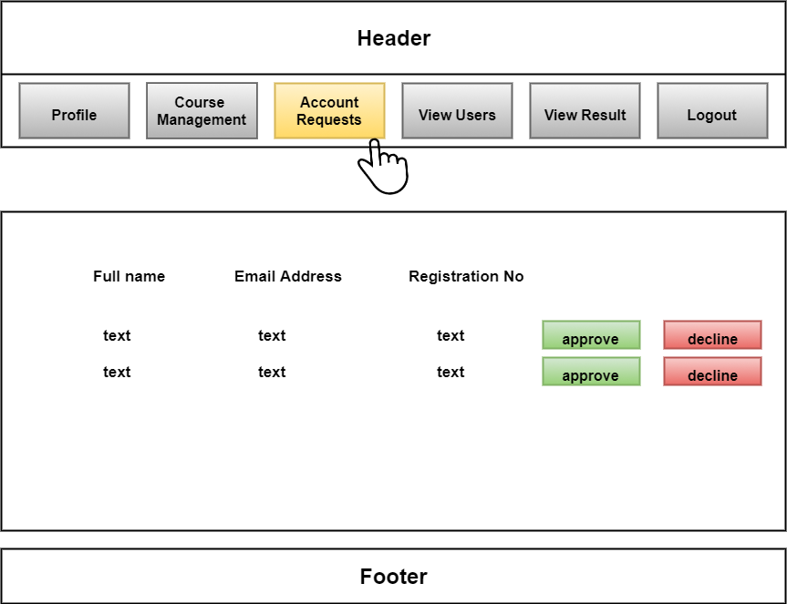

Figure 200 Account Requests

* + - View Users

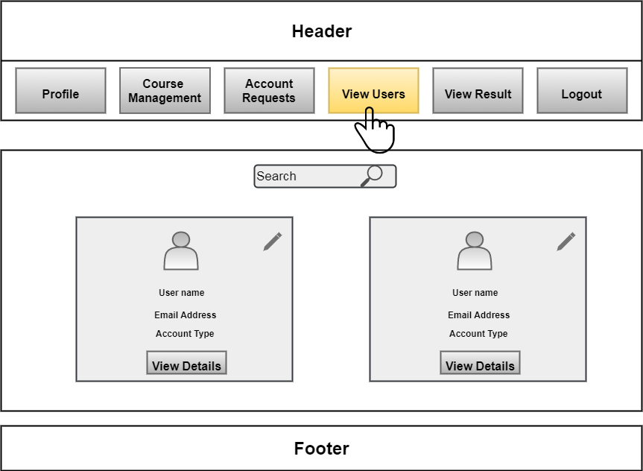

Figure 201 View Users

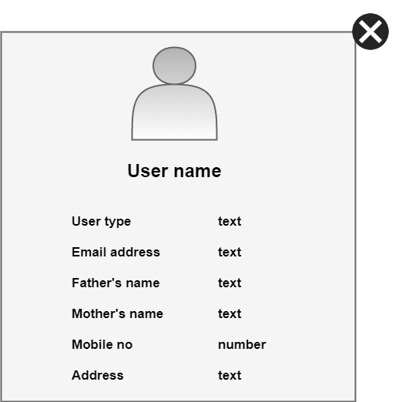

Figure 202 View User Details

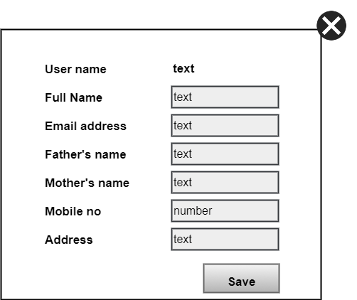

Figure 203 Edit User Information

* + - View Result
      * Course wise Result

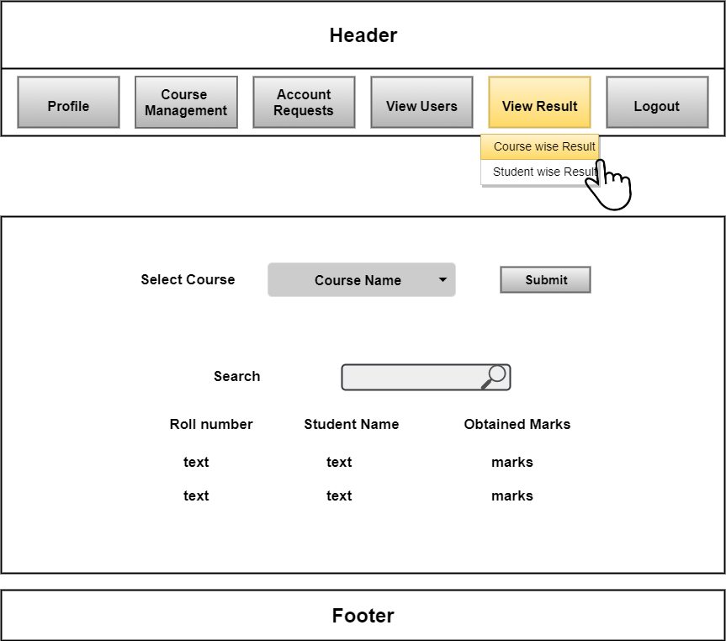

Figure 204 Course wise Result

* + - * Student wise Result

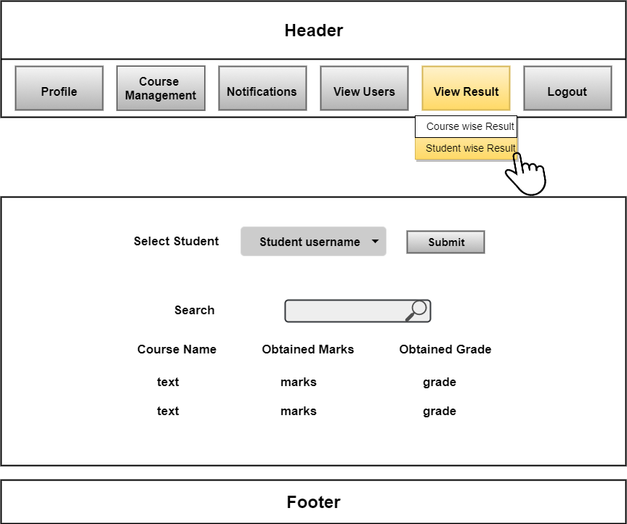

Figure 205 Student wise Result

* + Teacher
    - Profile

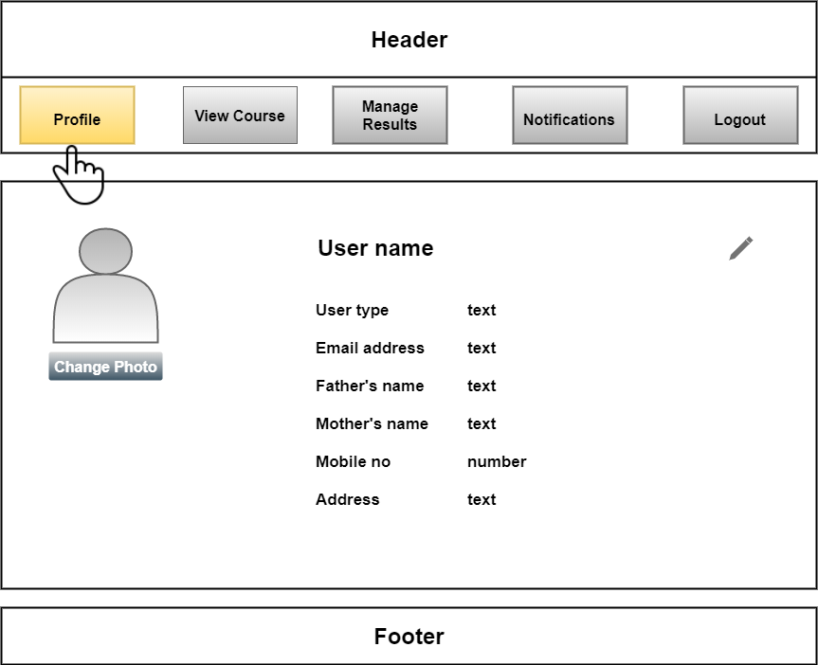

Figure 206 Teacher's Profile

* + - View Course

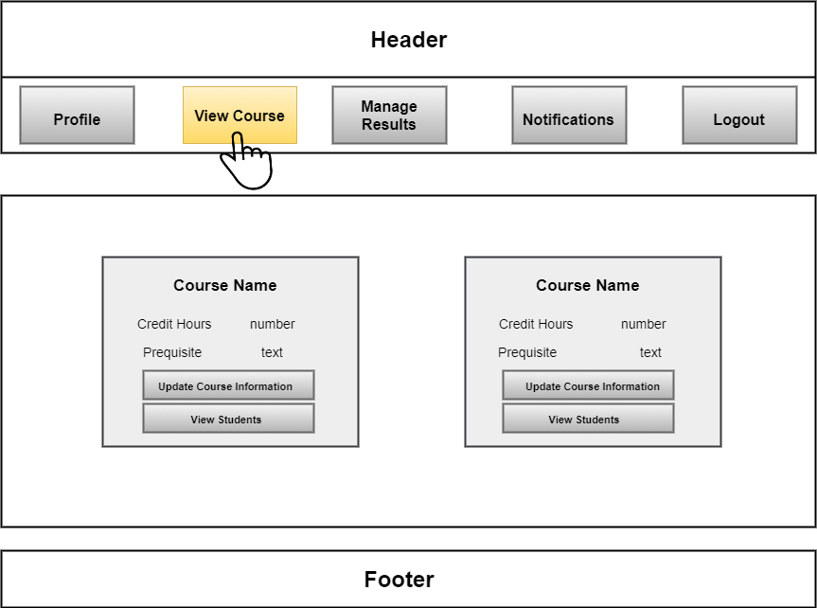

Figure 207 View Courses

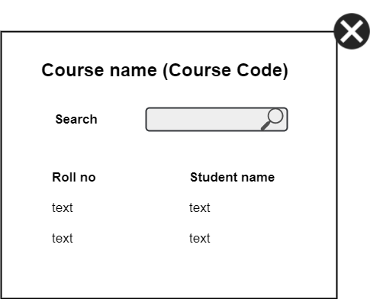

Figure 208 View Students

* + - Manage Results

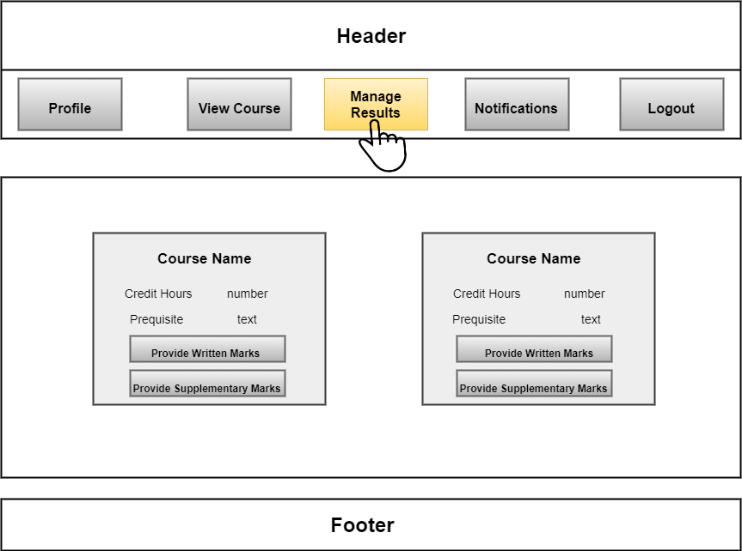

Figure 209 Manage Result

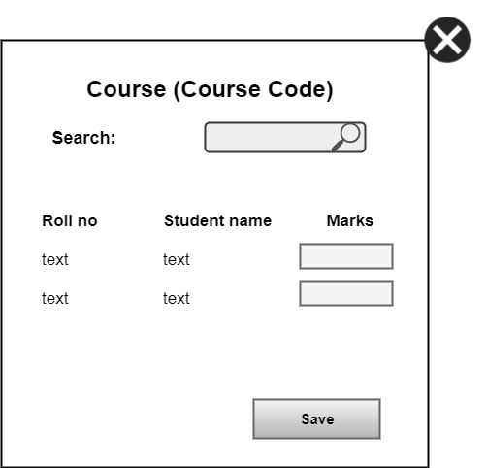

Figure 210 Provide Marks

* + - Notifications

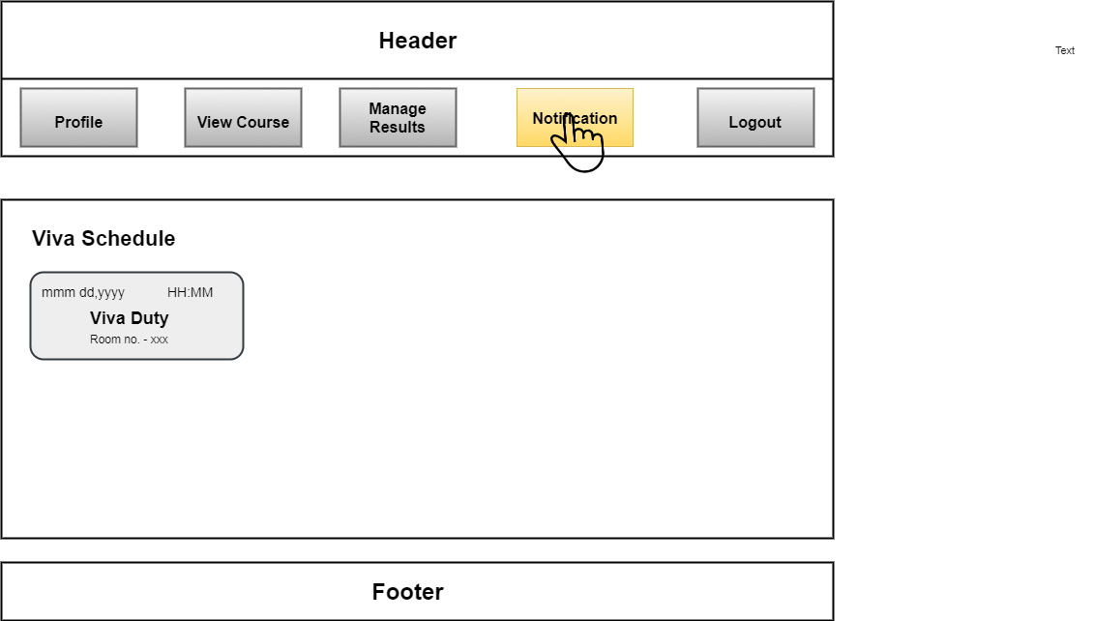

Figure 211 Notifications

* + Student
    - Profile

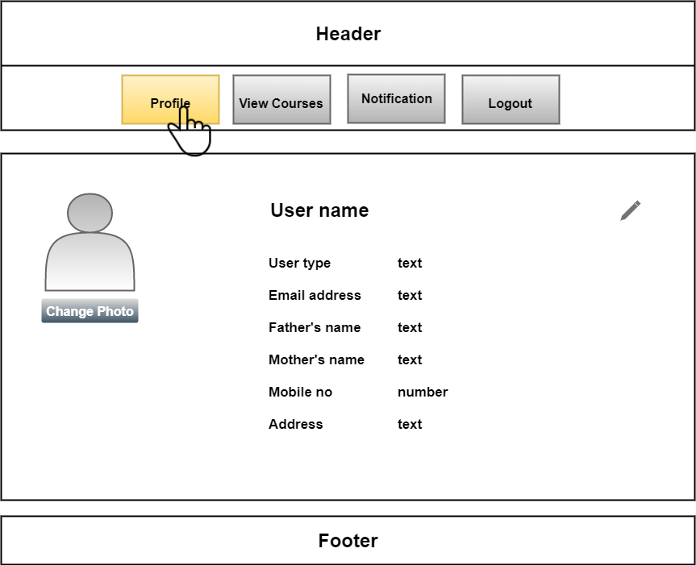

Figure 212 Student Profle

* + - Download Report Card

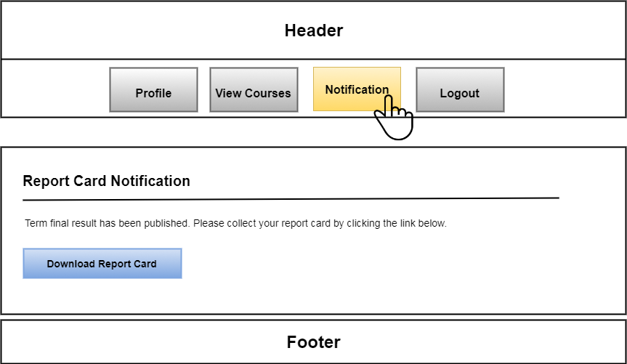

Figure 213 Download Report Card

* + - View Courses

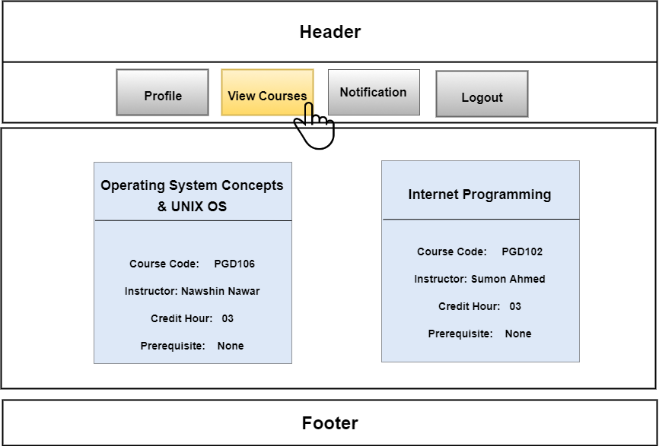

Figure 214 View Courses

* + Exam Controller
    - Profile

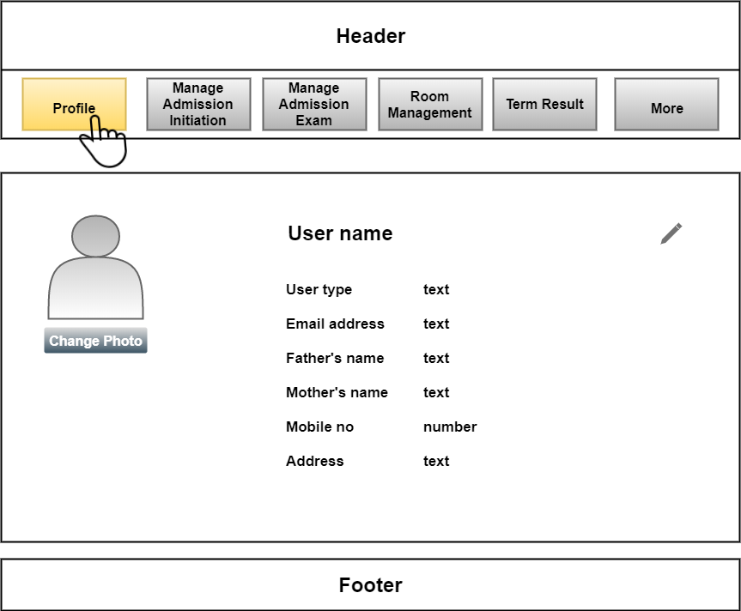

Figure 215 Exam Controller's Profile

* + - Manage Admission Initiation

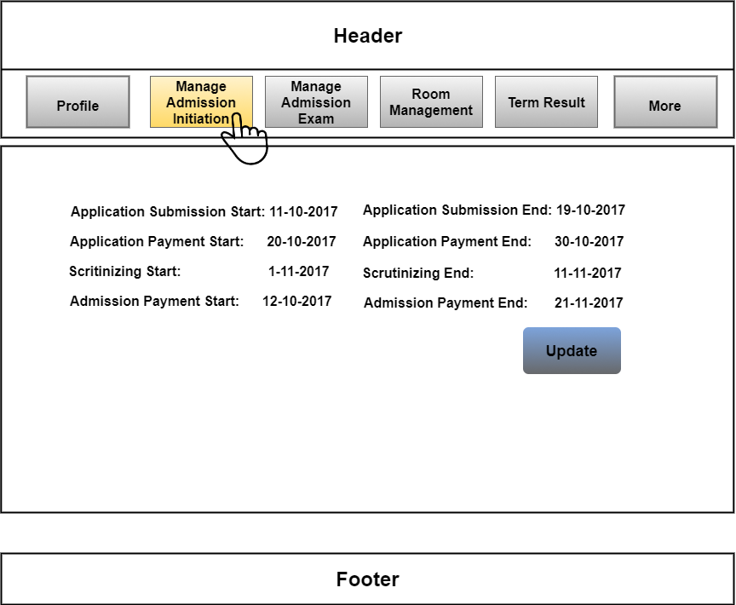

Figure 216 Manage Admission Initiation

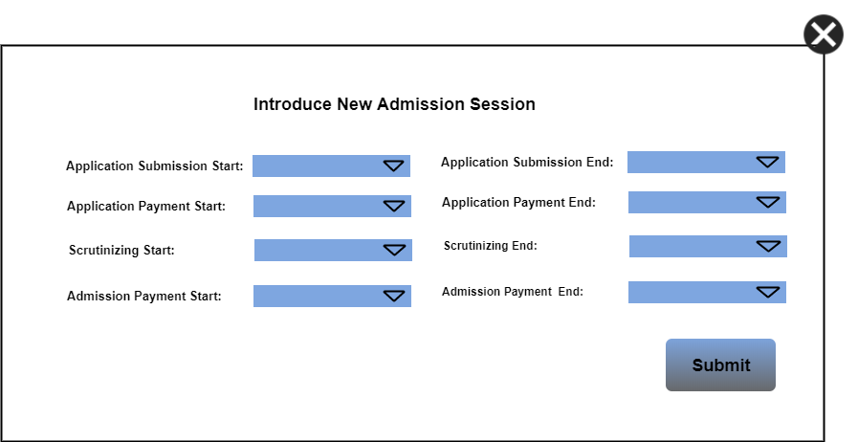

Figure 217 Setting New Admission

* + - Manage Admission Exam

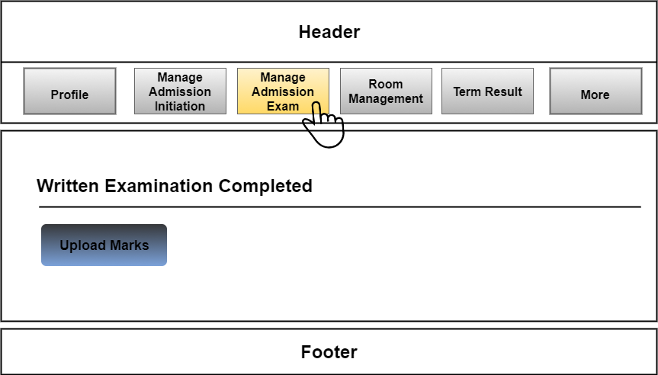

Figure 218 Manage Admission Exam

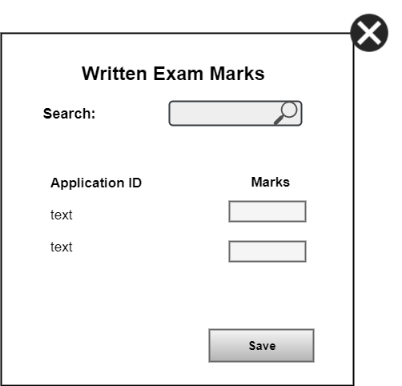

Figure 219 Provide Written Marks

* + - Room Management

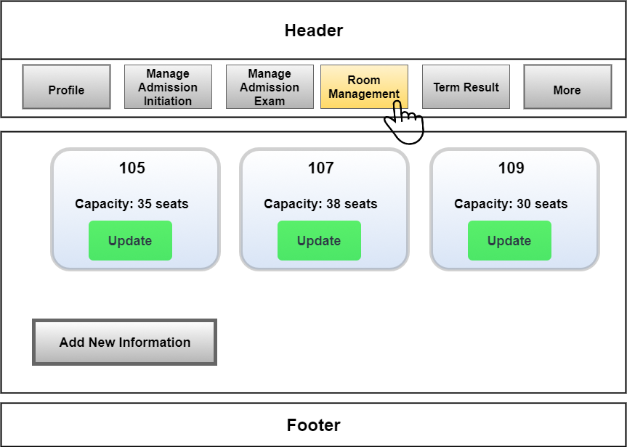

Figure 220 Room Management

* + - Term Result

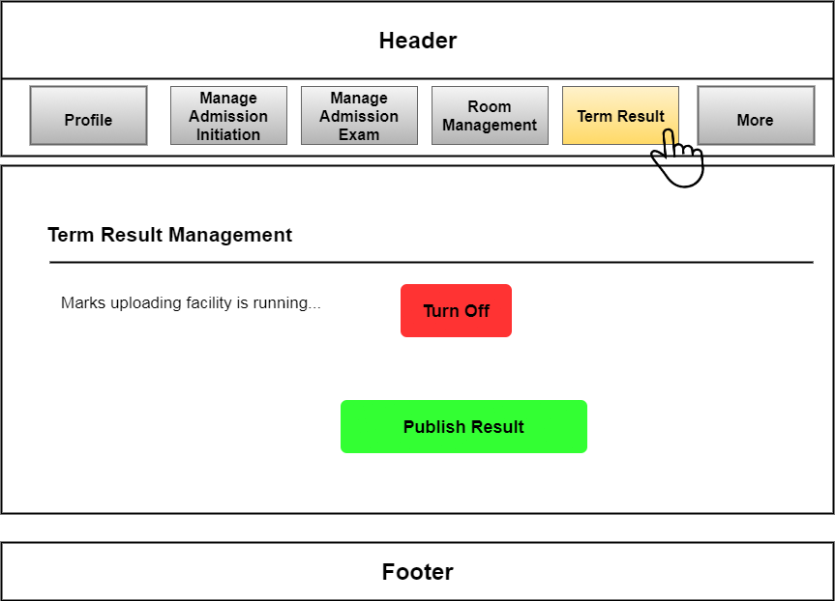

Figure 221 Term Result

* + - Update Signature

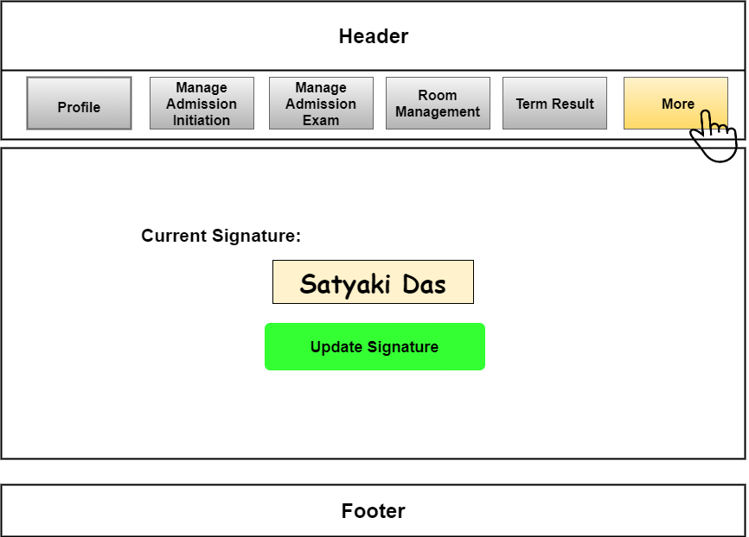

Figure 222 Update Signature

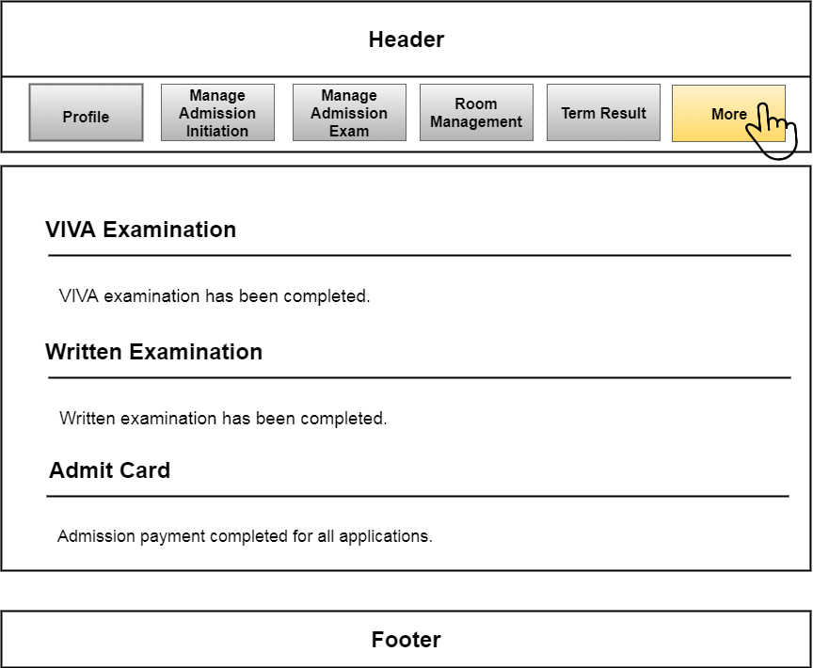

* + Receptionist
    - Profile

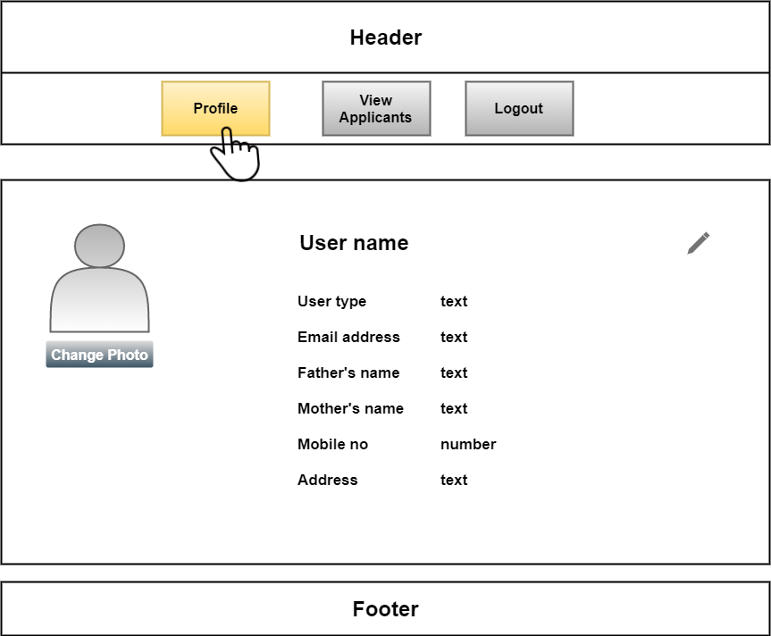

Figure 223 Receptionist Profile

* + - View Applicants

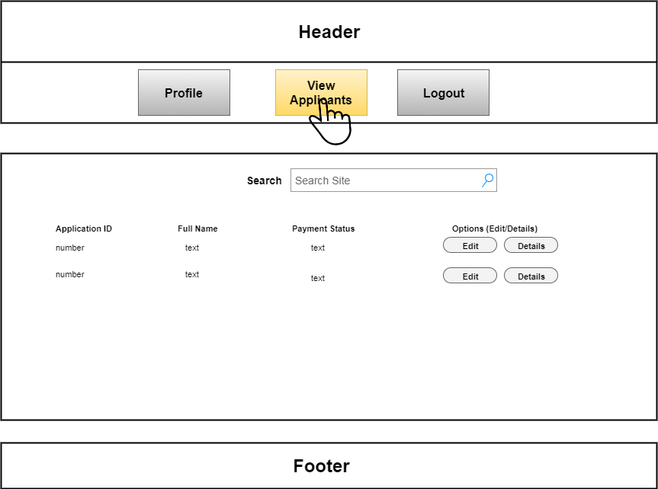

Figure 224 View Applicants

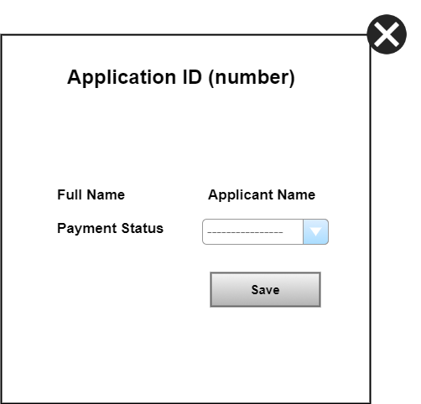

Figure 225 Update Payment Status

* + Scrutinizer
    - View Applicants

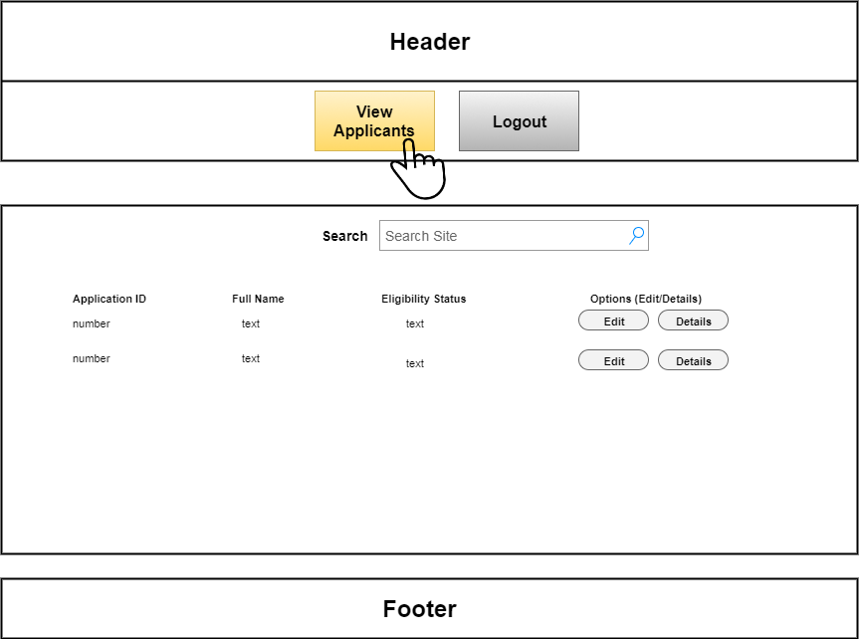

Figure 226 View Applicants (Scrutinizer)

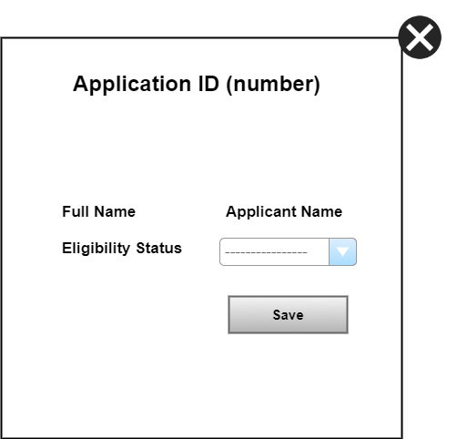

Figure 227 Update Eligibility Status

### 4.2.2 Define Events that will Cause the State of the User Interface to Change

External Object

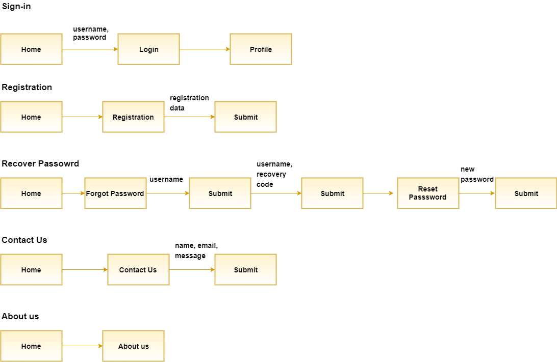

Scrutinizer

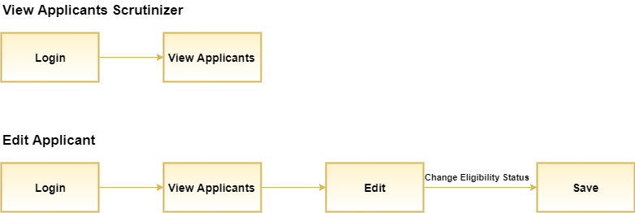

Program Chairperson

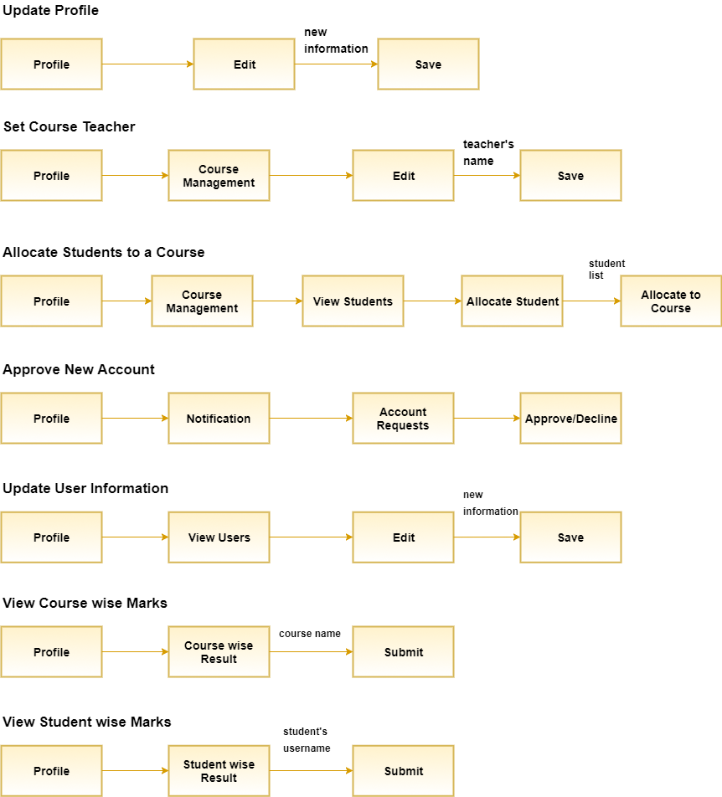

Receptionist

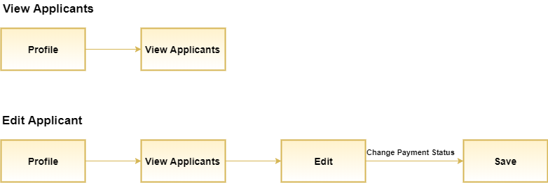

Teacher

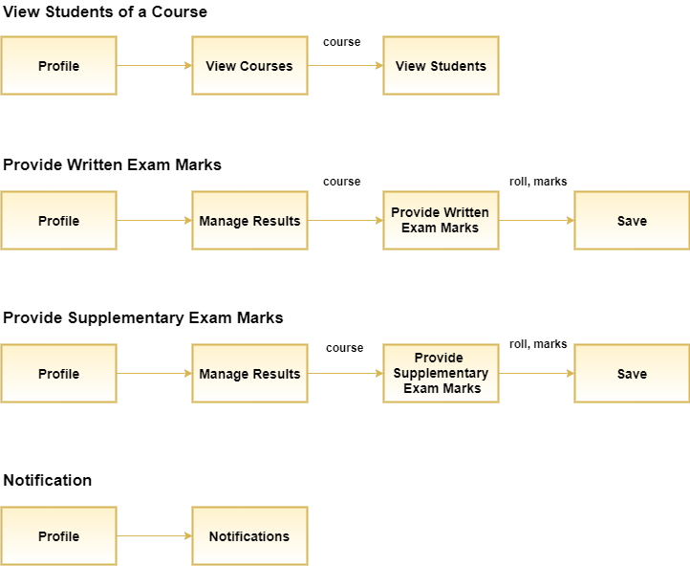

Student

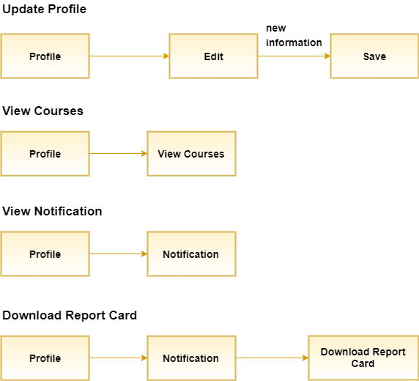

Exam Controller

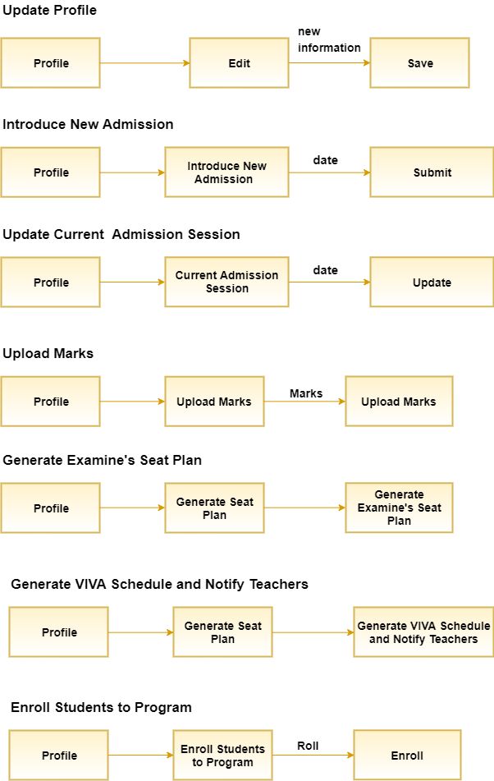

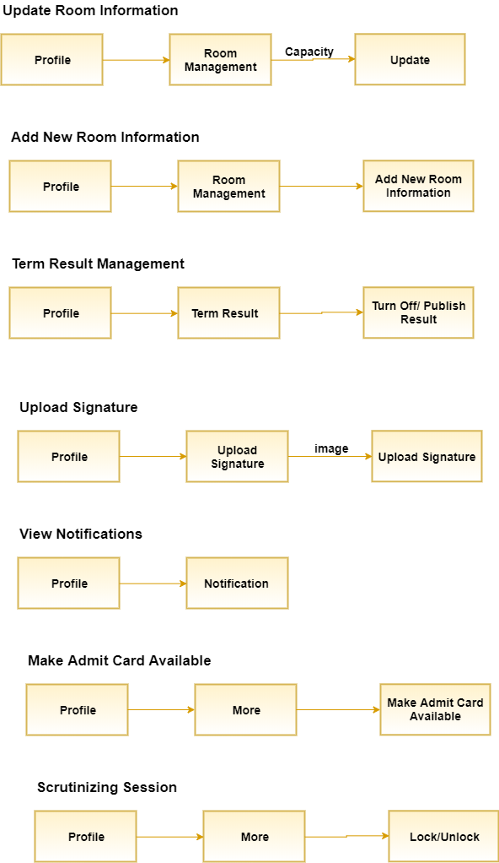

### 4.2.3 Depict Each Interface State as It Look to End User

Home Page

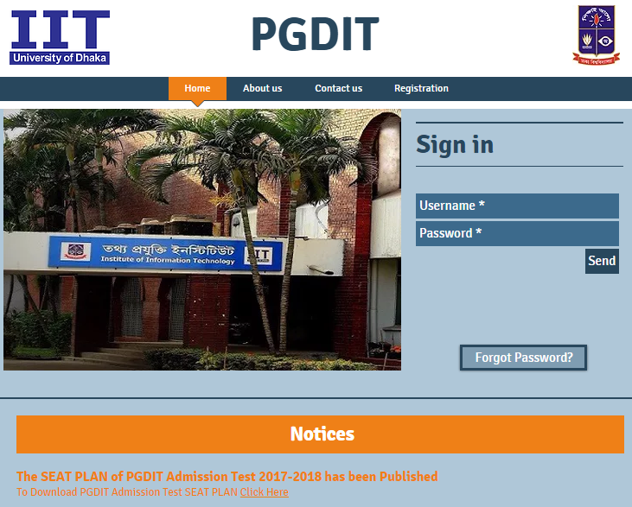

Figure 228 Home Page

Registration Page

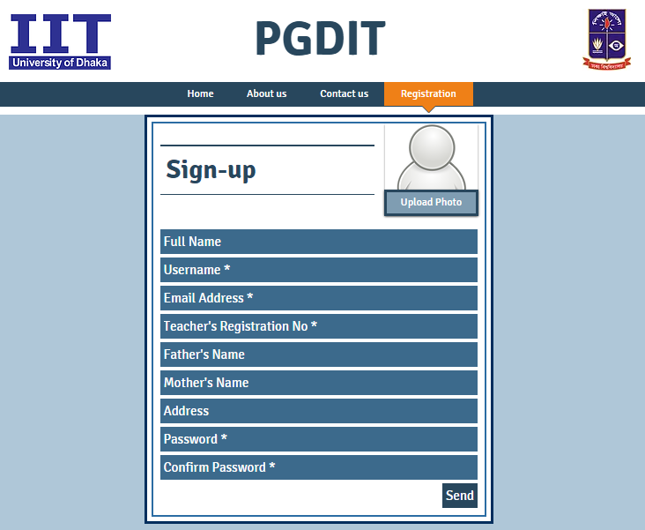

Figure 229 Registration Page

About us Page



Figure 230 About us Page

Contact us Page

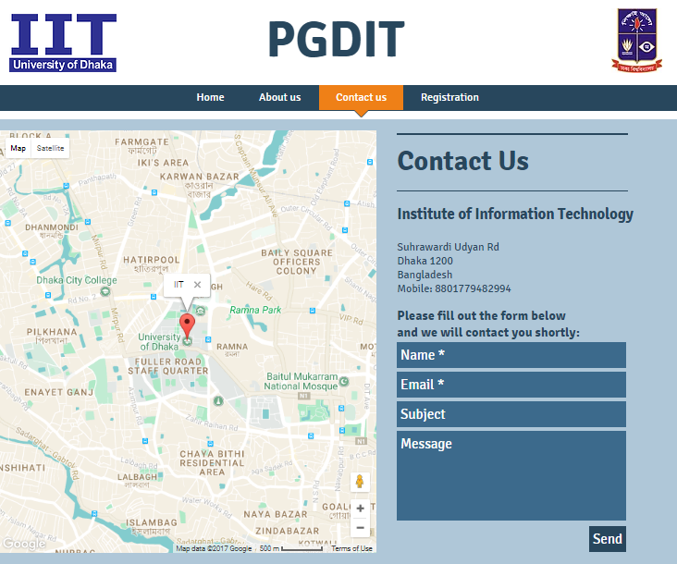

Figure 231 Contact us Page

Program Chairperson: Profile

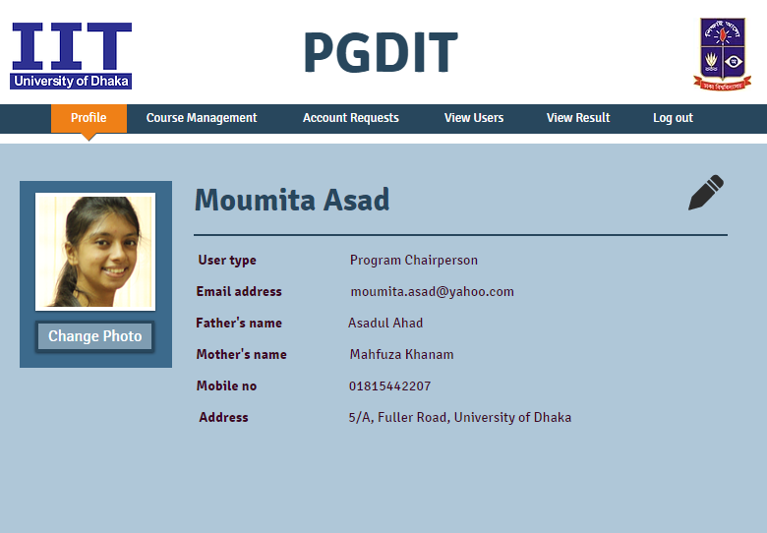

Figure 232 Program Chairperson:Profile

Program Chairperson: Course Management

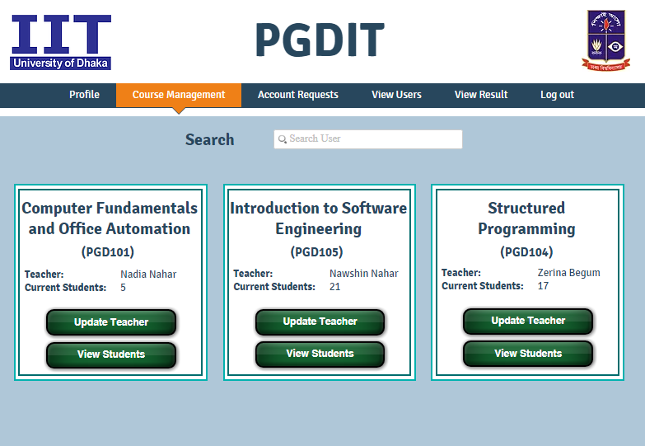

Figure 233Program Chairperson: Course Management

Program Chairperson: Account Requests

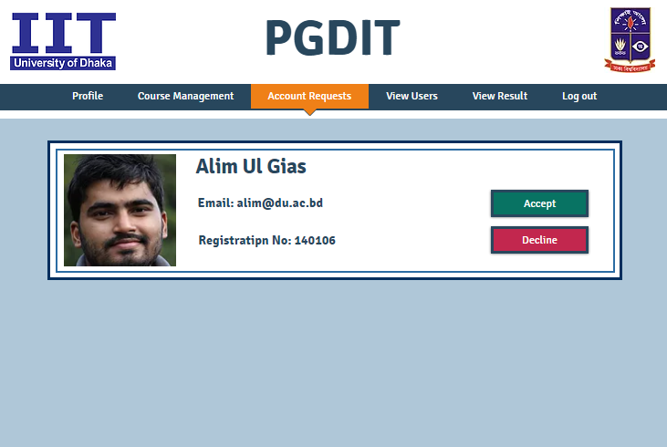

Figure 234 Program Chairperson: Account Requests

Program Chairperson: View Users

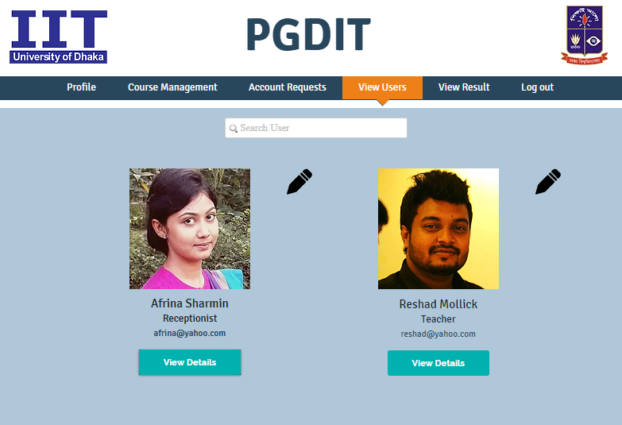

Figure 235 Program Chairperson: View Users

Teacher: Profile

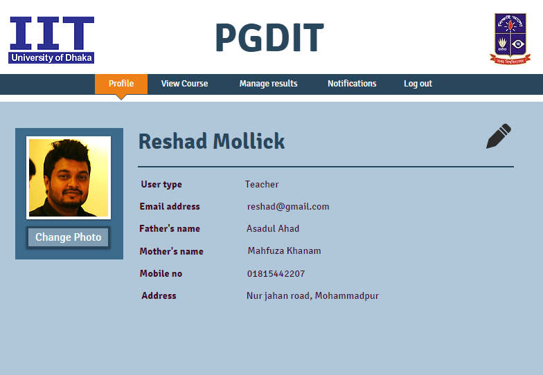

Figure 236 Teacher: Profile

Teacher: View Course

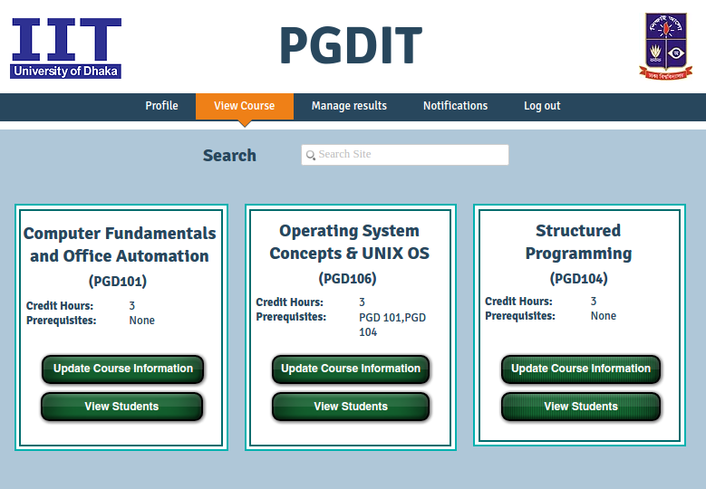

Figure 237 Teacher: View Course

Teacher: Manage Results

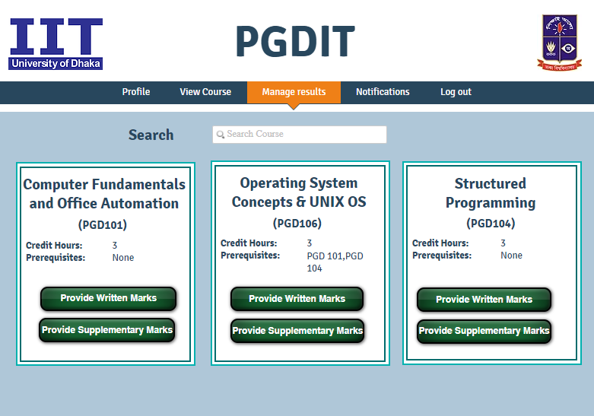

Figure 238 Teacher: Manage Results

Teacher: Notifications

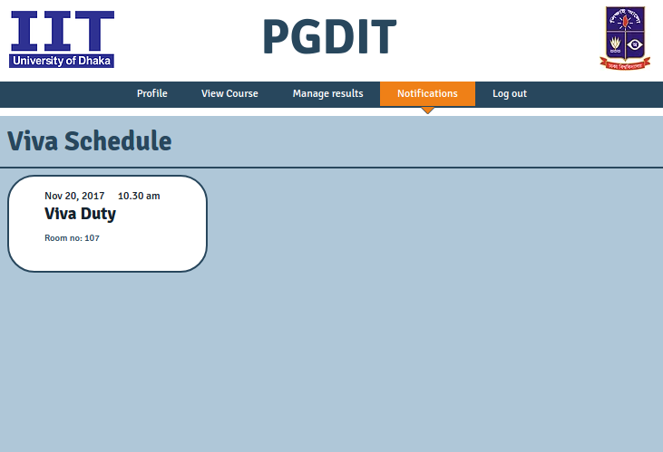

Figure 239 Teacher: Notifications

Exam Controller: Profile

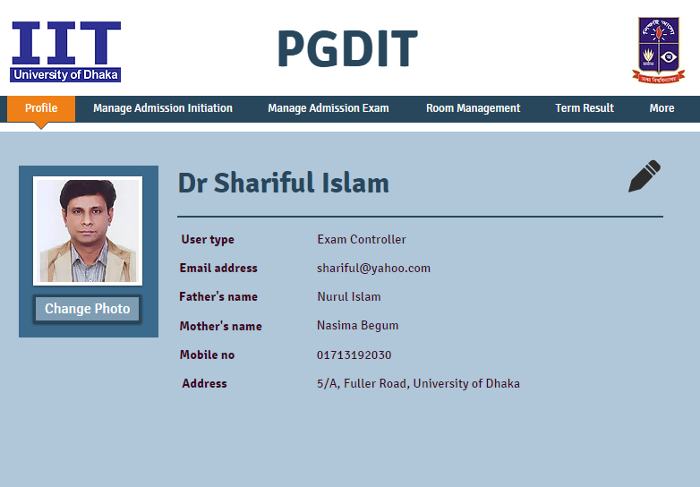

Figure 240 Exam Controller: Profile

Exam Controller: Introduce New Admission

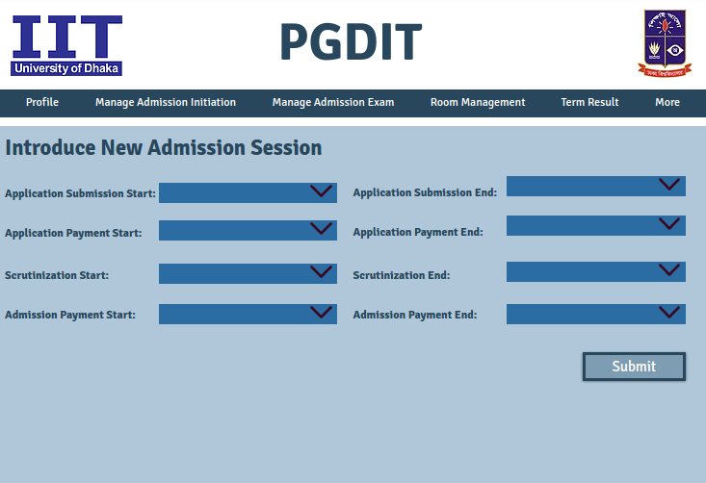

Figure 241 Exam Controller: Introduce New Admission

Exam Controller: Update Admission Information

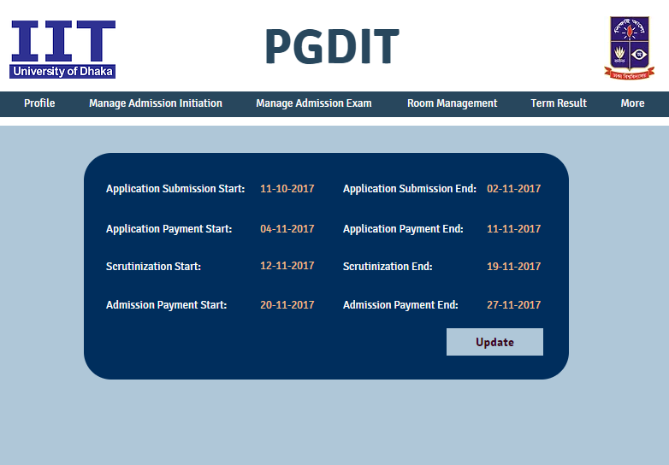

Figure 242Exam Controller: Update Admission Information

Exam Controller: Additional Admission Initiation Activities

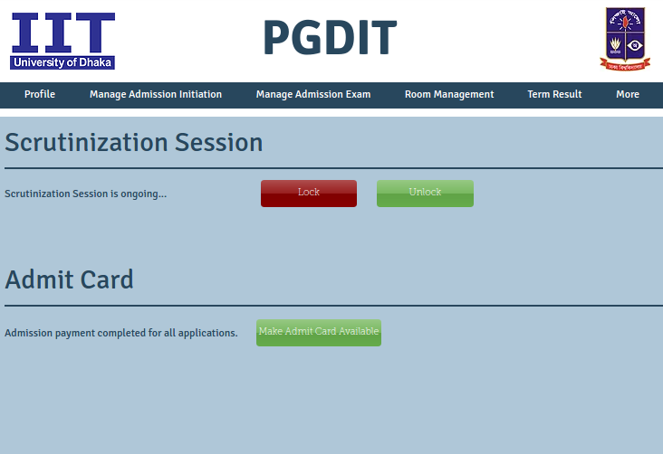

Figure 243 Exam Controller: Additional Admission Initiation Activities

Exam Controller: Upload Marks written/VIVA

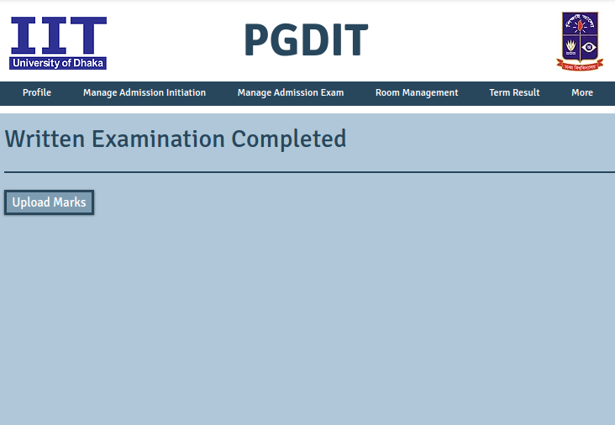

Figure 244 Exam Controller: Upload Marks written/VIVA

Exam Controller: Generate Seat Plan

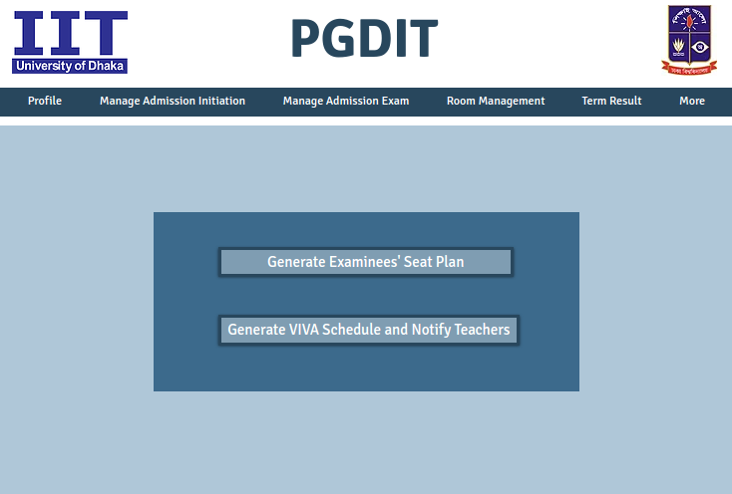

Figure 245 Exam Controller: Generate Seat Plan

Exam Controller: Update Enrollment State

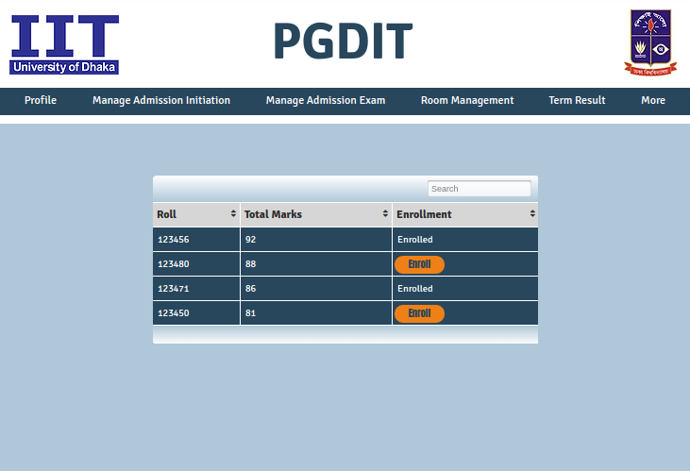

Figure 246 Exam Controller: Update Enrollment State

Exam Controller: Manage Rooms

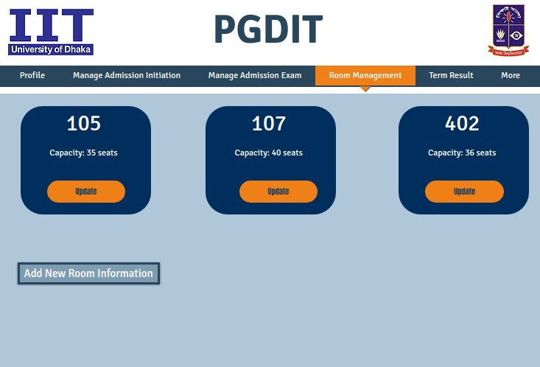

Figure 247 Exam Controller: Manage Rooms

Exam Controller: Term Result Management

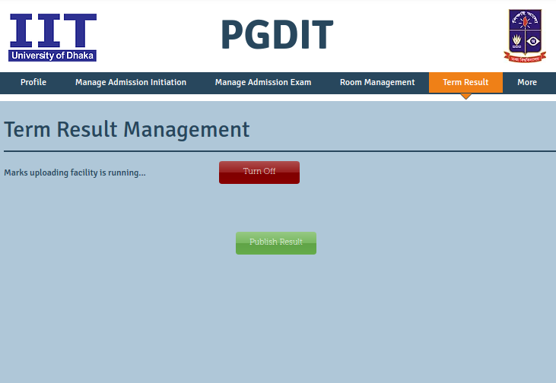

Figure 248 Exam Controller: Term Result Management

Exam Controller: Update Director’s Signature

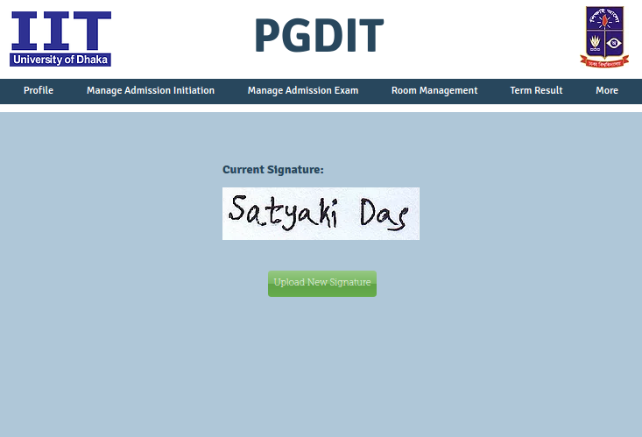

Figure 249 Exam Controller: Update Director’s Signature

Exam Controller: Notifications

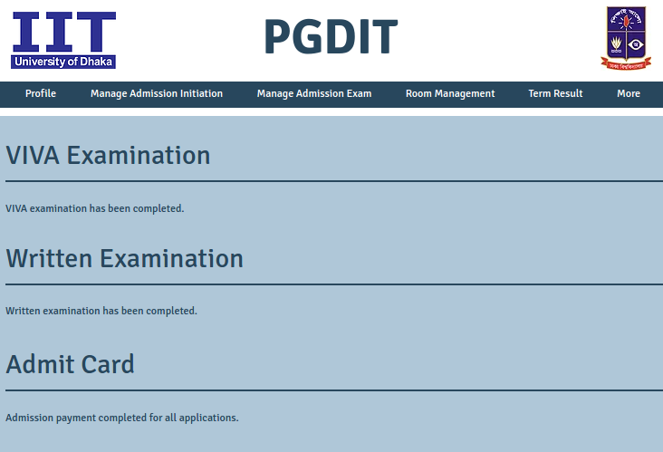

Figure 250 Exam Controller: Notifications

Student: Profile

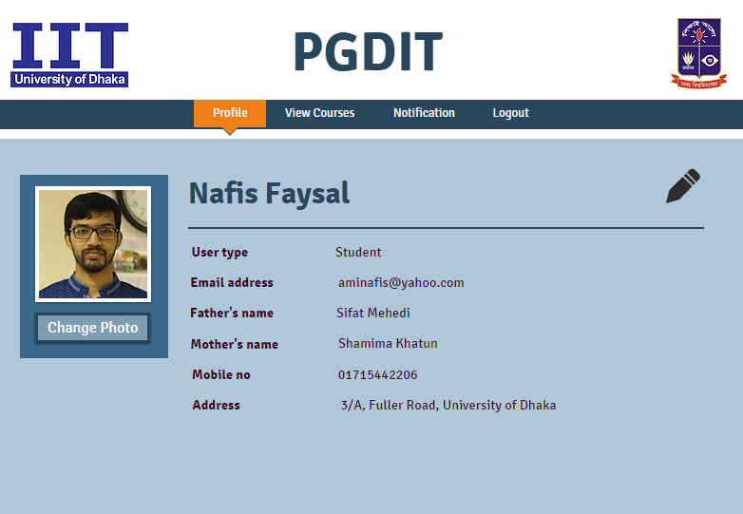

Figure 251 Student: Profile

Student: View Running Courses 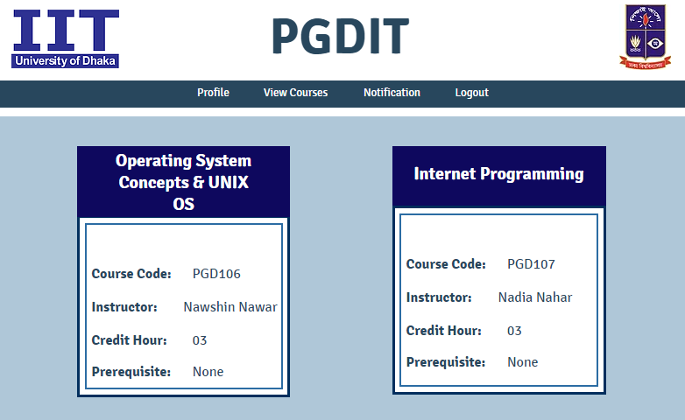

Figure 252 Student: View Running Courses

Student: View Courses Not Yet Taken

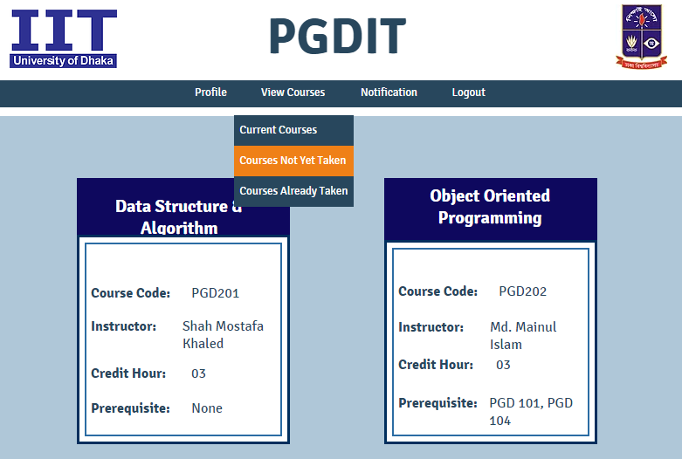

Figure 253 Student: View Courses Not Yet Taken

Student: View Courses Already Taken

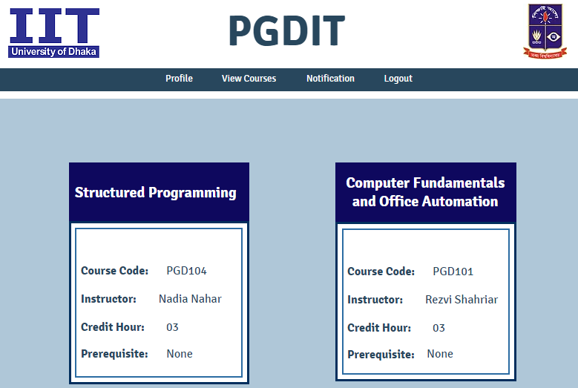

Figure 254 Student: View Courses Already Taken

Student: Notifications

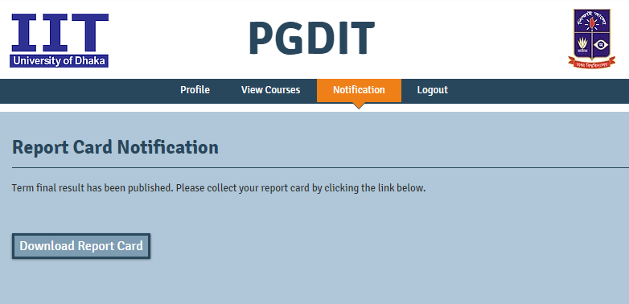

Figure 255 Student: Notifications

Scrutinizer: View Applicants

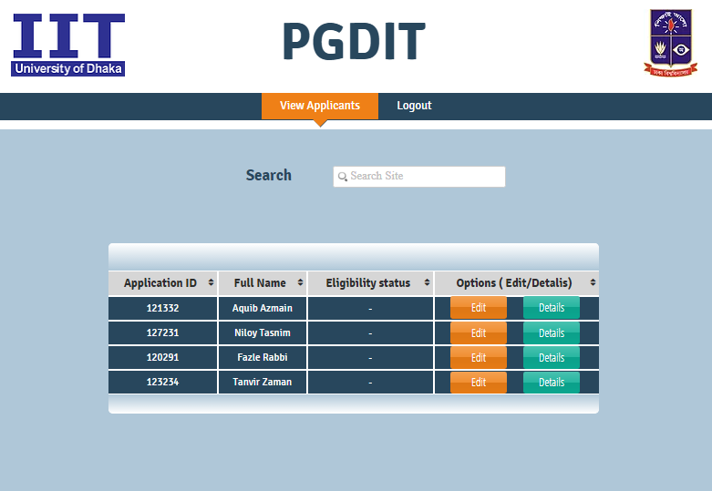

Figure 256 Scrutinizer: View Applicants

Receptionist: Profile

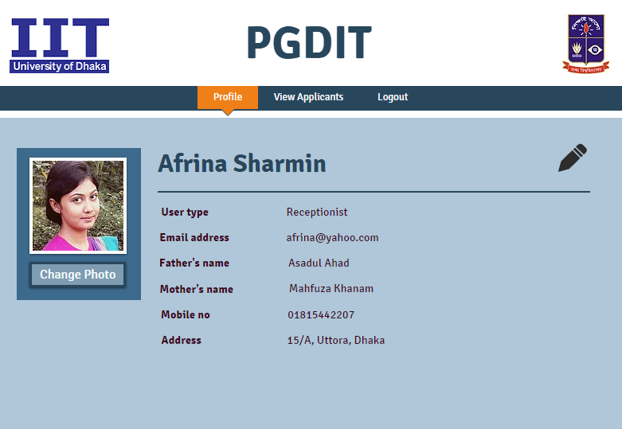

Figure 257 Receptionist: Profile

Receptionist: View Applicants

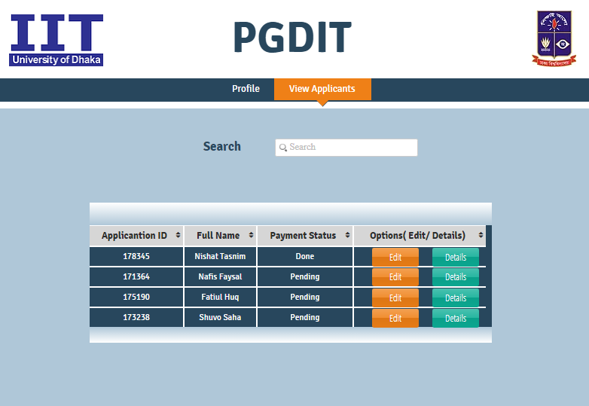

Figure 258 Receptionist: View Applicants

# References

* Pressman, Roger S. Software Engineering: A Practitioner's Approach (7th Edition)
* User Interface Design Basics, https://www.usability.gov/what-and-why/user-interface-design.html, last accessed on: 10.11.2017
* What is state diagram (state machine diagram or statechart diagram), http://searchsoa.techtarget.com/definition/state-diagram, last accessed on 14.11.2017